Getting Started with the
Epson XP-2100 Printer

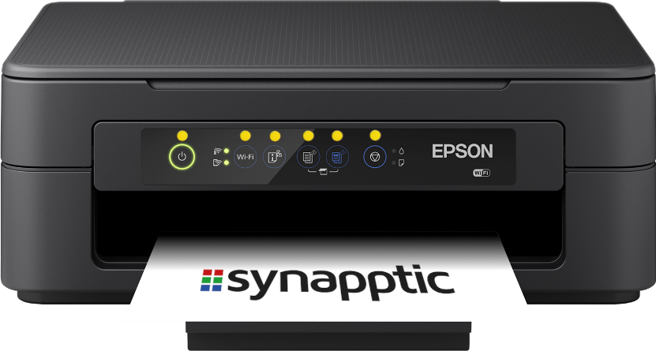

1. Unpacking

The box contains the printer, Epson warranty paperwork and a pack of 4 inks for the printer.

Open the box and remove all plastic wrapping from the printer. Also remove all the blue tape, which is placed on certain parts of the printer to stop them vibrating and moving during transit.

2. Quick tour

This section describes the various parts of the printer.
Paper support (in-tray)
Scanner lid
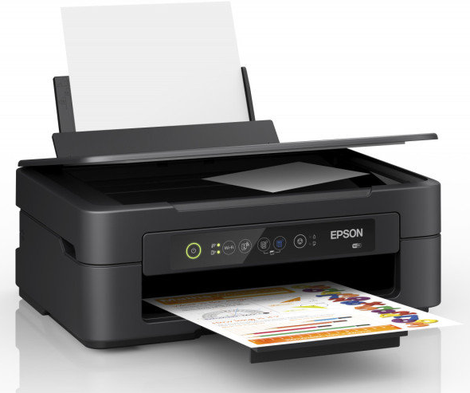
Paper support
(out-tray)
Control Panel

Paper Output Tray

The front of the printer has a large opening where the paper appears after printing. At the bottom of the opening is a pull-out tray for paper to rest on after being printed. Pull out this tray when using the printer.
Control Panel

Above the paper output opening is the control panel. This contains six buttons that can be used to control the printer. Each button has a raised coloured dot above it. From left to right the button are:

Power button: Use this to turn the printer on and off

Wifi button: Press for 10 seconds to make the printer look for a new Wifi connection

Wifi report button: Press to print details of the current Wifi connection

Photocopy B&W: Copy the current page or photo on the scanner glass in black and white

Photocopy colour: Copy the current page or photo on the scanner glass in colour

Stop printing: Press this button to stop printing or to replace ink cartridges when the ink warning light comes on.

Lights on the Control Panel

Wifi Lights:
To the left of the Wifi button are two lights, one above each other. The top one stays illuminated if the printer is connected to your Wifi. The lower light indicates if the printer is connected directly to a device with something called Wifi-Direct. The lower light can be ignored.

Ink and Paper Lights:
To the right of the Stop Printing button are two lights, one above each other. The top light illuminates if ink needs replacing, the bottom if blank paper needs replacing.

Scanner Lid

The top surface of the printer forms the scanner lid. Open this to place
a page or photo on the scanner glass, ready to be copied.

Paper In-tray

The top back edge of the printer, where the scanner lid hinges, has an opening to load blank paper. Lift the small cover and move the blue slider inside to match the width of paper you are loading. Keep the paper pushed against the right hand side of the opening and adjust the slider on the left to meet the edge of the paper.

Pull up the very back edge of the printer to form a rest for the paper to lie against. The rest tilts back slightly.

Location of Ink Cartridges

With the printer’s control panel facing you, feel along the left and right sides of the printer. A finger sized gap on each side allows the top half of the printer to open up, revealing the inner workings. The ink cartridges are located in a little holder on the right hand side, inside the printer. The cartridge holder will only be accessible when the Stop Printing button has been pressed on the Control Panel. Do not try and pull out the cartridge holder yourself, or the printer will break!

Location of ink cartridge holder

The top half of the printer latches open. Push the blue catch on the left hand side to allow the top half of the printer to close again.

Power inlet

The power inlet socket is located at the back of the printer in a small recess. Plug the small end of the power cord into this socket and the other end into a wall socket.

3. Switching on for the first time

- Ensure both paper tray supports are pulled out. Load some plain A4 paper into the top opening

- Open the top half of the printer to show where the ink cartridges are located

- Plug in the power cord and switch on the printer. The empty holder for the ink cartridges should automatically move over to the left, ready for the ink cartridges to be inserted. If it doesn’t move over, just press the Stop Printing button.

4. Loading ink for the first time

When the printer is first switched on, the ink cartridge holder should move over automatically, ready to have the cartridges inserted.

Never try and move the cartridge holder yourself, or you will break the printer!

There are four different coloured cartridges. Each will only fit in the correct slot.

From left to right the cartridge colours must be: Black, Yellow, Magenta and Cyan.

Close the top half of the printer when complete.

5. Connecting to Wifi

The easiest way to connect the printer to your Wifi connection is to use WPS.

- Turn on the printer and press the Wifi Button for 5 seconds. The lights to the left of the Wifi button will begin to flash alternately

- As quickly as you can, press the WPS button on your Wifi router

- Wait for the top light, to the left of the Wifi button on the printer, to turn on permanently. This may take a minute or two

- If both lights flash together at the same time, there is a problem with connecting to your Wifi. Turn off the printer and try again.

To view the current Wifi settings, press the Wifi Report button. The printer will print details of the current Wifi settings.

To fully reset the printer’s Wifi settings, press and hold the Wifi Report button, then press and hold the Wifi button. Keep both pressed for 10 seconds.

6. Installing the Epson Apps

Epson Print Enabler
From the Tools menu in Synapptic, use the Play Store app to search for and install the Epson Print Enabler app. This allows Synapptic, and other apps, to communicate with an Epson printer.

Epson iPrint
In addition to the Print Enabler app, we recommend installing the Epson iPrint app. This app allows you to view and configure printer settings, update your printer’s software, check ink levels, etc.

7. Printing from Synapptic

Use Synapptic to print photos, notes emails and letters. Further details and help is available in Synapptic, or through the Synapptic User Manual.

8. Replacement ink and paper

At Synapptic we stock a full range of paper and inks for all Epson printers. Please contact us if you would like to place an order.

9. Replacing empty ink

When ink starts to run out in a particular cartridge, the ink light will begin to flash. When a cartridge is completely empty the ink light will stay on permanently and the printer will not print.

Open the top half of the printer, then press the Stop Printing button. The ink cartridge holder will move to the centre of the printer and the empty cartridge will align with a small arrow shaped bump just below the bottom of the cartridge holder.

Press the Stop Printing button again. The cartridge holder will either move a little, so the bump aligns with another empty cartridge, or the holder will move to the right, ready to have the cartridge or cartridges replaced.

Close the top half of the printer when complete.

10. Full user manual

This document provides a quick summary of the printer. A full User Manual can be downloaded from the Epson website by searching for “Epson XP 2100 printer user manual” or by typing in the following URL:

https://download.epson-europe.com/pub/download/6334/epson633412eu.pdf

©Synapptic Ltd 2022. All rights reserved. Document version 1.0.

