

Synapptic Software

for Phones and Tablets

User Manual

1. About this user manual 7
2. Turning the device on and off 7
2.1 Turning the device on 7
2.2 Turning the device off 8
2.3 The lock screen 9
3. Operating the menus and Touch Screen 9
3.1 The menu structure in more detail 10
3.2 Cancelling / closing a screen or menu 11
3.3 Screen orientation 12
4. Changing the volume 12
5. Changing the magnification and contrast 13
6. Product help 14
7. Connecting to Wifi 14
8. Using the Synapptic keyboard 17
8.1 Typing with the on-screen keyboard 17
8.2 Voice recognition / dictation 19
8.3 Voice recognition special voice commands 20
8.4 AI Helper 21
8.5 Using a wireless or wired keyboard 22
9. Making calls / receiving calls 23
9.1 Using the number pad 23
9.2 Using the address book 24
9.3 Recently called 25
9.4 Important contacts 25
9.5 Call settings 26
10. Answering and ending calls 27
11. During a call 28
12. Text messages 29
12.1 Composing a new message 29
12.2 All messages 30
12.2.1 Read message 31
12.2.2 Read Conversation 31
12.2.3 Reply 32
12.2.4 Delete 32
12.2.5 Forward 32
12.2.6 Links 32
12.2.7 Save 32
12.2.8 Add Contact 32
12.2.9 Block Number 32
12.3 Unread messages 32
12.4 Sent message 32
12.5 Draft messages 33
12.6 Saved messages 33
12.7 Failed messages 33
12.8 Delete messages 33
12.9 Text settings 34
13. Ask Synapptic 35
14. Emails 38
14.1 Composing a new message 38
14.1.1 Adding attachments 39
14.2 Fetching new emails 39
14.3 Inbox 40
14.3.1 Read email 41
14.3.2 Conversation 41
14.3.3 Reply 41
14.3.4 Delete 41
14.3.5 Forward 41
14.3.6 Save 41
14.3.7 Links 42
14.3.8 View Attachments 42
14.3.9 Print 42
14.3.10 Reply to all 42
14.3.11 Mark as read / unread 42
14.3.12 Add Contact 42
14.4 Inbox unread 42
14.5 Sent emails 42
14.6 Saved emails 43
14.7 Drafts 43
14.8 Failed emails 43
14.9 Delete emails 43
14.10 Email settings 44
14.10.1 Basic settings 44
14.10.2 Advanced settings 44
14.11 Test email 45
14.12 Speak on arrival 45
14.13 Auto fetch 45
14.14 Email subject (Automatic) 45
14.15 Delete old emails 46
15. WhatsApp 46
15.1 Answering and Ending calls 46
15.2 WhatsApp Menu 47
15.2.1 Call Contact 47
15.2.2 Chats 47
15.2.3 Send Attachment 48
15.2.4 WhatsApp 48
15.2.5 Show Reminder 48
16. Address book 49
16.1 Adding, editing and deleting contacts 49
16.2 Address book settings and importing contacts 51
16.3 Block Numbers 51
16.4 Finding and filtering contacts 52
17. Calendar 53
17.1 Agenda view 53
17.2 Week view 54
17.3 Month view 55
17.4 Calendar Settings 56
17.5 Making Appointments 56
17.5.1 Advanced Mode 57
17.5.2 Basic Mode 59
17.6 Calendar reminders 60
18. Alarm Clock 60
18.1 Creating a new alarm 61
18.2 When the alarm sounds 62
19. Voice memos 62
20. Notepad 64
20.1 Creating a new note 64
20.2 Viewing a saved note 65
20.3 Editing a note 65
20.4 Emailing a note 66
20.5 Deleting a note 66
20.6 Renaming a note 66
20.7 Printing a note 66
20.8 Searching notes 66
21. Camera 67
21.1 Using the camera 67
21.2 Viewing photos 68
21.3 Searching photos 69
21.4 Renaming a photo 69
21.5 Emailing a photo 70
21.6 Deleting photos 70
21.7 Camera settings 70
22. Toolbox 71
22.1 Be My Eyes 72
22.2 Weather 72
22.2.1 My Weather 73
22.2.2 Current weather details 73
22.2.3 7-Day forecast 74
22.2.4 Add location 75
22.2.5 Delete location 75
22.2.6 Settings 75
22.3 Electronic magnifier 76
22.3.1 Use magnifier 76
22.3.2 Viewing saved images 78
22.3.3 Deleting saved images 78
22.3.4 Renaming saved images 78
22.3.5 Emailing a saved image 78
22.4 Reading machine 79
22.4.1 Normal mode 79
22.4.2 Ignore Columns mode 80
22.4.3 Document history menu 81
22.4.4 Reading machine settings 82
22.5 Colour identifier 83
22.6 Where am I? 83
22.7 App launcher 84
22.8 Play Store 85
22.9 Letter writing 85
22.9.1 Writing a new letter 86
22.9.2 Opening, editing and printing a letter 87
22.10 Chatbot 87
22.11 Visionbot 88
22.12 Screen Mirroring 89
22.13 QR and Barcode Scanner 90
22.14 Calculator 91
22.15 Clock 91
22.16 Timer 92
22.17 Stopwatch 93
22.18 Torch 93
22.19 Compass 94
22.20 Spirit level 94
22.21 Meta AI 94
23. Entertainment menu 97
23.1 Music player 97
23.2 Internet radio 99
23.2.1 Searching for a station 99
23.2.2 Playing a station 100
23.2.3 Browsing for stations 100
23.2.4 Favourite stations 101
23.3 Audio Books 102
23.3.1 Playing a Book 102
23.4 RNIB Reading Services 103
23.4.1 Search 103
23.4.2 My Books 103
23.4.3 Downloads 103
23.4.4 Book Menu 104
23.5 Calibre 105
23.5.1 Calibre Menu 105
23.5.2 Search Results 105
23.5.3 Book Menu 106
23.6 USB Audio Player 107
23.6.1 Import 107
23.7 UK TV 109
23.8 BBC iPlayer 110
23.9 YouTube 112
23.10 RSS news 114
23.11 Entertainment Settings 115
24. Social media 115
25. Web browser 116
25.1 Using the Web Browser 117
25.1.1 Basic mode 118
25.1.2 Advanced mode 120
25.2 Text only view 124
26. News from Synapptic 124
27. Tablet / Phone information 125
28. Tablet / Phone settings 126
29. Help 133
30. Android screens 133
31. Turn off 133
32. Appendix A - Connecting to a computer 134
33. Appendix B - Customising the Main Menu 136
33.1 Adding, deleting and moving menu items 136
33.2 Menu style 138
33.3 Reset menu 138
34. Appendix C - Updating Synapptic software 139
35. Appendix D – Eccentric reading and line view mode 141
36. Appendix E – Using Synapptic Reader 143
37. Appendix F – Synapptic Keyboard in Android 146
38. Appendix G – The Synapptic printing menu 148
39. Appendix H – Register for RNIB Audio Books 149
40. Appendix I – Register for Calibre 150
About Synapptic 152

About this user manual

Thank you for purchasing Synapptic Software! This User Manual gives details of how to operate Synapptic running on your tablet or smartphone.

Further information is available on our website, or by emailing help@synapptic.com.

This User Manual is also available as a Microsoft Word document, a PDF document, a Text-Only document, Audio MP3 files or an Audio CD. These are available upon request or can be downloaded from our website at www.synapptic.com/downloads

Turning the device on and off

A phone or tablet has three power states: Fully on, fully off and Standby. When in Standby mode, the screen will appear off, but the device will still be alive on the inside, ready to receive calls or emails, etc.

In Standby mode the device will use very little power and can last a week or more on a single charge. Standby mode will be activated automatically if the device is not used for a number of minutes.

Turning the device on

To turn the device on, when it is fully off, press and hold the power button for 3 seconds. After a moment, a short sound will play and then launch the Main Menu about 30 seconds later.

The power button is usually a small button about 1/4 inch (1cm) long on the edge of the device. However, this can vary depending on the device being used.

If the device is in Standby mode, just press the power button very briefly. The device will turn on instantly.

A lock screen may display immediately after the phone or tablet turns on. See section 2.3 below for details.

Turning the device off

Briefly press the power button on the edge of the device to turn the screen off and place the device in Standby mode.

It is normal practice to leave phones and tablets in Standby mode and not switch them fully off.

To fully turn off your device select the Turn Off option on the Quit Synapptic menu, located at the end of the Main Menu. The Android Power Off screen will display and Synapptic Reader will speak out the various menu options. These are usually Power Off, Restart and Emergency mode. Select the Power Off option, then select it again to confirm.

See Appendix E for further details about navigating Android screens with Synapptic Reader.

The lock screen

When the device is switched on, a lock screen may display, depending on the lock screen settings.  The lock screen will be a Swipe screen, a normal PIN number screen, a silent PIN number screen, a fingerprint, or will be disabled altogether. | 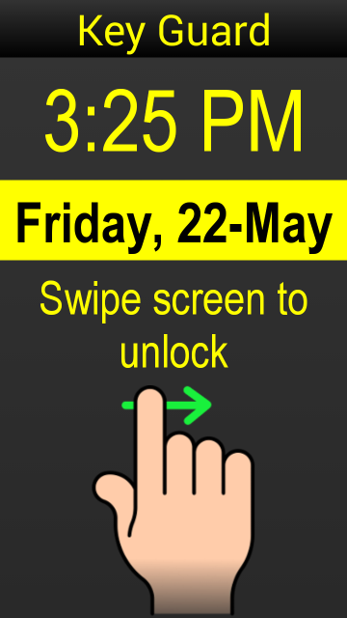 | 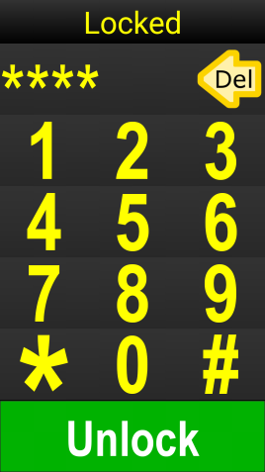
A Swipe lock screen covers the menus to reduce the risk of a bag or pocket accidentally operating them. A PIN number lock screen requires a security number to be typed in before any of the Synapptic menus can be operated.

To unlock a Swipe lock screen, place a finger on the far left of the screen and swipe it all the way across to the same point on the right hand side. A bell will sound and the lock screen will close, revealing the menus.

To unlock a PIN number lock screen, use the number pad displayed to type in the correct PIN number.

See the Settings section later in the manual for further details.

Operating the menus and Touch Screen

All Synapptic screens have a consistent look, feel and operation. Once you have learnt how to use one menu, all other menus can be used just as easily.

The following describes how to operate the tablet with its default factory-supplied settings. These include voice output, yellow text on a black background and a magnification level giving 4 menu items on each screen.

The structure of the Main Menu is very simple. At the top is the Menu Title, under which is a Previous Page button, a number of menu options, then finally a Next Page button at the bottom of the screen.  To operate the menu, place your finger towards the top of the screen and keep it gently pressed down on the screen. | 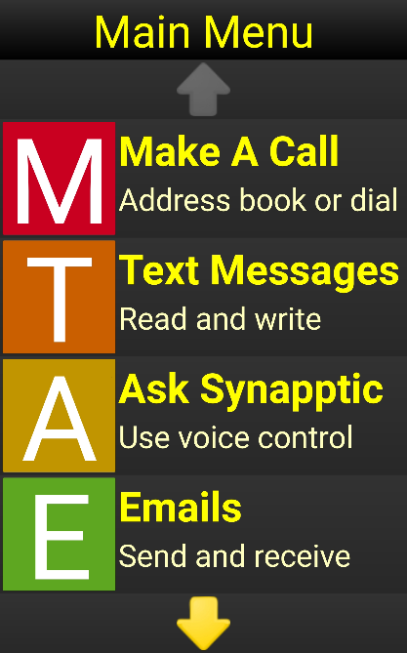

Slide your finger down the screen and do not lift up your finger until you have found the menu option you wish to select. Lifting your finger off the screen will indicate that you wish to select this option. If you do not wish to select any option, just slide your finger back off the top of the screen.

As your finger moves onto each menu option, a beep will sound and the option will be both highlighted and spoken out.

The menu structure in more detail

Menu Title: At the very top is the menu title. When this is touched, the name of the current menu is spoken, along with the current page number and total number of menu pages. (At the default magnification, four menu items are displayed on each page).

Previous Page: If the menu items are spread over several pages, use this option to go back to a previous page.

The 4 Menu Items: The first page of the Main Menu has the following menu options. (Menus are slightly different between Tablets and Phones):

Phone Menu Tablet Menu
Make a Call Ask Synapptic
Text Messages Emails
Ask Synapptic WhatsApp
Emails Address Book

As your finger moves over each option, a beep sounds to indicate you have moved to a new option, the option is both highlighted and spoken out. If your device supports vibration, a short vibration will be made each time a new option is selected.

Next Page: If the menu items are spread over several pages, use this option to go to the next page of the menu.

Cancelling / closing a screen or menu

In the top left corner of every screen is a red cross. As you move your finger over it, the voice speaks out the words "cancel and go back".

Use this red cross to cancel the current screen or menu and go back to the previous one.

The red cross is not shown on the first page of the Main Menu, as this is the starting screen.

Top Tip Number 1: Keep your finger pressed on the screen and slide it over the screen until you find the option you want. Lift up your finger to select an option. Slide your finger off the top of the screen to not select any option.

Top Tip Number 2: Cancel a screen or menu quickly by swiping your finger or thumb over the red cross and off the edge of the screen. This has the same effect as pressing the red cross.

Screen orientation

By design, most screens will not change orientation as the phone or tablet is rotated. The screens that do automatically change orientation are the keyboard, web browser, screens that display a note, email or text message and screens for playing TV and YouTube.

If you wish all screens, including menus, to change orientation as the tablet or phone is rotated, select the Auto Rotate option in the Tablet or Phone Settings menu. See the Settings section in this User Manual for details.

Changing the volume

Use the volume keys on the edge of the phone or tablet to change the volume. The volume keys are normally on the edge of the device. The volume key can be a single long button, that has one end for volume up and one end for volume down, or two smaller buttons close together.

The volume keys will normally change the volume of the voice and any associated beeps.

Further adjustment of voice, notification tone, ringtone, call volume and other sounds is done via the Sounds option on the Tablet/Phone Settings menu.

The volume keys can also have a special function on certain screens. For example, the volume keys can be used as navigation buttons to move to the next heading, paragraph or button on an app or web page, or will change the magnification of an image when using the magnifier.

See the Synapptic Reader settings and Web Browser setting for details of how to disable the volume buttons as navigation buttons.

Changing the magnification and contrast

The contrast of icons, colour of text, size of text and back colour can all be changed. Please see the Settings Menu for more details.
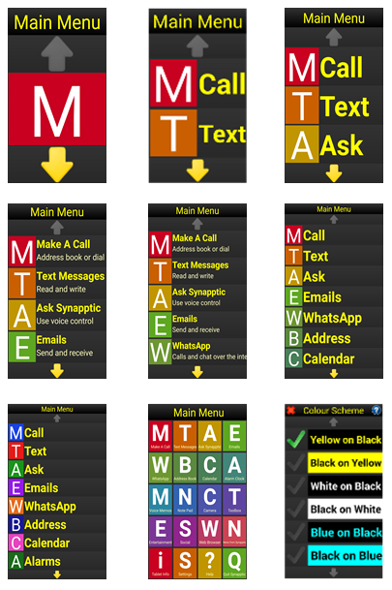

In addition to changes in colour, the items on the menus can be moved or deleted and the Main Menu style can be changed from a multi-page list to a single page grid. See the Customise option in the Settings Menu for further details.

Product help

In the top right of each screen is a blue icon with a white question mark in the middle - this is the Help Button. Press the Help Button to show specific help for that screen. The help will consist of one or many help documents and video tutorials displayed in a list. Select an item in the list to view the document or play the video.

When reading a Help Document, use the Up and Down arrows at the top and bottom of the screen to move between pages. Alternatively, press the Read All button in the top right of the document, to have the entire help document spoken aloud. Help documents can be closed in the normal way, using the red cross in the top left of the screen.

Use the Help menu option towards the end of the Main Menu to search and view all help documents.

Note: After a video has finished playing, press the red cross in the top left corner of the screen to return to the Help Menu.

Further help is available on our website at www.synapptic.com or via our telephone helpline on 0191 909 7 909.

Connecting to Wifi

Many Synapptic features require a connection to the Internet. Some of these include Email, Web Browser, Reading Machine, TV, YouTube and Internet Radio.

When at home or in a cafe or hotel, we recommend connecting to Wifi. When away from a Wifi connection the phone or tablet may still connect to the Internet via the mobile phone network, if it accepts a SIM card.

From the Tablet Settings or Phone Settings menu select the Wifi option. Four options are available.  The top option is the Wifi Signal, which will read out the current connection status.  The second option allows you to turn the Wifi on and off.  The third option will show a list of all Wifi networks in range. | 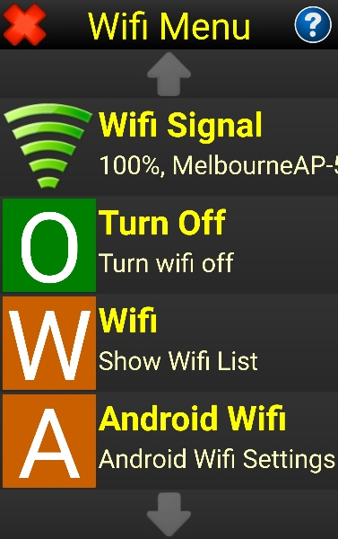

The fourth option opens the Android Wifi settings, which are more comprehensive but not normally needed.

To connect to a Wifi for the first time, select the third option for Wifi List.

The Wifi connection with the strongest signal is usually at the top of the list. This is most likely the one to select.  Select the appropriate Wifi connection from the list and type the password if required.  The status of each connection is shown and spoken out as your finger moves up and down the list. | 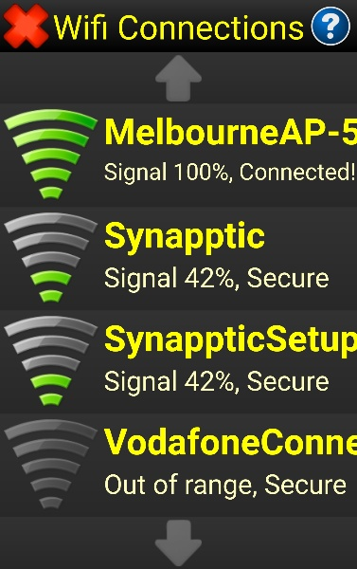

Once successfully connected, all Wifi passwords are remembered. Wifi connections with remembered passwords are automatically connected again when they come into range. To make the system forget a password, just select any previously connected Wifi entry and pick the Forget option from the menu.

Wifi connections will have one of the following statuses:

Connected: Only one item in the list can be connected at a time. If you select the connected item, a menu will display, with an option to forget the password and disconnect the connection.

Secure: Secure indicates a password will be required to connect to this Wifi. Select this Wifi, then type in the password.

Open: Open Wifi connections do not require a password. However, if you experience difficulties accessing the Internet through an open connection, try using the Web Browser and open a page such as www.google.com. Although the Wifi connection may not need a password, registration may be needed before a full connection to the Internet is allowed.

Top Tip 1: Passwords are case sensitive. If you accidentally type an incorrect password, re-select the item from the Wifi list and select the Forget option from the menu. Then, select the item again from the list and type in the corrected password.

Top Tip 2: After connecting to an open Wifi connection that does not require a password, try using the web browser and navigating to www.google.com. If a registration page displays instead of Google, you will have to follow the instructions on the page to gain full access to the Internet.

Top Tip 3: Hold your finger on an entry in the Wifi list to hear the full details. A letter by letter version of the Wifi connection will be spoken out at the end, to help distinguish a particular connection. (Wifi connection name are quite often not full words, but combinations of letters and numbers).

Top Tip 4: We recommend using Synapptic to configure all Wifi connections. If Wifi connections are created using Android screens, only those same Android screen are able change those Wifi connections. Synapptic can only change Wifi connections configured from Synapptic.

Using the Synapptic keyboard

The Synapptic keyboard screen is used in many places within Synapptic.

It is also available outside of Synapptic, see Appendix F for further details.

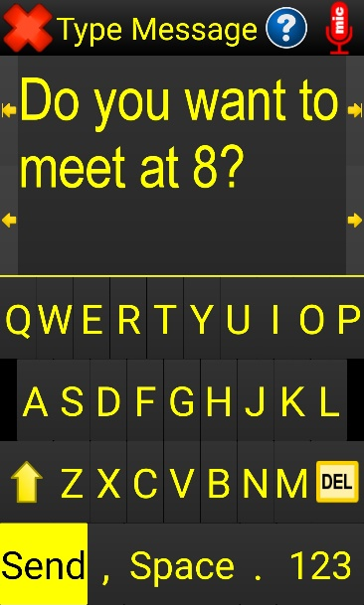 | 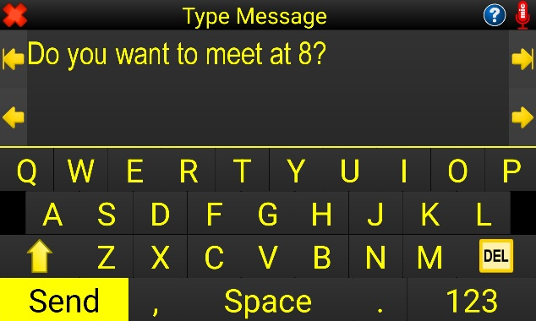 | 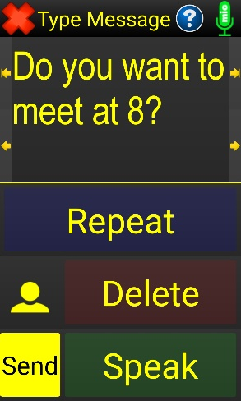
Portrait | Landscape | Dictate

Whenever the keyboard displays, there are four ways of typing:

1. Type with the on-screen keyboard
2. Dictate a message with your voice
3. Dictate changes to the AI Helper
4. Using a physical keyboard (wireless or wired)

When typing text you can seamlessly switch between any of the four options.

Typing with the on-screen keyboard

The on-screen keyboard will automatically adjust to the orientation of the tablet or phone. It will display in a portrait or landscape orientation.

The keyboard screen is split into two sections. The top half shows the text already typed in, the lower half contains the keys of the keyboard.

Tap each key to type that letter. The letters you type will be shown in the top half of the screen.

Alternatively, place your finger in the lower half of the screen, keeping it pressed on the screen. Slide your finger around to explore the keys of the keyboard. Each letter your finger passes over will be spoken out and shown in large print in a little popup area above your finger. Lifting your finger off the screen on a particular letter will type that letter.

If you make a mistake during typing, press the Delete key (located under the letter L and to the right of the letter M). The delete key always deletes the character to the right of the cursor, unless the cursor is at the end of the text, in which case it deletes the last character typed.

Touch the top half of the keyboard screen to have the voice speak out the text that has been typed. The arrow keys to the left and right of the text, on the edge of the screen, move the cursor back and forward through the text, either a letter or word at a time. Each time the cursor is moved, the voice speaks out the word or letter to the right of the cursor.

Top Tip 1: The size of the text in the upper half of the keyboard will change with the general zoom level. It can also be changed independently of the zoom level by using the Text Size option in the Settings Menu. This allows the text size for reading and writing to be adjusted to the perfect level.

Numbers and Symbols

Press the 123 button at the bottom right of the keyboard screen to change between the letters keyboard and the numbers and symbols keyboard.

The numbers and symbols keyboard has multiple pages, each showing a different set of symbols and characters.  Press the page key to change between pages of symbols. The Page key is located where the Shift key would normally be - just above the Send key at the bottom left of the keyboard. | 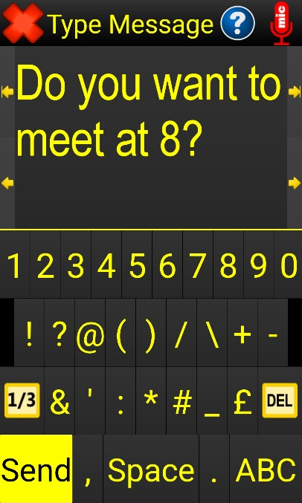 | 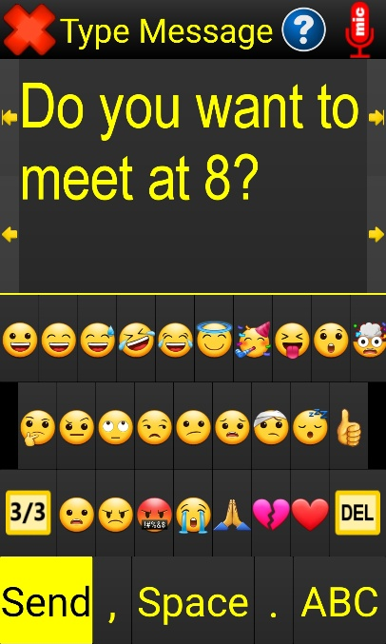

Voice recognition / dictation

Voice recognition allows text to be dictated, instead of typed with the keyboard.

Use the microphone icon in the top right of the keyboard screen to turn voice recognition on and dictate your message, instead of typing it. Press it again to turn voice recognition off. Text can be written using a combination of typing and dictation.

With Voice recognition turned on, the letters of the keyboard are hidden and five large buttons are displayed instead.

Press the 'Press to Speak' button at the bottom of the screen when you are ready to speak. Wait for the beep, then start speaking. Speak clearly in your normal voice and say a few words or a short sentence. When nothing is spoken for 2 seconds the system will assume you have finished speaking and convert your speech into text, which will be added to the text at the top of the screen.

To repeat what the system last understood you to say, press the Repeat Button. If the system understood you incorrectly, press the Delete button and try again. (Note: After deleting your last utterance, the delete key reverts back to being a normal delete key, that will delete previous text letter by letter).

From Voice Recognition you can also access the AI Helper, which lets you ask for changes. The AI Helper button is next to the Delete button, further details can be found in the AI Helper section.

When finished with Voice Recognition, either press the microphone icon again in the top right of the screen or press the confirmation button in the bottom left of the screen.

Voice recognition special voice commands

Certain voice commands can be spoken to type special characters or press certain buttons. These are listed below:

The following commands will type the corresponding punctuation and can be used on their own or within a sentence:
Full stop, Question mark, Exclamation mark, Comma, New line, New paragraph.

The following commands will automatically close the Voice Recognition screen and send the text message, email or continue to the next screen:
Continue, Send email, Send text message, Send message.

Other commands:
Delete All: The system will ask for the delete command to be repeated before actioning it. All typed or dictated text will then be deleted.
Shift key on, Shift key off, Caps lock on, Caps lock off: These commands will press the shift key or turn caps lock on or off.

The following commands will type the corresponding punctuation, number, bracket, etc:
Space, At sign, Underscore, Dash, Plus sign, Multiply sign, Equals sign, Forward slash, Back slash, Colon, Semi colon, Quotes, Pound sign, Dollar sign, Percent sign, And sign (or ampersand), Left (curly, square, angled) bracket, Right (curly, square, angled) bracket, Apostrophe, Hash, Letter A, Letter B, Letter Z, etc. Letter Alpha, Letter Bravo, Letter Zulu, etc. Number 0 to 9, Smiley face, Sad face, Wink face, Oh my god face.

Top Tip 1: The AI Helper can be shown or hidden with the voice command ‘AI Helper On’ or ‘Off’.

AI Helper

The AI Helper lets you change your message by describing the changes you’d like.
In the same manner as Speech Recognition, press the 'Ask’ button at the bottom of the screen when you are ready to speak. Wait for the beep, then start speaking.  You can ask for the changes with natural language such as: ‘Check my spelling’, ‘Delete the second paragraph’ or ‘Translate this into Italian’. | 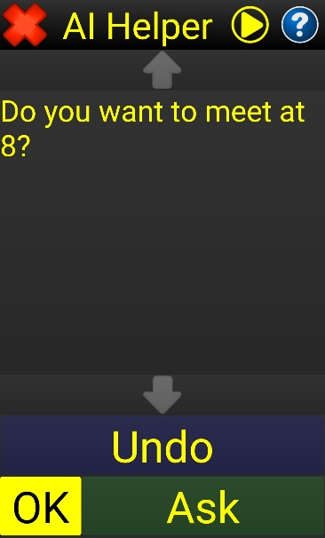
The Helper will replace your text with the changes you’ve asked for. You can press the Undo button to revert any change.

When you’re done with the Helper, press the OK button in the bottom left of the screen to keep the changes. You can also press the Cancel button in the top left to discard all changes.

Using a wireless or wired keyboard

Tablets and phones can be fully operated with a wireless or wired keyboard. We recommend the Synapptic wireless keyboard.

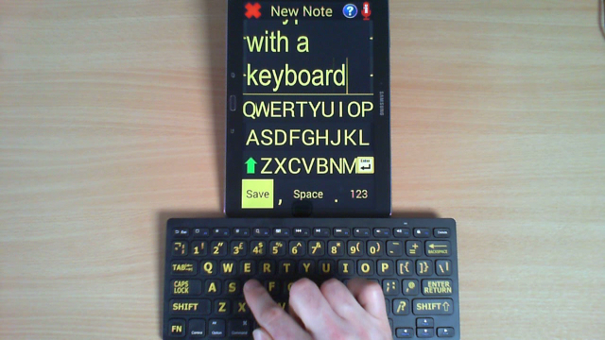 | 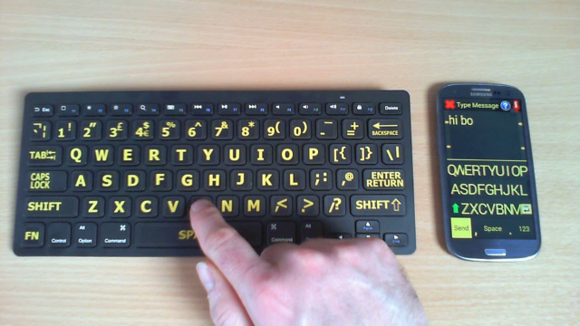
Wireless keyboard  connected to a tablet | Wireless keyboard  connected to a phone

Whenever the on-screen keyboard is displayed, text can also be typed with a wireless or wired keyboard. In addition to this the arrow keys on the keyboard can be used to navigate around all menus and screens, and the Enter key used to select an option.

Top Tip 1: When using the wireless keyboard, press the keyboard shortcut CTRL+Enter to press the Send, OK or Done button in the bottom left of the keyboard.

Top Tip 2: The Tab key can be used to toggle the arrow keys between navigating about the typed text and navigating about the screen.

Making calls / receiving calls

This section only applies to smartphones and tablets that accept a SIM card, and make calls on the standard mobile phone network. (To make free WhatsApp calls over the Internet see the WhatsApp section of this manual).

To make a normal telephone call, select the Make Call option from the Main Menu. The Make Call Menu will then display.

The Make Call Menu consists of three main options at the top, followed by any contacts marked as being important contacts. At the very end is a Settings option.  Important contacts are included on this menu so they can be selected quickly and easily. | 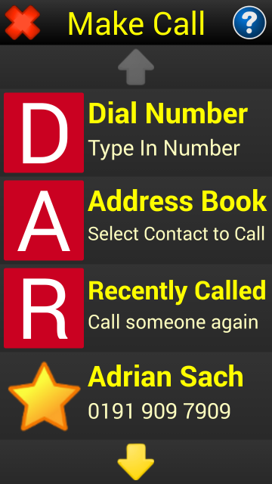

Using the number pad

Use this option to show the number pad and dial a specific telephone number.  Either press each digit on the number pad, or use your finger to explore the screen and find the required digit, then lift your finger off the screen to select that digit.  The complete number is shown at the top of the screen, just above the number 1 key. Keep your finger pressed on the screen in this area to hear the number spoken out, and check the digits have been input correctly. | 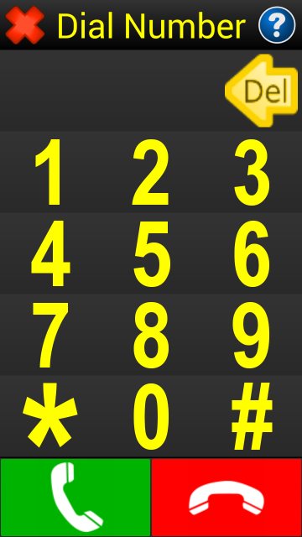

Above the number 3 key is a delete button. Press this to delete the last digit typed. To delete the entire number, press the red Clear Number button in the bottom right of the screen.

When all digits of the number have been typed, press the green Dial Button in the bottom left to dial the number.

To make an international call, select the star key twice to type a plus sign, followed by the country code and phone number.

The Call Information screen will display whenever a call is active. See further below for details about this screen.

Using the address book

Use this option to call someone who's number is already stored in the address book. A list of contacts will be displayed that have telephone numbers. If a contact has more than one telephone number, they will be listed multiple times - once for each telephone number.

Use the Next Page and Previous Page buttons to move between the pages of contacts.  Move your finger over each contact to hear their name and telephone number spoken out.  Release your finger when the correct contact has been found. A confirmation screen will display. Select Yes and their number will be dialled. | 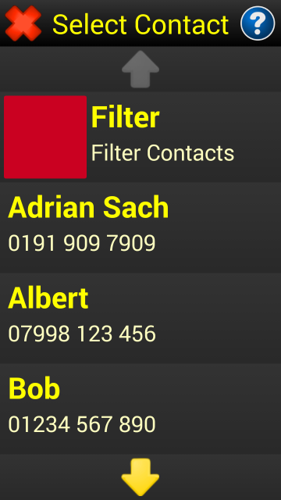

Use the Filter Contacts option at the top of the list to filter and search for specific contacts. See the Address Book section of this User Manual for further details.

Recently called

Each call made, received or missed is added to the Recently Called list.

For each entry in the Recently Called list the name of the person calling or called is shown, along with the date, time and duration of the last call.  Select an entry to see details of the call, call the person again, add them to the address book or delete the entry.  You can also block the number, to prevent nuisance calls or texts. | 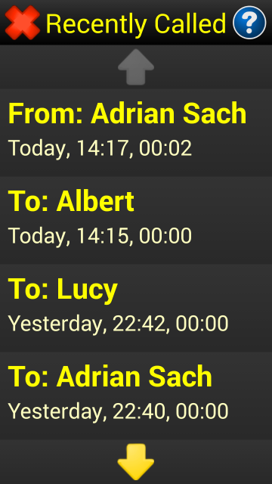

Important contacts

Important contacts are listed directly on the Make Call menu, from the fourth menu option onwards. This allows you to call Important Contacts numbers quickly.

To have a contact appear on the Make Call Menu, add it to the Address Book as an Important Contact.

Each Important Contact on the Make Call Menu is displayed with a yellow star to the left.

Call settings

At the end of the Make Call menu is the Call Settings option. Use this to change call related settings.

Announce Caller: For extra privacy the caller announce feature can be turned off for incoming calls.  Ringer: This settings allows ringtones and ringer modes to be changed, along with ringer volume.  Speakerphone: Set the speakerphone to be always on or not.  Call Volume: This lets you choose the starting volume of all phone calls.  Call Screen: Select which screen is shown when you are on a call.  Voicemail Number: If the SIM card does not contain a voicemail number, use this option to type one in. | 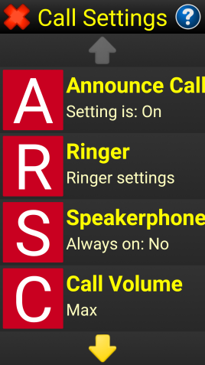

Answering and ending calls
This section applies to phones / SIM tablets only.

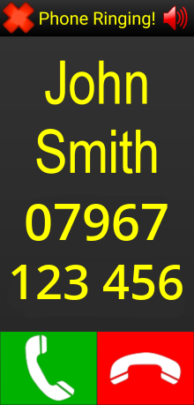 | 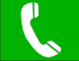 When the device rings, use the green Answer button in the bottom left of the screen to answer the call.  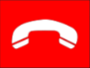 Use the red Reject button in the bottom right to reject the call.

In addition to the answer and reject buttons, all Synapptic smartphones and SIM enabled tablets are configured with helpful shortcuts that allow calls to be answered or rejected using physical buttons.

Volume Up button = Answer call
Power Button = End a call

If these shortcuts are not enabled on your phone, use the Interaction and Dexterity option in Android Settings to set the answering and ending calls options.

During a call
This section applies to phones / SIM tablets only.

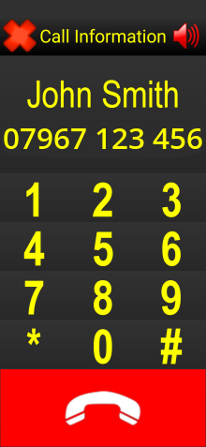 | After answering an incoming call or after successfully making an outgoing call, the Call Screen will display.  Use the number pad if you need to operate a telephone menu and are being asked to “press 1 for sales or 2 for technical support”, etc.

Use the button in the top right of the screen to turn the loudspeaker on or off and listen to the call through the loudspeaker instead of the earpiece.

Press the large red button at the bottom of the screen to end the call. (Alternatively, you can use the Power button to end the call).

Top Tip Number 1: Use the Ringing Flasher option in the Phone/Tablet Settings Menu to make the whole screen flash, instead of just the title at the top of the screen.

Top Tip Number 2: Use the Speaker button in top right corner of the Synapptic Call Screen to have the call play through the speaker, instead of the ear piece.

Top Tip Number 3: If you always want the loudspeaker turned on for calls, use the Settings option on the Make a Call menu and change the Speakerphone option to Always on.

Notes: When the phone is placed near to your ear, the screen is temporarily turned off, so the side of your face or ear does not activate anything on the touch screen.

Text messages

Text Messages are short messages sent between mobile phones (and tablets that can accept SIM cards). Messages are delivered almost instantly.

From the Main Menu, select the Text Messages option. From here, options are available for composing new messages and reading received messages.

When the Text Messages menu option is select for the very first a warning message asking to allow access may display on some devices. If this happens, select the Allow option and follow the instructions spoken and displayed on screen.

Composing a new message

From the Text Menu select the Compose New option. The Compose Message menu will display.

Use this menu to address the text message. Either type the number of the person to send the message to, select a person from the Address Book or use the Multiple option to send a message to multiple people at once.  After addressing the text message, the keyboard will show for the message to be typed in or dictated. | 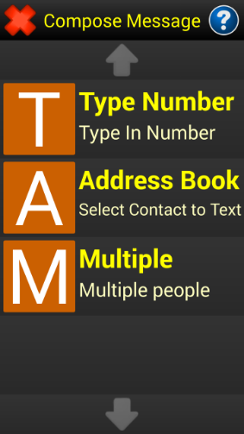

Messages can be typed or dictated. See the Using the Keyboard section for full details on how to use the on-screen keyboard.

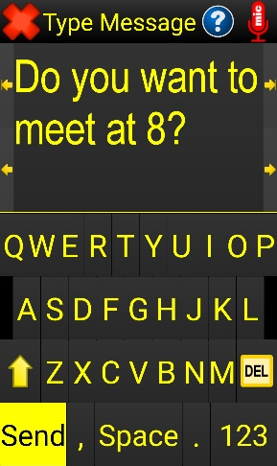 | 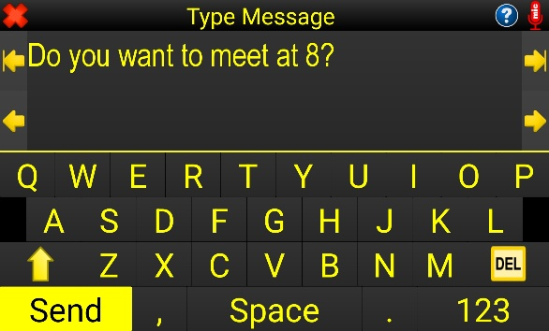 | 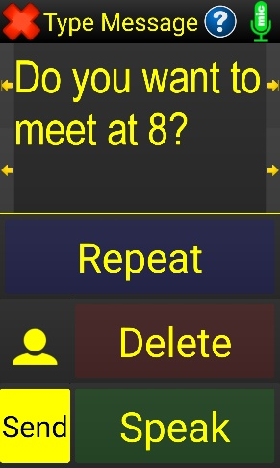
Portrait | Landscape | Dictate

Press the Send key in the bottom left hand corner to send the text message. Before sending, a Yes / No / Drafts menu is displayed to confirm if you wish to send the message now or save it as a draft to be finished later.

All messages
This option displays a list of all text messages received. If they are new and unread the word New is shown by the side of the message.  The newest messages are at the top of the list. When you move your finger over each message, the sender, date/time and message are spoken out. | 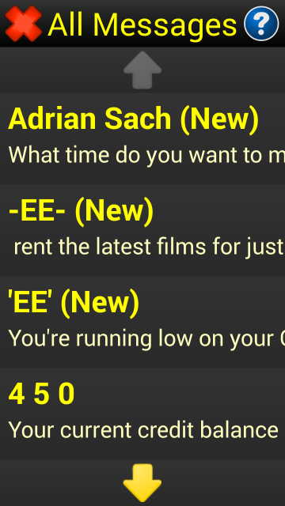

After selecting a message the Message Menu is displayed, where options are available to read the message, delete it, forward it, reply to it, save it or add the sender to the Address Book. See below for details. | 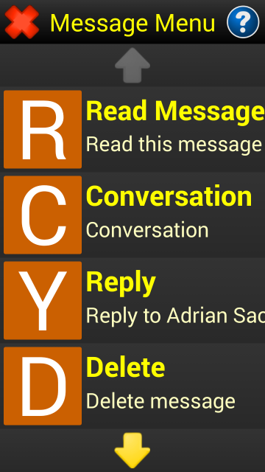

In more detail, the Message Menu options are:

Read message
The Read Message option displays the full message on screen. If the message is too long to fit on one page, it is split over multiple pages.  Use the Previous and Next buttons to move between pages.  An option can be set to force messages to display on just one page. See the Text Settings section below for details. | 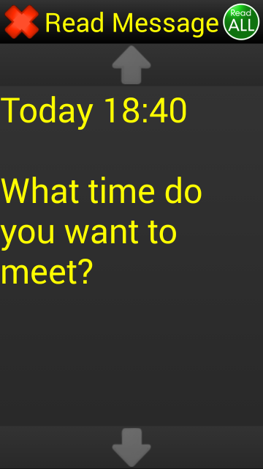

Use the Read All button in the top right of the screen to read all pages of text in one go.

The size of the message text varies with zoom level, but can be adjusted independently using the Text Size option in the Settings Menu.

Read Conversation
Use this option to read, in order, all messages sent just between you and the selected person. The messages are presented in a list with the oldest message at the top.

Reply
Shows the keyboard, where the reply message can be typed.

Delete
Deletes the message permanently.

Forward
Allows a copy of the current message to be forwarded to other people.

Links
Shows a list of any website links contained within the text message

Save
Saves the message into the Saved text messages list for safe keeping, or easy access.

Add Contact
Adds the sender of this message, along with their telephone number, to the Address Book.

Block Number
Blocks this telephone number, preventing any call or text message from reaching you.

Unread messages

Exactly the same as All Messages above, except the messages are filtered to only show messages that are unread.

Sent message

Exactly the same as All Messages above, except the messages are filtered to only show messages you have sent.

Draft messages

When sending a text message an option exists to save the message into the Drafts list, instead of sending it. This is useful if you wish to complete the text message at a later date.

Saved messages

Any saved messages are displayed here. This is useful if you wish to keep a text message safe, or keep it somewhere different to allow quick access to it.

Failed messages

Exactly the same as All Messages above, except the messages are filtered to only show messages that did not send. Messages commonly fail to send if there is no phone signal for a prolonged period of time, or the mobile number being sent to is incorrect.

If there are failed messages, a notification will be given each time the Text Message menu option is selected. To get rid of this notification, just delete any messages in the failed messages list.

Delete messages

Each individual text message can be deleted using the Text Message Menu for a specific message. However, the Delete Messages option on the main Text Menu allows multiple messages to be deleted at the same time.  After selecting this option the system will ask where you wish to delete multiple emails from. This can be from Received messages, Sent messages, Saved messages, Failed messages or Drafts. | 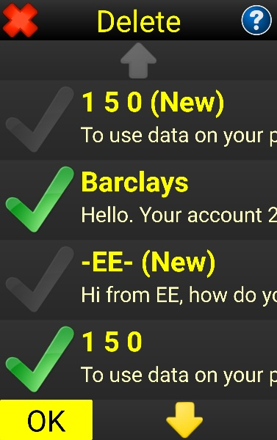

Select the messages you wish to delete and move to a different page to select more. Each message selected for deletion will have a green tick to the left of it. The description for that item will also include details about it being ticked or not.

When ready, press the OK button in the bottom left corner of the screen. Any ticked messages will be deleted.

Text settings

A number of settings specific to text messages are configurable here.

Fit to Screen: Use this option to force text messages to fit on just one page.

Speak On Arrival: Configure if the name of the sender is announced when a new message arrives.

Delete Messages: Use this option to quickly delete all old messages, just leaving the latest 10.

Ask Synapptic

Use this feature to control Synapptic with your voice. Start calls, send messages, change settings, ask questions and more.  To start, tap the screen, wait for the beep, then speak the command.  This feature uses AI. All information is private and not used off device. You can disable AI entirely in the settings menu. | 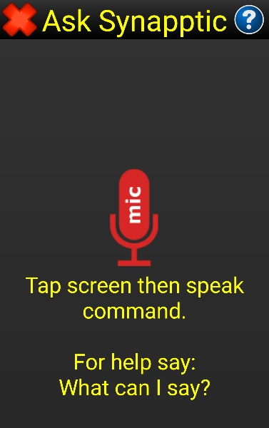
For help with available voice commands, say the command "what can I say". A special help page will display, detailing all the commands that can be spoken. These are also detailed below:

Voice Command | Description
Call (followed by a contacts name). | Dials the contact's first telephone number.
Text (followed by a contacts name). | Starts a text message to the contact's first telephone number.  You can include your message in this command - for example 'Text Good Morning to Alex'.
Email (followed by contacts name). | Starts a new email to the contacts first email address.  You can include the email subject or message in this command – for example ‘Email George to say I’m running late.’
Call or Text (followed by a contacts name) on WhatsApp. | For example, 'Call Taylor on WhatsApp' or 'Text "How are you?" to Sam on WhatsApp'.  Calls will give an option of voice or video calls. Texts can include a message.
Ask a question | For example, ‘Recommend a good Italian restaurant in Durham’, ‘What is the phone number for London Taxis?’ or ‘What is the population of the UK?’.  The AI will respond or search the web for an answer. You can close the response and ask follow up questions or give more information.
Ask a question about something visible. | For example, ‘What’s in front of me?’, or ‘Read this bus timetable’.  This will open the VisionBot, which takes a photo using the device camera to generate an answer.
Set a timer (followed by a number of minutes or time of day). | At the given time, an alarm will sound. You can Pause or Cancel the timer too.
(Menu Name). | Speak the name of any item on the Main Menu to start that option.
View photos. | Shows photos taken with the camera.
Launch (followed by the name of an app that is installed). | Opens up the Application, with Synapptic Reader if it is installed.  For example, 'Launch Audible'.
What's the time?  What date is it? | Displays and speaks out the time/date on screen.
Phone Signal, Wifi Signal or Battery Level. | Check your phone, wifi or battery level.
Search for (followed by a number of search words). | Shows a list web pages that match your search words.
Listen to (followed by the radio station you’d like to listen to). | Starts playing the Radio Station.
Watch (followed by the channel name). | Starts playing one of the UK TV Channels available in the Entertainment Menu.
Help (followed by the topic you'd like help on). | Shows a list of help pages relating to the topic.
What settings can I say? | Shows a list of voice commands for changing settings.

The commands to change settings are shown by the ‘What settings can I say?’. They are also listed below:

Voice Command | Description
Reset Menu | Puts the menu back to its default layout
Move Up or Move Down (followed by the name of a menu) | Moves the menu up or down one space on the Main Menu.  You can also say Move (followed by the name of a menu) to the top or bottom.
Increase or Decrease (followed by a setting name) | You can change Voice Volume, Voice Speed, Ringtone Volume or Zoom Level.  For example, ‘Increase Voice Volume’.
Setting name (followed by a number) | You can set Voice Volume, Voice Speed, Ringtone Volume and Zoom Level directly to a number.  For example, ‘Zoom Level 7’.
Turn On or Turn Off (followed by a setting name) | You can toggle Voice, Wifi or Speakerphone on or off.  For example, ‘Turn Off Speakerphone’.
Ringer Mode (followed by the mode) | You can set the phone ringtone mode to Normal, Silent or Vibrate.  For example, ‘Ringer Mode Silent’

Emails

Use your tablet or phone to send and receive emails. From the Main Menu select the Emails option. From here, options are available for composing new messages and reading received messages.

Composing a new message

From the Email Menu select the Compose New option. The Compose Message menu will display.

Use this menu to address the email. Either type the email address of the person to send the message to, select a person from the Address Book or use the Multiple option to send one email to multiple people.  After addressing the email, the keyboard will show for the email subject to be typed in or dictated.  The email subject is normally just a few words. After completing this Synapptic will ask for the main message to be typed in or dictated. | 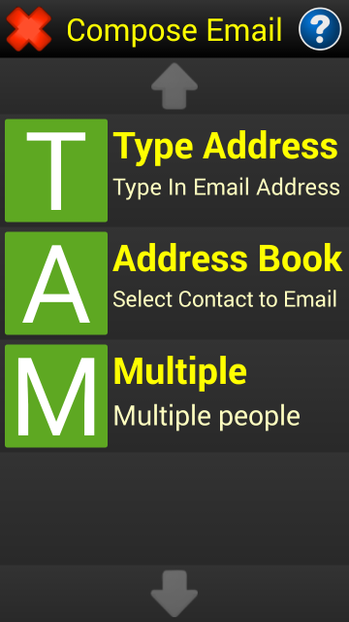

For further details on how to use the keyboard for typing or dictating messages, see the Keyboard section of this User Manual.

Portrait | Landscape | Dictate
Press the Send key in the bottom left hand corner to send the text message. Before sending, a Yes / No menu is displayed to confirm if you wish to send the email.

Adding attachments

There are two ways to attach files to an email.

- To attach a single note or photo quickly, go to the Notes, Memos or Camera menu option on the Main Menu first, where options are available to create a new email with the appropriate note, photo or memo attached.

- To attach several photos, notes or memos to an email, use the Attachments option from the menu displayed at the end of the composing email process.

Fetching new emails

Use this option to fetch any new emails immediately. After a short pause, any new emails will be downloaded and synchronised. (The voice will speak out details of any problems encountered with fetching emails when using this option).

Please see the option in Email Settings for Auto-Fetch. This setting allows emails to be downloaded and synchronised automatically.

Top Tip: Make sure your email settings are configured to use IMAP as the Email Mode. IMAP allows one email address to be shared across several devices. Emails are downloaded to each device, then synchronised between them. If an email is read, or deleted on one device, that change is synchronised and shown on all devices. See the email settings below for further details.

Inbox

The Inbox displays a list of all email messages received. If they are new and unread the word New is shown by the side of the message.  Emails with attachments are shown with a '*' shown by the side. The voice also speaks out that there is an attachment.  The newest messages are at the top of the list. When you move your finger over each message, the sender, date/time and message are spoken out. | 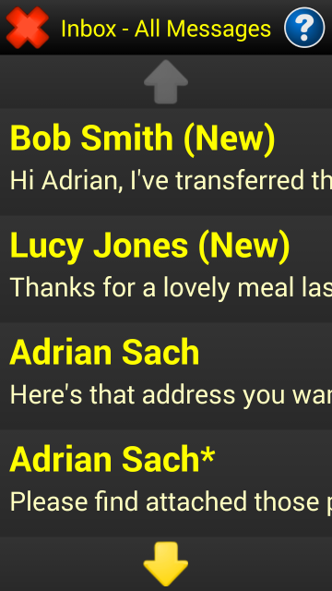

After selecting a particular message the Message Menu is displayed, where options are available to read the message, reply to it, delete it, forward it, save it, view links or images in the email, view attachments, mark as read or unread or add the sender to the Address Book. See below for details. | 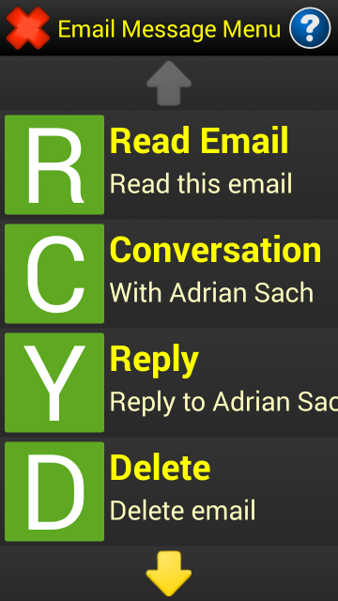

In more detail, the Message Menu options are:

Read email
The Read Email option displays the full email message on screen. If the message is too long to fit on one page, it is split over multiple pages.  Use the normal Previous and Next buttons to move between pages.  Use the Read All button in the top right of the screen to read all pages of text in one go. | 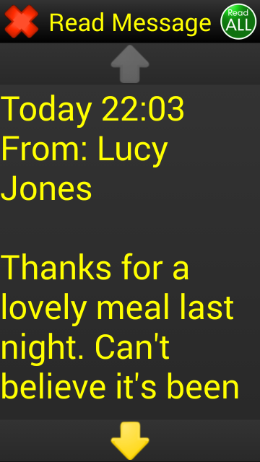

The size of the message text varies with zoom level, but can be adjusted independently using the Text Size option in the Settings Menu.

Conversation
Use this option to read, in order, all emails sent just between you and the selected person. The emails are presented in a list with the oldest message at the top.

Reply
Shows the keyboard, where the reply message can be typed.

Delete
Deletes the message permanently.

Forward
Allows a copy of the current email to be forwarded to another person. Any attachments in the original email are also sent.

Save
Saves the email into the Saved Emails list for safekeeping, or easy access.

Links
Shows the email in the Web Browser, so any links can be followed or images viewed.

View Attachments
Shows a list of files attached to this email. These could be photos, PDF documents, word documents, etc. Selecting an attachment will open it using either Synapptic or an appropriate app installed on the device. Synapptic Reader will provide speech feedback if an app is used to open the attachment.

Print
Print the selected email with either a standard or large print size.

Reply to all
Creates a new email automatically addressed to both the sender and all other recipients the sender sent the email to.

Mark as read / unread
This option will mark the selected email as either read or unread. This can be useful if you use your Inbox as a bit of a to-do list!

Add Contact
Adds the sender of this message, along with their email address, to the Address Book (if they don't already exist).

Inbox unread

Exactly the same as the Inbox above, except the messages are filtered to only show emails that have not been opened yet.

Sent emails

Exactly the same as the Inbox above, except the emails are filtered to only show ones you have sent.

Saved emails

Any saved emails are displayed here. This is useful if you wish to keep an email safe, or keep it somewhere different to allow quick access to it.

Drafts

Any partially completed emails saved as drafts are displayed here. Select one of the draft messages to continue editing and send it.

Failed emails

Exactly the same as the Inbox above, except the messages are filtered to only show emails that did not send. Emails may fail if the email settings are incorrect, the email address of the recipient is wrong or there is no Internet connection for a prolonged period.

Delete emails

Each individual email can be deleted using the Email Message Menu for a specific message. However, the Delete Emails option on the main Email Menu allows multiple emails to be deleted at the same time.  After selecting this option the system will ask where you wish to delete multiple emails from. This can be from the Inbox, Sent emails, Saved emails, Failed emails or Drafts. | 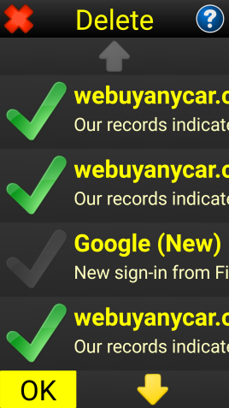

Select the emails you wish to delete and move to a different page to select more. Each email selected for deletion will have a green tick to the left of it. The description for that item will also include details about it being ticked or not.

When ready, press the OK button in the bottom left corner of the screen. Any ticked emails will be deleted.

Email settings

Use the Email Settings menu to type in your email settings, test email settings and configure email related features.
The available options are:

Basic settings
To configure email settings for common email addresses, just type in the following three pieces of information.

- Full Name: Your Full Name.
- Email Address: Your full email address.
- Password: The password for your email account.
- Email Mode: Use the Email Mode option to select if emails should be retrieved via POP3 or IMAP. IMAP is the recommended option and is especially good if multiple devices will share a common email address.

Important Note: If you change your email settings the emails in your Inbox may be lost. Always move important emails to the Saved Emails list first, for safekeeping, before changing emails settings.

When finished, press the red cross in the top left of the screen. If the system reports that email settings completed successfully, you have successfully completed email setup and there's nothing else to do. If you get any other message, you will need to use the Advanced Email Settings menu option to fill in the missing settings that could not be found automatically.

Advanced settings
This option only needs to be used if your email details were not recognized in the Basic Email Settings section.

Use the Advanced Settings to type in the following information:

- Outgoing SMTP Username, Outgoing SMTP Password, Outgoing SMTP Server, Outgoing SMTP Port.

- Incoming POP3/IMAP Username, Incoming POP3/IMAP Password, Incoming POP3/IMAP Server, Incoming POP3/IMAP Port.

Reply Address: Use this option if you wish the reply address for emails sent, to be different than the email address typed in Basic Settings.

Please contact us if you need help with email settings.

Test email
This option tests the email settings to ensure they are correct, by sending and receiving a test email. If you receive a message saying that the receive test encountered problems, your email settings may actually be fine. It could just be that the test email has taken too long to arrive. Try getting someone else to send you a test email and/or try sending an email from Synapptic to someone else.

Speak on arrival
When a new email arrives, a sound is made and the voice speaks out details of the sender. Use this option to turn the announcement of emails on or off.

Auto fetch
Use this option to turn on or off the automatic fetching of new emails. By default this is switched off to ensure mobile phone data charges are not incurred by constantly checking for emails.

Email subject (Automatic)
To make composing emails quicker and easier, the email subject can be set to Automatic. When set to Automatic, Synapptic will automatically fill in the email subject for you, based on the first 5 words of the main email message. When set to Manual, text for the email subject must be typed in separately.

Delete old emails
Options here vary according to the Email Mode settings. When the Email Mode is set to POP3, options are available to delete old emails. When the Email Mode is set to IMAP, an option is available to delete all emails previously downloaded, and to re-synchronise them again from the server or cloud.

(To delete multiple email, please use the Delete Emails option on the Email menu).

WhatsApp

WhatsApp is an app made by Meta that lets you make voice or video calls over the internet, for free. You can also send text, photo and audio messages. To use it, you need an account with WhatsApp, which is tied to a mobile phone number. One account can be linked to multiple devices, so they all receive the same messages and calls.

Answering and Ending calls
When you make or receive a WhatsApp call, Synapptic will show the call screen. It works in the same manner as the regular call screen, with a green Answer button in the bottom left and a red Reject button in the bottom right.

While a call is ongoing, the WhatsApp app will show in the background. If it is a video call, the video from the other person will be shown.

The red End Call button will cover the bottom of the screen, or the cancel and go back button in the top left will let you return to Synapptic while the call is still ongoing. You can then return to the call from the WhatsApp menu.

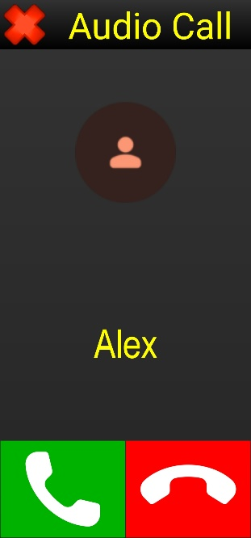 | 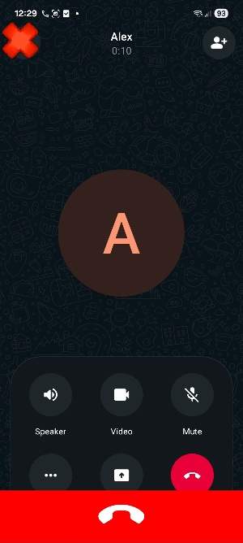 | 
Call Screen | Ongoing Audio Call | Ongoing Video Call

The Synapptic call screen provides a voice for these but the overlay prevents interacting with the WhatsApp buttons directly. You can disable this overlay and use the regular WhatsApp buttons from the Reader Settings, covered in the Settings section of this manual.

WhatsApp Menu
The WhatsApp Menu makes it easier to navigate and interact with the app. The WhatsApp Menu has 5 options:

Call Contact
Use this option to make a voice or video call. It opens a list of all contacts in your Address Book who have made a WhatsApp account.  When you select a contact, you will be given options to start a video call, an audio call or to cancel the call.  Chats  Chats will open the list of all WhatsApp contacts. When you select a contact, you can View your chat history with that person, or compose a new message. | 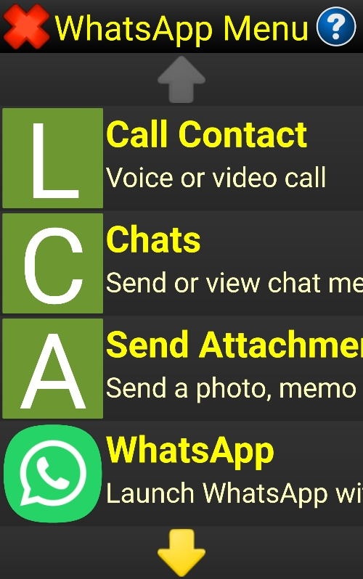
Selecting View opens WhatsApp to that chat directly. This isn’t part of Synapptic and uses Synapptic Reader to provide a voice. See Appendix E for further details about navigating Android screens with Synapptic Reader.  Compose lets you type a message, using the Synapptic interface. When you are ready to send, it opens WhatsApp with the message already typed and a reminder to press the Send button in WhatsApp itself.  Send Attachment |  | 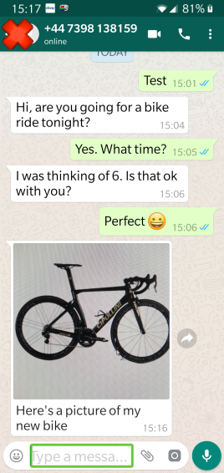
This works the same as Composing a message, with the option to attach a Photo, Video, Note or Voice Memo after picking a contact.

WhatsApp
This is a way to open WhatsApp directly.

Show Reminder
This option lets you toggle the ‘press Send in WhatsApp’ reminder when sending a message.

Address book

Telephone numbers, email addresses and postal addresses etc. can be added, edited and deleted using the Address Book option.

The Address Book is used in other parts of Synapptic, when addressing emails, calling people and sending text messages.

By default, the contacts are stored in your Google account, in the Google cloud! This means all addresses and telephone numbers are automatically backed up and can be automatically shared between different phones and tablets. Only contacts stored in Google or in the Phone are displayed in Synapptic. Contacts stored in a SIM card are not displayed. (See below for details about importing contacts from a SIM card).

If required, a friend or family member can login to the Google account, from any web browser, and type in names, telephone numbers and email addresses. These new details will appear almost instantly in the Synapptic address book.

Adding, editing and deleting contacts

The following will detail how to add, edit or delete contacts from the address book.

From the Main Menu select the Address Book option, then select Add, Edit, Delete or View.  These four menu options are explained below: | 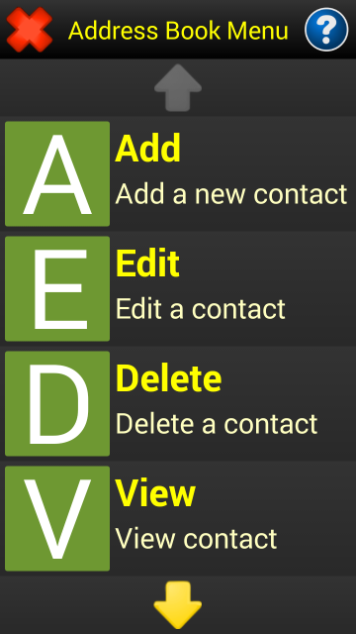

Add New: This will take you step-by-step through the process of adding a new contact. Asking for each piece of information in turn, and waiting for it to be typed in. You will be prompted to type in:
- Full Name
- Telephone-1, Telephone-2, Telephone-3
- Email-1, Email-2
- Postal Address-1, Postal Address-2
- Notes
- If this is an important contact or not

(Important contacts will show in a convenient location on the menu when addressing a text message, email or selecting a contact to dial, etc.).

During the process of typing in the various telephone numbers and addresses, the red cross in the top left can be pressed to exit the process. Everything previously typed will be saved.
Note: Information typed is only saved when the Next button is pressed.

Edit Contact: First pick the contact to edit from the list. Each telephone number and address, for this contact, previously typed in will be displayed one after another. Press the Next button to continue to the next piece of information, or use the keyboard to change or correct the information displayed.

Delete Contact: Select the contact to delete from the displayed list of contacts. A message will display asking to confirm you wish to delete the contact. Select the yes option to delete the contact permanently.

View: This options shows a list of all contact names. Select a particular contact to see their details on the screen and hear them spoken out. If there is more information than can fit on a single screen, use the Down Arrow at the bottom of the screen to show further pages.

Address book settings and importing contacts

There are four options on the Address Book Settings menu.

Import: Use this option to copy contacts from your SIM card to the Synapptic address book. If a contact already exists, duplicates will not be made.

Storage: An advanced setting that does not normally need to be changed. It's usually set to Normal.

Synapptic: Add Synapptic to the Address Book. This option is hidden if Synapptic has already been added.

Blocked Numbers: View, Block or Unblock phone numbers.

Block Numbers

At the top of the page there is an option to Add a Blocked Number, followed by a list of numbers that have been blocked.  A blocked number cannot reach you by phone or text message, which can cut out nuisance calls.  If the phone number is for a contact, their name will be shown and read out.  To unblock a number, select it from the list and select the yes option when asked to confirm. | 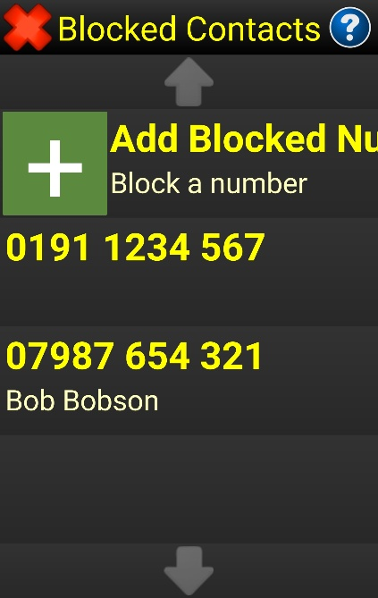
You can also block numbers from the Text Message menu or the Recently Called menu.

Finding and filtering contacts

Whenever a list of contacts is displayed from the Address book, a Filter option is shown at the top.

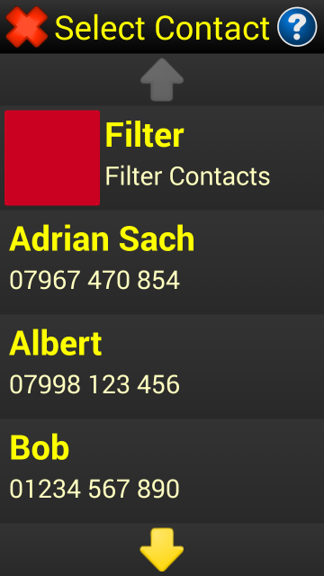 | 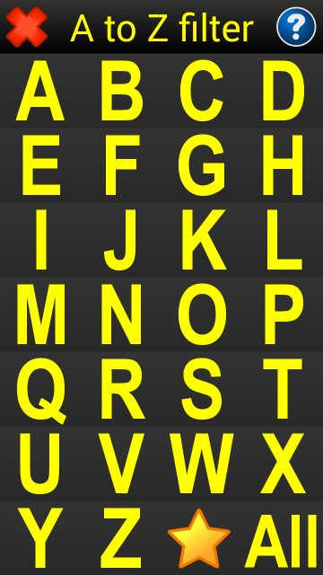 | 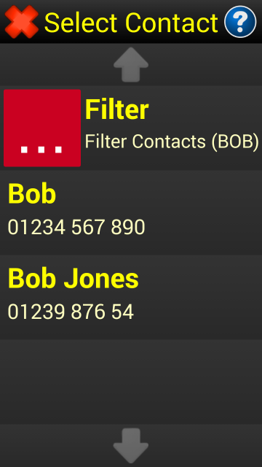
Filter Option | Quick A to Z filter | Full Search

Use this option to quickly filter names starting with a particular letter. A list of letters from A to Z will display on the screen. Select a letter to filter the Address Book to just show contacts starting with that letter. Press the yellow star to show important contacts and the All option to show all contacts again.

If you wish to search for a particular name, or part of a name, press the Help icon in the top right of the A to Z filter screen, then select the Search option in the list of help. A keyboard will display. Type in the name, or part of the name, to search for. The Address Book will be filtered to just show contacts that match this name.

Calendar

The Calendar allows you to create and view appointments.  There are three ways to view your calendar appointments and a settings option to customize the look and feel of the views.  Details of each option are given below: | 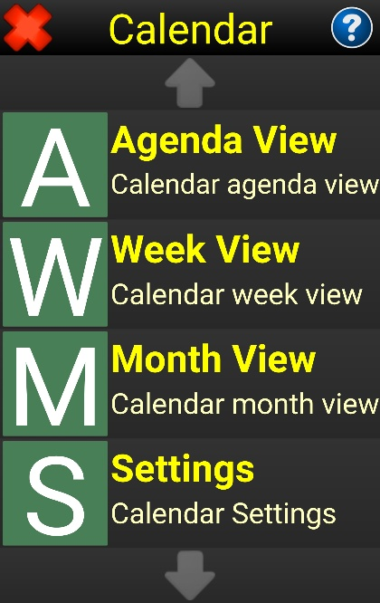

Agenda view

The Agenda View shows you the appointments in your calendar. They are listed in date order from today.  The top option is Filter. Select this to change the range of appointments shown.  Select an item in the list to View full details, Edit or Delete the appointment. | 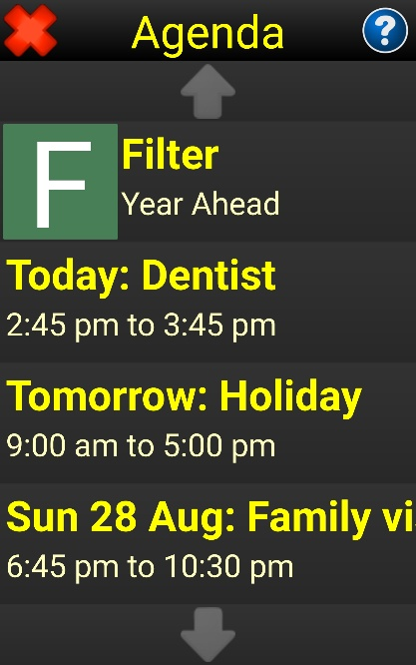

Week view

The Week View shows the seven days of the current week, starting from Monday.

Keep your finger on any day to have the voice read out all appointments. Selecting a day shows the Day View, where you can add new appointments, as well as view, edit or delete existing ones.

The look of the Week View can be changed by the Style option in Calendar Settings.

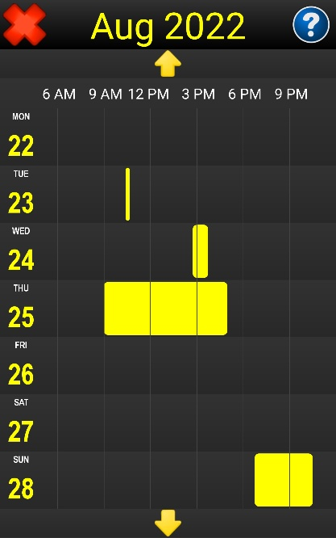 | With Grid Style the whole week is shown on a single page and appointments are shown as a visual highlight.  The up and down arrow keys change which week is being shown.

With List Style the first two options allow the previous or next week to be quickly selected.  The days are listed after, while the up and down arrow keys move between the pages, if there are more days than can fit on one page. | 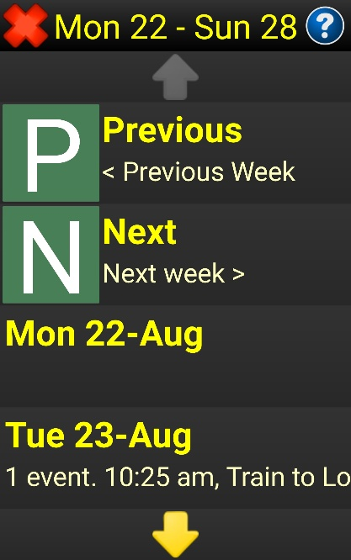

Month view

The Month View shows the days of the current month.

Keep your finger on any day to have the voice read out all appointments. Selecting a day shows the Day View, where you can add new appointments, as well as view, edit or delete existing ones.

The look of the Month View can be changed by the Style option in Calendar Settings.

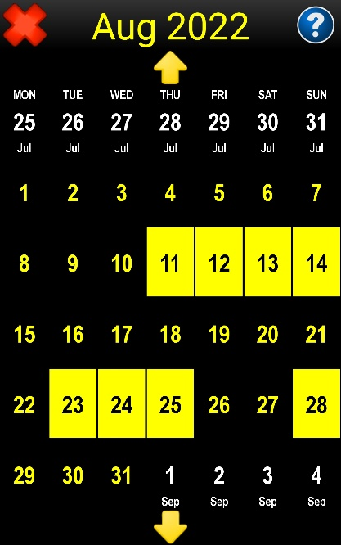 | With Grid Style the whole month is shown on a single page with Monday on the left, Sunday on the far right and six rows for the weeks.  A few days from the month before and after are included to fill out every day of the week.  The up and down arrow keys change which month is being shown.

With List Style the first two options allow the previous or next month to be quickly selected.  The days are listed after, starting from the first day of the month.  The days are listed after, while the up and down arrow keys move between the pages, if there are more days than can fit on one page. | 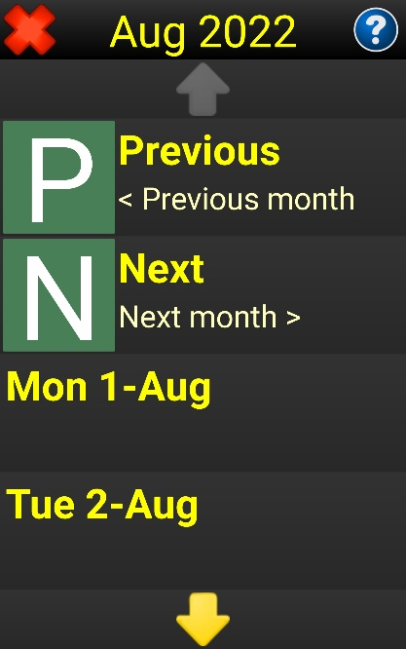

Calendar Settings

There are a few settings specific to the calendar.

Calendar Style: This affects how the Week and Month view appear. List style has multiple pages with larger options for each day while Grid style shows the whole week or month at once, with a visual highlight showing when you are busy.

Calendar Mode: This affects how appointments are created or edited. Basic mode lets you make simple appointments very easily, while Advanced mode has options for end times, all day or recurring appointments.

Synchronize: Back up your calendar by connecting it to your Google account. If you have multiple devices connected to the same Google account, then all those devices will share the same calendar and any changes made to one will appear on the others.

Time Format: Select either 24 hour or 12 hour am pm format. Note: The format selected here also changes the date format on the lock screen and the information screen.

Notification: This notification sound will be play when reminders are given.

Making Appointments

To create, edit or delete an appointment, first use the Week or Month Views to find a particular day.  Select New Entry to create a new appointment, or select an existing appointment for options to View, Edit or Delete.  The next step is controlled by the Mode option in Calendar Settings. | 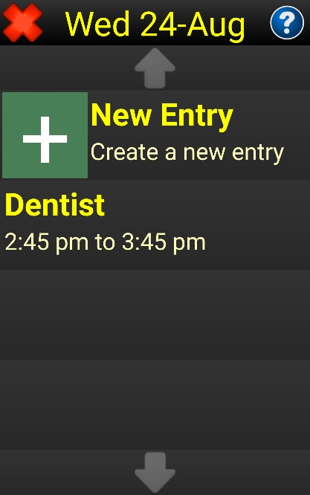

Advanced Mode

When creating or editing appointments in Advanced mode, it opens a new menu with four options.  Details of each option are given below:  Name: Type in the name for the appointment, then press Save in the bottom left corner of the keyboard screen to save the change. | 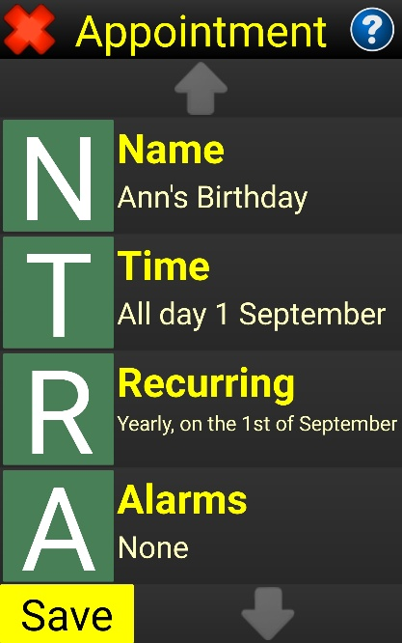

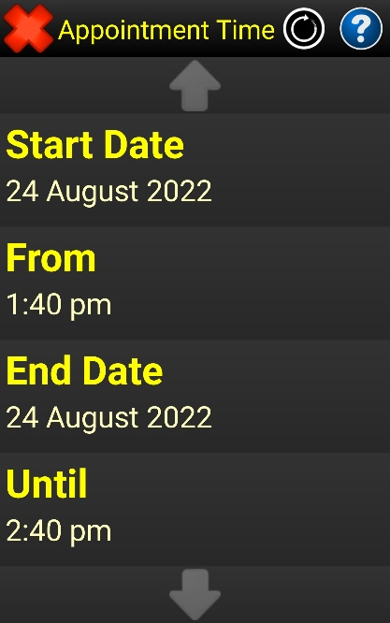 | Time: From here, you can select the start date and time, as well as the end date and time. This allows you to set the duration of the appointment, as well as having the appointment stretch over multiple days.  In the top right of the Time menu, next to help there is an All-day button.

All-day appointments hide the From and Until time options. They are useful for events such as holidays or anniversaries, which don’t occur at a specific time.

When viewing the appointments for a given day, All-day appointments are shown first and have a different highlight in the week view.
Recurrence: This lets you create appointments that automatically repeat themselves. This can be useful for birthdays, a regular meet up or daily reminders.

First, you select how frequently the appointment should recur. You can select daily, weekly, monthly or yearly.

Note: Weekly will let you choose which days of the week, including multiple days.

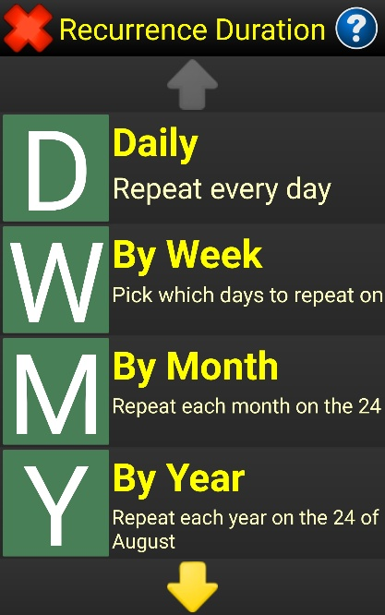 | 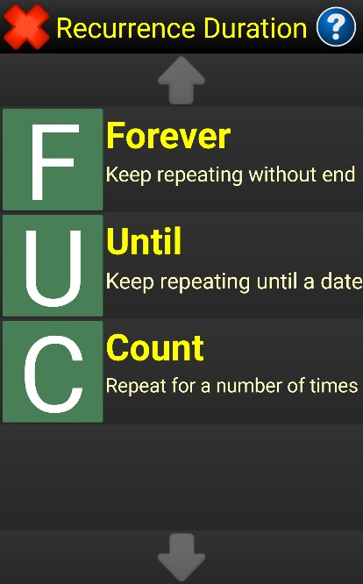
Second, you select how long the appointment should recur for. There are options for forever, until a specific date or for a given number of times.

Alarms: For each appointment, you can have multiple alarm reminders.  Pick from reminders at or minutes before the appointment up to a month before.  Note: If it is a recurring appointment, each occasion will have these reminders. | 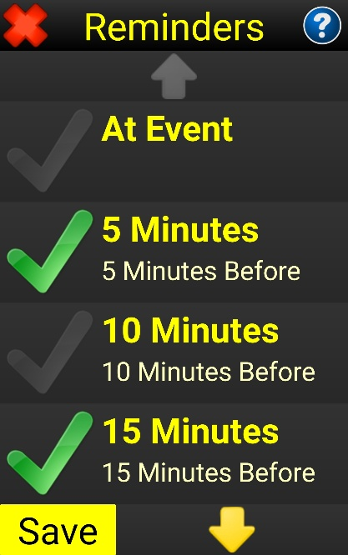

Basic Mode

Basic mode lets you make simple appointments very easily, but it doesn’t have options for recurring, timed or all-day appointments.

When you create or edit an appointment in Basic mode, it opens the keyboard screen. Type the name for the appointment, then press Next in the bottom left corner.

It will then ask for the Hour, followed by the Minute. Use the up and down arrows, then press Continue at the bottom of the screen.

Finally, a list of reminder times will show. Pick one or many reminders from 5 minutes before up to a month before, then press Save in the bottom left corner.

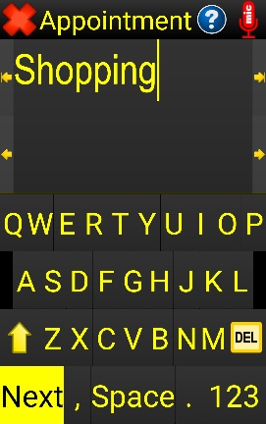 | 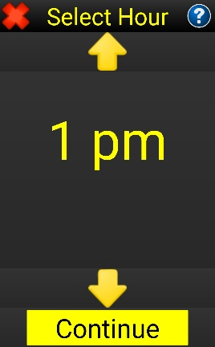 | 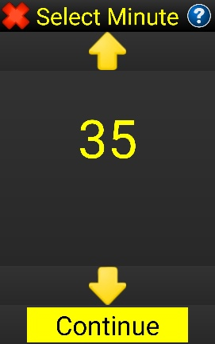 | 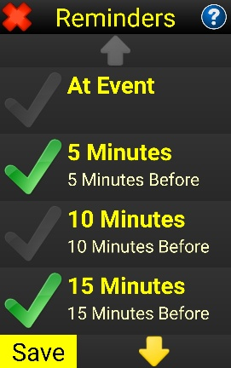

Calendar reminders

If a calendar reminder has been set, and is due, a screen will appear with details of the appointment. A sound will also play.  Use the Stop button to permanently stop the reminder and the Snooze button to pause the alarm for five minutes. | 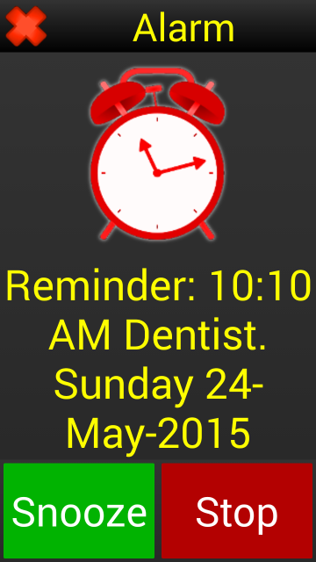

Alarm Clock

Use the Alarm Clock to create alarms and reminders that repeat at regular times, on various days of the week. (If you need a one-off alarm for a particular date in the future, use a calendar reminder).  The Alarm Clock menu consists of an option at the top for creating new alarms and a list of existing alarms underneath, that can be turned on and off, edited or deleted. | 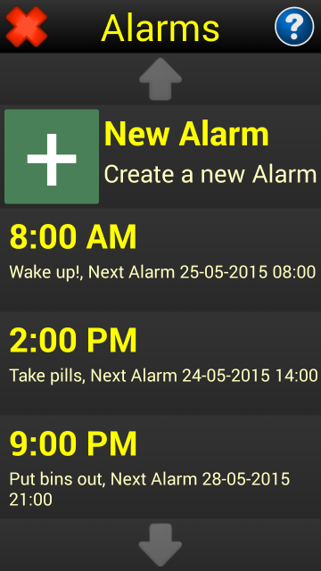

Creating a new alarm

To create a new alarm, select the New Alarm option at the top of the menu. A number of screens will display guiding you through the process of creating the alarm.

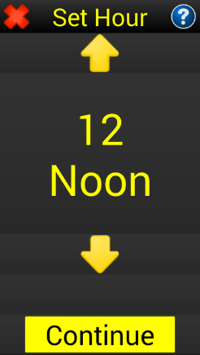 | 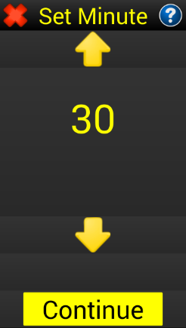 | 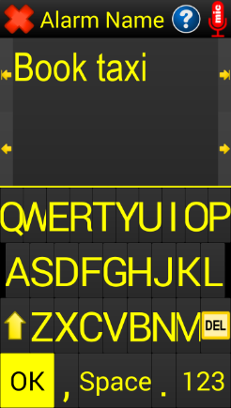 | 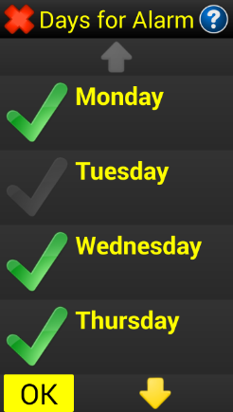 | 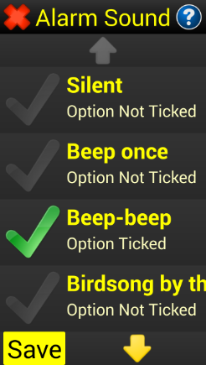

The first screen to display is for selecting the hour for the alarm. Use the up and down arrows on the screen to set the hour and the Continue button at the bottom of the screen to continue.

Next, select the minutes for the alarm. Use the up and down arrows on the screen to set the minutes and the Continue button at the bottom of the screen to continue.

A keyboard will display. Type in the Alarm name, and press the OK button in the bottom left of the keyboard to continue.

Next, select the days for the alarm. Un-tick any days when the alarm should not go off. Tick the days when the alarm should go off. By default all days will be ticked.

Finally, pick a specific alarm sound for this alarm. Different sounds can be useful to identify different types of alarm. Press the Save button in the bottom left to save this alarm.

When the alarm sounds

When the alarm goes off, a screen displays showing details of the alarm. The selected notification sound will also play.  Use the Stop and Snooze buttons at the bottom of the alarm screen to either stop the alarm or make it snooze for 5 minutes. If you select stop, the alarm will set itself again for the next appropriate date and time. | 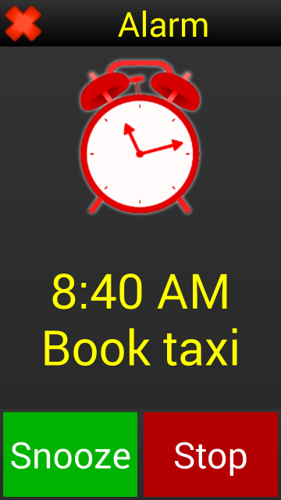

Voice memos

Use Voice Memos to make recordings of your voice. Recordings can be renamed, played back and even emailed. This is great for recording shopping lists, addresses, recipes or any other audio notes.  At the top of the Voice Memos screen is an option to record a new voice memo. Under this is an option to search voice memos. A memo must be named to appear in the search results. See below for details.  The rest of this screen lists all previously recorded memos, along with their date and time. If a memo has been renamed its name will be shown along with the recording date.  If there are more memos recorded than will fit on one page, use the Up and Down arrows to move between pages. | 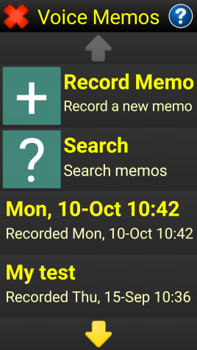

To record a new voice memo select the Record New Memo button at the top of the screen.  Tap the screen to start recording and tap again to stop, when finished recording.  When finished, select the red cross in the top left hand corner. The list of recorded memos will display again, with the newly recorded memo at the top of the list. | 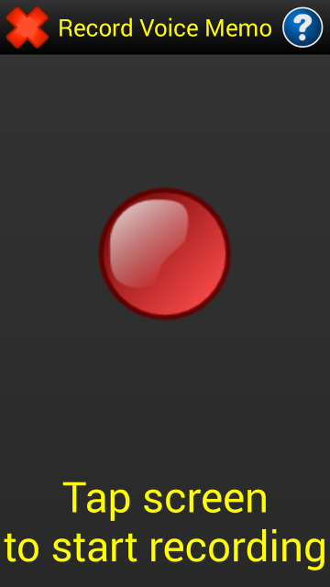

To play a memo, select it from the list. A further menu will display, giving options to Play, Email, Delete or Rename the memo.  Rename a memo to have it appear in search results when that name (or part of it) is searched for. This is a great way of grouping and quickly finding specific memos. | 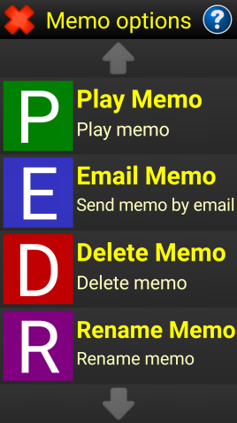

Top Tip! If you want to group a number of memos together just rename them all with similar names or a similar word, so they all show in the search results together. For example all memos of recipes could be renamed recipe something, so when you search for the word recipe, they all show together.

Notepad

Use the Notepad to make notes and keep lists. Notes can be typed, or dictated with voice recognition.  At the top of the Notepad screen is an option to create a new note, followed by a search option and a list of saved notes, with the latest at the top.  Use the up and down arrows to scroll through the list of notes, if there are more than can fit on one page. | 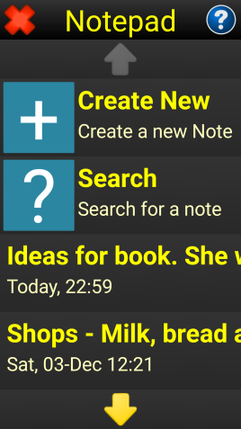

Creating a new note

Select the Create New Note option at the top of the Notepad screen to create a new note. The Keyboard will display.  Type or dictate the new note. Press the Save button in the bottom left of the screen to save it. | 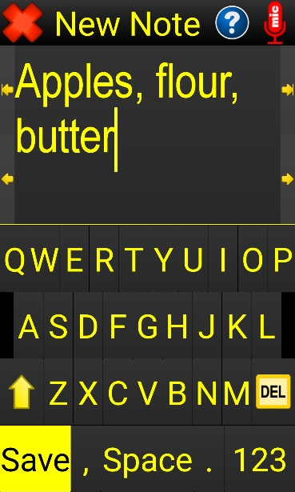 | 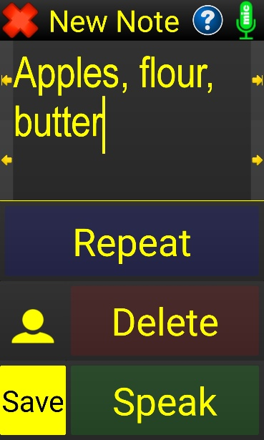

To dictate the note, press the microphone button in the top right corner of the keyboard screen.

For further details about using the keyboard, please read the Using the Keyboard section towards the start of this User Manual.
To view, edit, email, delete, rename or print a note, first select the required note from the list. | 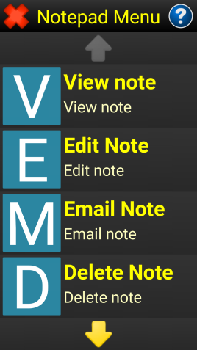

Viewing a saved note
After selecting a note from the list, select the View Note option. The note will display.  Use the Read All button in the top right to have the entire note read aloud. Alternatively, use the up and down arrows to scroll through the note page by page.  If required, use the line view button to view the text as a single scrolling line. See Appendix D for further details. | 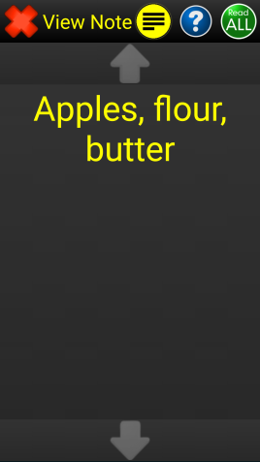

Editing a note
To edit a note, first select it from the list and then pick the Edit Note option from the menu. The keyboard will display and the text can be edited. See the Using the Keyboard section earlier in this User Manual for further details about typing, editing and deleting text.

Emailing a note
To email a note, first select it from the list and then pick the Email Note option from the menu. The note will be attached to a new email and the process of composing that email started. See the Email section earlier in this User Manual for further details about composing and sending an email.

Deleting a note
To delete a note, first select it from the list and then pick the Delete Note option from the menu. You will be prompted to confirm you wish to delete the note. The note will then be permanently deleted.

Renaming a note
Allows the note to be renamed, so it's easier to find when searching for a particular note or notes.

Printing a note
Pick a note to print from the list of existing notes. From the menu that then displays select the Print option. The standard Synapptic Print menu will show, where there are options to set the print size, preview the document and send the note to the printer.

For further details about the standard Synapptic Print Menu, please see Appendix G.

Searching notes
Use the Search option on the Notepad menu to search for a specific note. The search word or words you type in will be looked for in both the name and contents of the notes. Any matching notes will be displayed in the list.

By using key words in the Note's name or in the text of the note it's easy to search for both groups of related notes or specific notes.

Camera

From the Main Menu, select the Camera option. The Camera Menu has options for using the camera, viewing photos, emailing photos, adjusting camera settings (such as flash, quality, etc.), searching photos and deleting old photos.  The Camera Menu options are detailed below. | 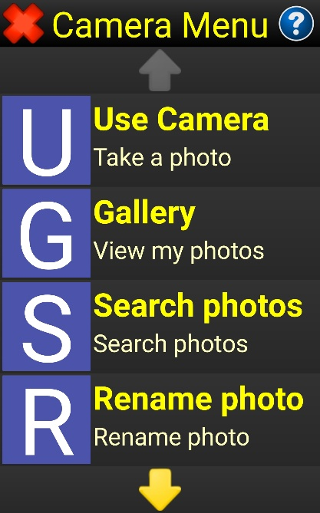

Using the camera
Select this menu option to take photos. The camera lens is on the back of the device. Point the lens at the object to be photographed. A preview image of the photo is displayed on the screen.  Touch the middle of the screen to take the photo. The camera beeps for a few seconds while focusing, the picture is then taken.  Use the volume buttons to zoom in and out. | 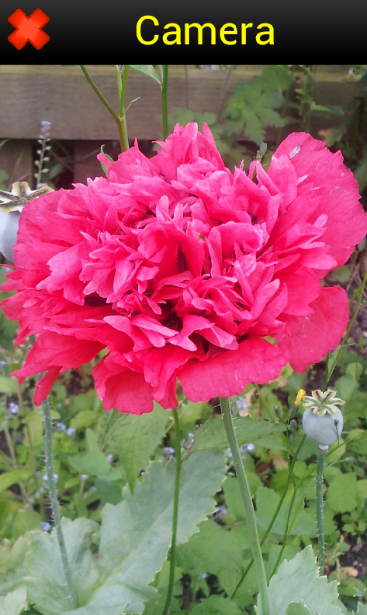

Viewing photos
Use the up and down arrows at the top and bottom of the screen to move back and forward between the various photos.  Press either of the arrows for a few seconds and Synapptic will automatically skip through the photos for you. This is useful if you have a large number of photos.  Touch the screen to show the photo full-screen. Touch the screen again to exit full-screen mode.  When in full screen mode use a pinch and zoom technique to magnify the image. Place two fingers on the screen and separate them to magnify the image. Bring them closer together to make the image smaller again.  Keep your finger pressed on the photo, in Normal View mode to hear details of when it was taken and any name it has been given.  You can press the Describe Photo button at | 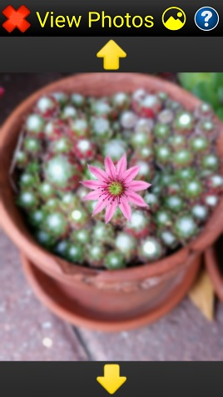  
the top right of the screen, just to the left of the help button. This will use AI to examine and describe what the photo looks like.

Alternatively, the top right button can be configured as the Start Slideshow button. The function of the button, the speed and the order of the slideshow can all be customized in the camera settings.

Note: Please see Appendix A for details on how to transfer photos to and from a computer.

Searching photos
Any photo that has been given a name will be searched (see below for details of renaming photos). After selecting the Search Photos menu option, type in the word or words to search for, then press the OK button in the bottom left of the keyboard screen to continue. | 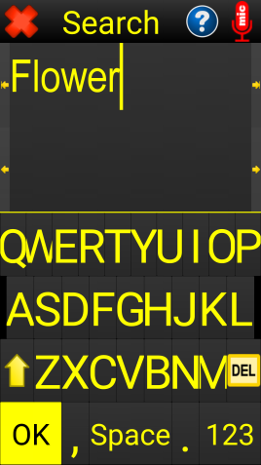 | 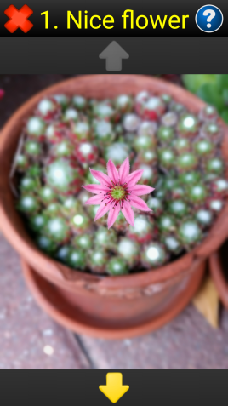
Any photos with a name containing the search words will be displayed. Use the up and down arrows in the normal way to show each of the photos found. See the View Photos section above for further details about viewing photos.

Renaming a photo
After selecting this option the View Photos screen will display. Select the photo to rename then press the OK button in the bottom left of the screen. The keyboard will display.  Type a name then press the Save button in the bottom left of the screen. | 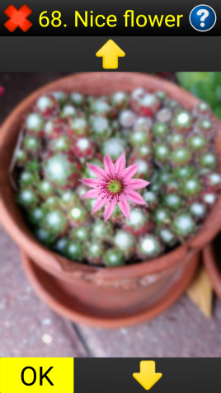 | 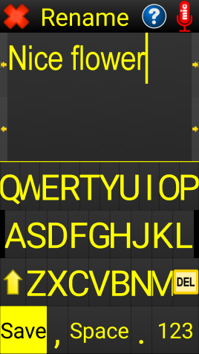

Photos that have been given names are searchable. This is great for quickly finding single or groups of photos.

Top Tip! Group photos together by giving them similar names. For example, include the words My Garden in photo names, so that all photos taken in your garden show together. The names of these photos could be My Garden Sunflower, My Garden Bench, My Garden Vegetables. When you search for My Garden, all the photos of your garden will display together in an album.

Emailing a photo
This option allows a photo to be emailed to one or many people. Select the Email Photo option, then select the particular photo using the up and down arrows.

Select the OK button in the bottom left of the screen to send the currently displayed photo. A new email will be created, with the photo attached. Prompts will then ask for the email subject and message in the normal way. See the Email section for further details.

Deleting photos
Select the Delete Photos menu option, then use the up and down arrows to move through all the different photos. When you find one you wish to delete, just tap the screen. A green tick will appear and the voice will indicate this photo has been selected. | 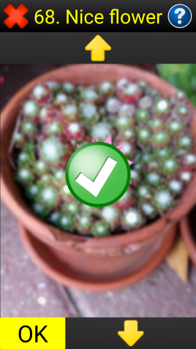 | 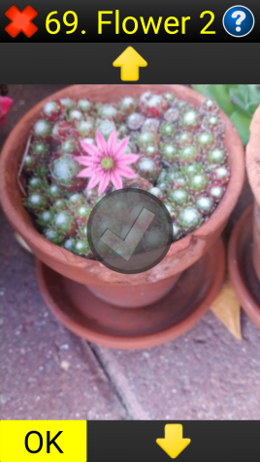

Move through the photos ticking all the photos that need deleting.

When ready, select the OK button in the bottom left hand corner of the screen. The ticked photos will be permanently deleted.

Camera settings
Use this option to change how the flash works, the quality of the pictures (picture size) and focus mode.

You can also choose how long the gallery slide show should show a photo and the order they appear in.

Toolbox

The Toolbox menu contains a number of useful tools, these are:

- Be My Eyes
- Weather
- Electronic Magnifier
- Reading Machine
- Colour identifier
- Where am I
- App Launcher
- Play Store
- Letter Writing
- Chatbot
- VisionBot
- Screen Mirroring
- QR and Barcode Scanner
- Calculator
- Clock
- Timer
- Stopwatch
- Torch
- Compass
- Spirit Level
- Meta AI

The operation of each tool is detailed below.

Be My Eyes
Be My Eyes is an app that can start a video call between you and a sighted volunteer, at any time of the day, for free. It was made for quick, on the spot help with visual problems like finding dropped items, checking your shirt matches your jacket or finding the expiration date on food.  Synapptic Reader will automatically start and read out items on the screen. See Appendix E below for further details about navigating Android screens with Synapptic Reader. | 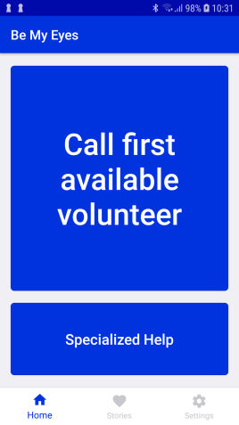

Press the large button in the centre of the screen labelled ‘Call first available volunteer’. This will start the call and someone should answer within 30 seconds. When they do, the volunteer will be able to see a video image relayed through the camera on the back of your device.

In addition to general help, more specialised help is available by pressing the Specialized Help button. Specialised help offers help from specific companies such as banks, Google and Microsoft.

Weather

Use the Weather option to find current weather and weather forecasts for just about any location in the world!  The options on the Weather Menu are detailed below.  Use the Add Location menu option first to add a new location. Then use the My Weather menu option to view weather details for any added locations. | 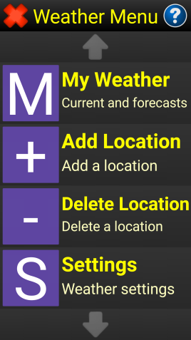

My Weather
The My Weather menu option shows a list of all locations previously added. These are the locations you wish to monitor weather for.  Each item in the list shows the location name, temperature, current weather description and current weather icon.  Slide your finger up and down the screen to hear a current weather summary for each location listed. | 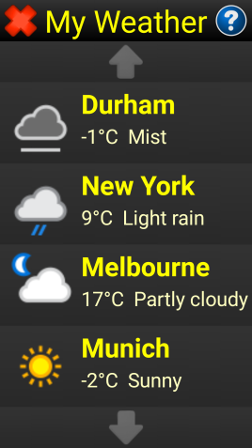

Selecting a particular item in the list will show a menu for that location, where you can choose to see the current weather in full detail or a 7-day forecast.

An internet connection is required to fetch the latest weather data. It is automatically updated every 15 minutes.

Current weather details
The Current Weather details screen shows full details of the current weather for the selected location.  Run your finger up and down the screen to hear each piece of information. The details listed are:  Date and time: The date and time of the current weather details. Note! The date and time is the local date and time at the selected location. | 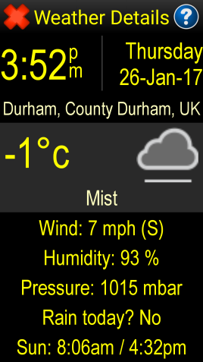

Location: The full location name. E.g. Durham, County Durham, UK.

Weather description: The temperature, weather description (cloudy, sunny, overcast, etc.) and an appropriate image (cloud, sun, etc) are shown here.

Wind: The wind speed and direction.

Humidity: The humidity as a percentage.

Pressure: The current atmospheric pressure.

Rain Today? Snow Today? : Is there rain or snow predicted today?

Sun: Sunrise and sunset times for this location today.

7-Day forecast
For the selected location, the 7-day forecast shows a weather summary for each of the next 7 days.  Each item in the list shows the location name, temperature, forecast weather description and forecast weather icon.  Slide your finger up and down the screen to hear a forecast weather summary for each day listed. | 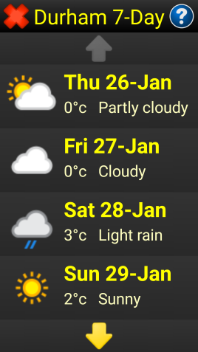

Selecting one of the days in the 7-day forecast will drill down to show an hour-by-hour breakdown of that day.  Slide your finger up and down the screen to hear a forecast weather summary for each hour listed. | 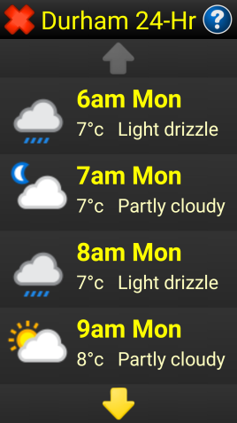

Selecting one of the hours in the hour-by-hour listing will drill down to show the full details of the forecast for that hour.  Run your finger up and down the screen to hear each piece of information. | 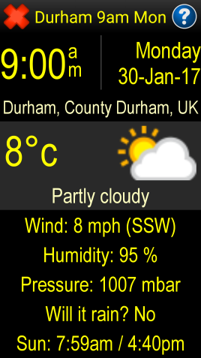

Add location
Use this option to add locations you wish to monitor weather for. Each location added will appear in the My Weather screen. A maximum of 10 locations can be added.

After selecting this option a search screen will display. Select the Search option at the top, then type in the location to search for. A list of matching locations and nearby locations are show underneath.

To search for a location in your home country, just type the town name or postcode / zipcode. To search for a location in a foreign country type the town name, followed by a comma and then the country name.

Note: Your home country is determined by the Language selected in the Phone or Tablet Settings Menu. This is automatically selected and doesn’t normally need to be changed.

Delete location
Use this option to delete one of the previously added locations, that show in the My Weather screen.

Settings
Change temperature, wind speed and pressure units using this menu option.

Temperature: Show temperatures in degrees C or degrees F.

Wind speed: Show speed in miles per hour or kilometres per hour.

Pressure: Show atmospheric pressure in millibars or inches of mercury.

Electronic magnifier
The Electronic Magnifier is a video magnifier that makes use of the camera on the back of the tablet or phone to magnify images up to 70 times, depending on the device being used.  The magnifier can also freeze images, zoom them to 100 times, save images and colorize images.  Details of the Magnifier Menu options are given below: | 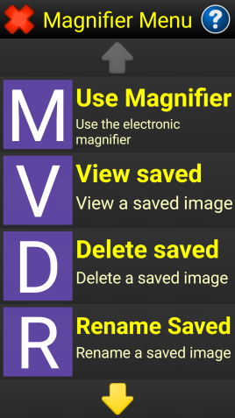

Use magnifier  This option will start the magnifier.  Hold the back of the phone or tablet about 6 inches away from the object or text to be magnified. Touch the screen to focus the image and use the volume keys on the edge of the device to zoom in or out. (Alternatively, use two fingers on the screen with a pinch and zoom technique to change magnification). If extra light is needed, press the Light Button at the bottom of the screen.  This mode is called Video Mode or Live View and shows a real time image of the object or text on screen. | 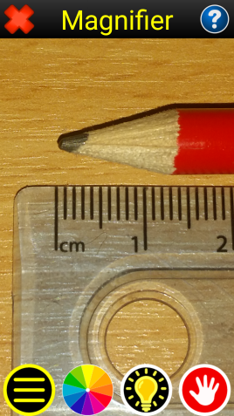

On top of the image at the bottom of the screen are a number of buttons. From left to right these are:

- Show/Hide: This button shows or hides all the buttons at the bottom of the screen. You may wish to hide the buttons to view the magnified image more fully.


- Change Colours: Use this option to change the colour and contrast of the Live View or Frozen image. The selected colour option will be remembered and automatically applied when the magnifier is used the next time. To quickly reset the colour option back to normal, press and hold this button for 5 seconds.

Each colour option has an Enhanced 1 and Enhanced 2 variant. All Enhanced 1 variants have additional Brightness and Contrast controls available by pressing the icon at the top of the screen next to the Help button. Adjustments to the Brightness and Contrast for the selected colour scheme are remembered. All Enhanced 2 variants are digitally enhanced to have 100% contrast.


- Light on/off: The light on the back of the device can be turned on and off using this option. This is useful when magnifying images in low light conditions.

  - Freeze: Pressing this option will freeze or un-freeze the current image. Once frozen, further buttons are shown above this one. The extra buttons are:    - Speak: to read out any text on this image    - Rotate: to rotate the frozen image    - Save: to save the frozen image | 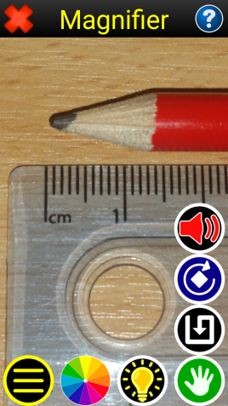

When the image is frozen the tablet or phone will vibrate and the voice will speak the word frozen. Your preferred colour option will be automatically applied as soon as an image is frozen. To reset to normal colours, just hold the Change Colours button for 5 seconds or press the button multiple times until the Normal option is reached.

Viewing saved images
Use this to load up a previously saved image from the Magnifier. A list of saved images will display. Use the up and down arrows to select the image to load and press the OK button in the bottom left of the screen to continue. The magnifier will then show this saved image as if it had just been frozen.

Deleting saved images
Deletes a previously saved magnifier image. A list of saved images will display. Use the up and down arrows to move through the various images and tap the middle of the screen to select an image to delete. A green tick will show in the middle of any image selected for deletion and the voice will speak out information about it being selected. Tap the screen again to un-select an image. Multiple images can be selected for deletion. Press the OK button in the bottom left of the screen to continue. All the selected images will then be permanently deleted.

Renaming saved images
Renames a saved magnifier image. A list of saved images will display. Use the up and down arrows to move through the various images to find the one to rename. Press the OK button in the bottom left of the screen to continue. A keyboard will display so a name can be typed in. Whenever this image is displayed, the voice will read out the name you have given it, and display it at the top of the screen.

Emailing a saved image
Use this option to email a saved image from the Magnifier. A list of saved images will display. Use the up and down arrows to move through the various images to find the one to send. Press the OK button in the bottom left of the screen to continue. The photo or image will be attached to a new email and the process of composing a new email started.

Reading machine

The Reading Machine makes it easy to read printed material like books, magazines, menus and other similar text. Text is both spoken aloud and displayed as large print text on screen.  The Reading Machine works by taking a photograph of the text, which it then converts into real text that is spoken out and displayed on screen.  The available menu options are: | 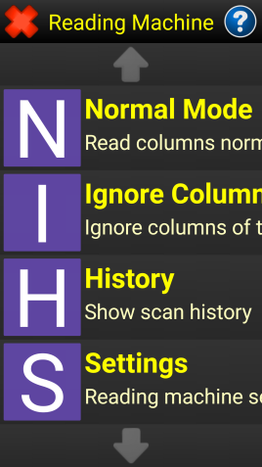

Normal mode

In Normal Mode the system detects columns of text and reads down them appropriately.  After selecting the Normal Mode option the camera will display. Position the camera, normally found on the back of the device, about 6 to 12 inches above the text. | 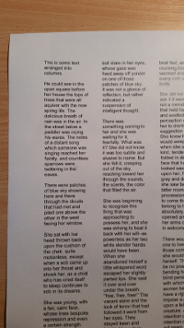 | 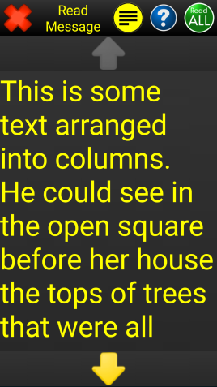
Move further away when the page is larger. For a typical page of A4 text, hold the camera about 12 inches (30 cm) above the text. For an A5 page of text hold the camera about 8 inches (20 cm) away.

When ready, touch the screen to take a photo of the text. The camera will focus and a bell sound will indicate the photo has been taken. After a few seconds of processing the text will be displayed on screen and the voice will start speaking it aloud. Use the up and down arrows to move between pages of the text. Alternatively, press the Read All button at the top right of the screen to have the entire page spoken, or the Line View button to read the text using an eccentric reading technique.

The text will be automatically added to the scanning history list and can be viewed, deleted, renamed or email again at any time by selecting the History option on the Reading Machine menu.

Note: An Internet connection is required for the Reading Machine to work. To fix problems with accuracy, or for very small text, use the Reading Machine Settings menu to increase the picture quality. Increasing the picture quality will increase the processing time, so increase it in small increments.

Ignore Columns mode

In Ignore Columns Mode the system ignores columns of text and reads from left to right. This is particularly useful for reading bank statements or similar documents.  After selecting the Normal Mode option the camera will display. Position the camera, | 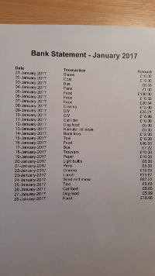 | 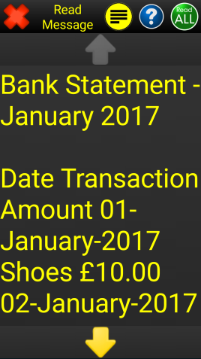
normally found on the back of the device, about 6 to 12 inches above the text.

Move further away when the page is larger. For a typical page of A4 text, hold the camera about 12 inches (30 cm) above the text. For an A5 page of text hold the camera about 8 inches (20 cm) away.

When ready, touch the screen to take a photo of the text. The camera will focus and a bell sound will indicate the photo has been taken. After a few seconds of processing the text will be displayed on screen and the voice will start speaking it aloud. Use the up and down arrows to move between pages of the text. Alternatively, press the Read All button at the top right of the screen to have the entire page spoken, or the Line View button to read the text using an eccentric reading technique.

The text will be automatically added to the scanning history list and can be viewed, deleted, renamed or email again at any time by selecting the History option on the Reading Machine menu.

Note: An Internet connection is required for the Reading Machine to work. To fix problems with accuracy, or for very small text, use the Reading Machine Settings menu to increase the picture quality. Increasing the picture quality will increase the processing time, so increase it in small increments.

Document history menu

Each time the Reading Machine is used, the text it reads out is automatically saved into a document. Use the History option to view, delete, rename, email or copy these documents.  The History screen consists of a search button at the top, followed by the list of saved documents. The most recent is located at the top. | 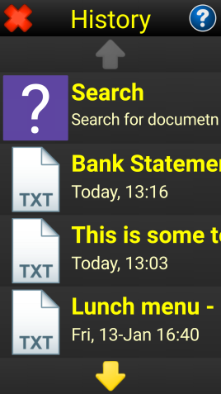

Searching the Reading Machine History

Select the Search option at the top of the History screen, then type in your search words. Any documents that contain the search words or that have a name containing the search words will be displayed.

Opening a Reading Machine History document

Slide your finger up and down the documents list to find the required document. After selecting a document, the Document History Menu displays. Select one of the five menu options, these being:

View: View the text of the saved history document. This will bring up the same screen as if you had just used the Reading Machine on the original text.

Delete: Permanently delete the selected document.

Rename: Rename the document, to make it easier to find.

Email: Creates a new email with the selected document attached.

Copy: Makes a copy of the selected document and transfers it to the Notepad feature in Synapptic for editing.

Reading machine settings

The following options are available on the Reading Machine Settings menu:

Settings: General settings that control how the camera functions within the Reading Machine. Change settings for Flash Mode, Picture quality/size and focus mode.

Clear History: Use this setting to reset the history and delete all history documents.

Please Note! An Internet connection is required for the reading machine to work. For very small text use the Reading Machine Settings to increase the picture quality slightly (this may increase processing times).

Colour identifier

The colour identifier uses the camera to identify colours. It can also be used to identify day and night.  Hold the camera's lens, on the back of the tablet or phone, about 2 inches (5 cm) from the object.  The object's colour is displayed on screen and spoken out every few seconds.  If the tablet or phone has a camera flash we recommend selecting the Automatic Lighting Control option for the most accurate results. | 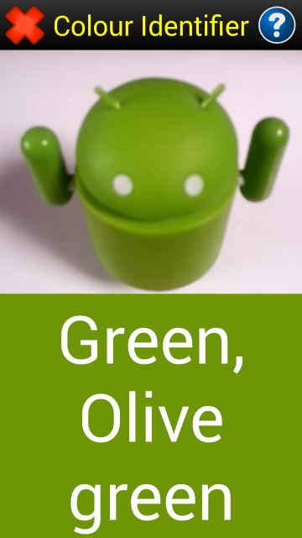

Where am I?

Find your current location along with a list of nearby pubs, hotels, shops and churches, etc.  This option uses the GPS satellite receiver to find your current location. It also uses an Internet connection to find the names of places nearby. | 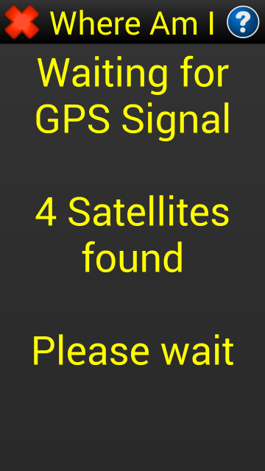 | 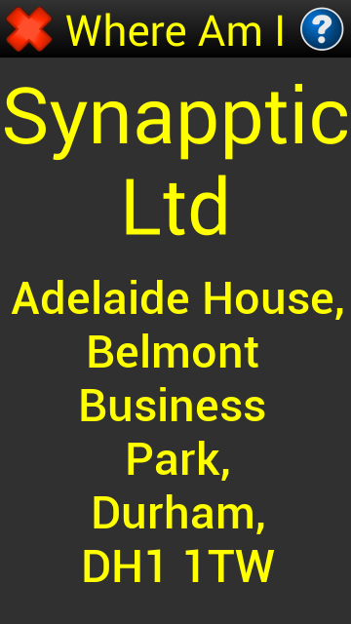

The tablet or phone will need to be in clear view of the sky in order to find your location.

Select the What's Nearby option to display a list of places and organisations near your current location. Select an item in the list to see the full details, including the address and telephone number. A button at the bottom of the details screen will dial the telephone number for you.  The GPS may need 30 seconds to warm up, after not being used for a while. | 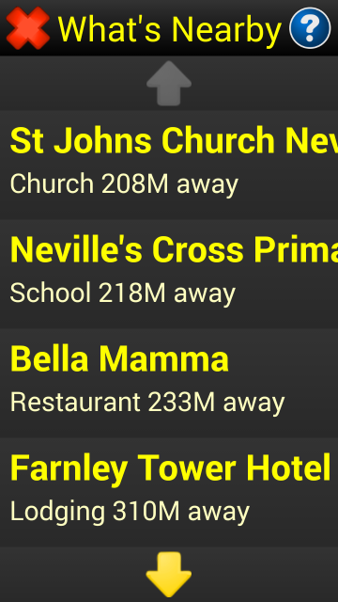

Note: The Where am I feature may not work when used inside a building.

App launcher

The App Launcher screen allows an existing Android App to be started directly from Synapptic.  Use the Search option at the top of the screen to search for a particular App, or just browse through the list of Apps. The Apps are listed alphabetically.  To appear in the list, an App must already be installed on the device. To install a new App, use the Play Store option on the Toolbox menu. | 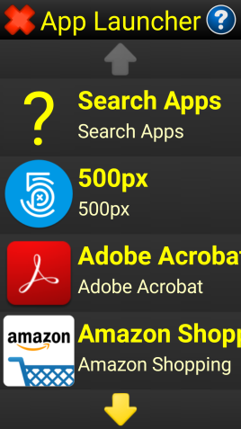

After selecting an App in the list, the App will show and Synapptic Reader will start and provide speech feedback. See Appendix E for further details about navigating Android screens with Synapptic Reader.

When finished using the App, press the red cross in the top left of the screen to return to Synapptic. You may have to press the red cross several time to close all the screens used by the app before Synapptic shows again.

Play Store

The Play Store is the standard way of adding or removing Apps from Android.  After selecting the Play Store menu option, Synapptic Reader will start and provide speech feedback.  See Appendix E for further details about navigating Android screens with Synapptic Reader. | 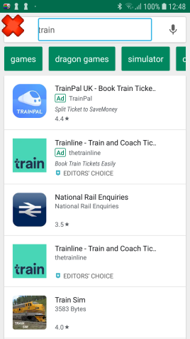
Use the search box at the top of the screen to type in search words. A list of matching apps will display below. Select an app to show further details and press the Install button on this further details screen to actually install the app.

Letter writing
Letters Writing helps you create professional looking letters using a simple template, which can be printed directly from your device.

The first available option is to create a new letter. Beneath it is an option to search through existing letters.  The rest of this screen lists all previously created letters, along with their date and time. | 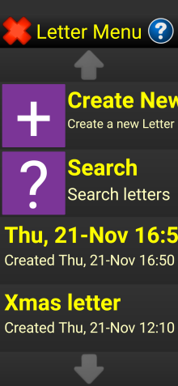

Writing a new letter

To create a new letter, select the Create New option.

The letter ‘template’ menu will display. Select each of the options and fill out the details as required to build up the new letter. Press the Save button in the bottom left corner when finished and your letter will be added to the list of existing letters, where it can be reviewed, edited and printed.  The following options are available:  Sender: Who the letter is from. This will be remembered between letters.  Recipient: Who the letter is addressed to. | 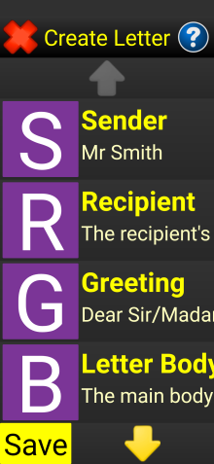

Greeting: By default this will be 'Dear Sir/Madam'. When you pick a recipient from the Address Book it will change Sir/Madam into their name. You can also enter your own greeting instead.

Letter Body: Use this to add the main paragraphs to the letter. Paragraphs can be added above or below existing ones.

Sign Off: This is the last lines of the letter and will automatically fill itself. You can also enter your own sign off instead.

Top Tip! When typing addresses, you can separate each line of the address with a comma and it will be displayed on a new line in the letter.

Opening, editing and printing a letter

Selecting any existing letter gives you the following options:

Print: Print out the selected letter. See Appendix G for details.

Edit: Allows you to edit an already created letter.

Delete: Remove the letter from your device.

Rename: This allows you to give a letter an easy to remember or search for name.

Chatbot
The Chatbot lets you ask questions to get direct answers. It is best suited for general knowledge questions such as ‘What restaurants are available in Durham?’, ‘What is the phone number for the NHS?’ or ‘What is the population of the UK?’.  It doesn’t have access to very recent information, so questions such as ‘What is on the TV tonight?’ or ‘When is the next bus due?’ will get a less useful response. | 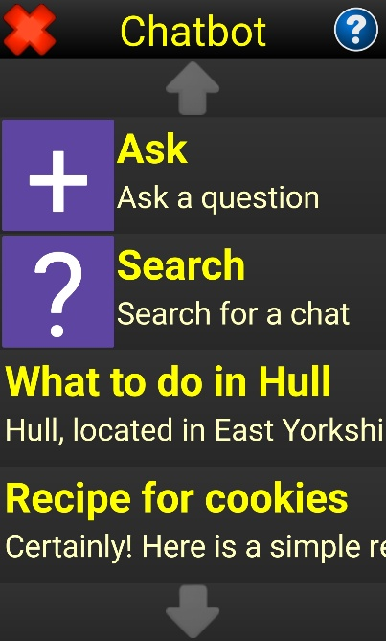

Chatbot uses voice recognition for questions. To ask a question select the ‘Ask’ option, wait for the beep then speak.

The Chatbot menu has a list of previous inquiries beneath the Ask option. Selecting one offers the following options:

View: See the full answer to the question.

Delete: Remove this question from the device.

Copy: Allows the answer to be copied when the keyboard is shown.

Delete All: Remove all chatbot questions from the device.

Visionbot
The Visionbot gives you a description of what the camera is pointed at.  The screen is split into two halves. The bottom half shows what the camera sees. When you tap it, it will take a photo then describe it.  The top half of the screen is the description. You can tap it to pause or resume reading out the description.  Once you have taken a photo, you can press the 'Ask a question' button near the top right of the screen. | 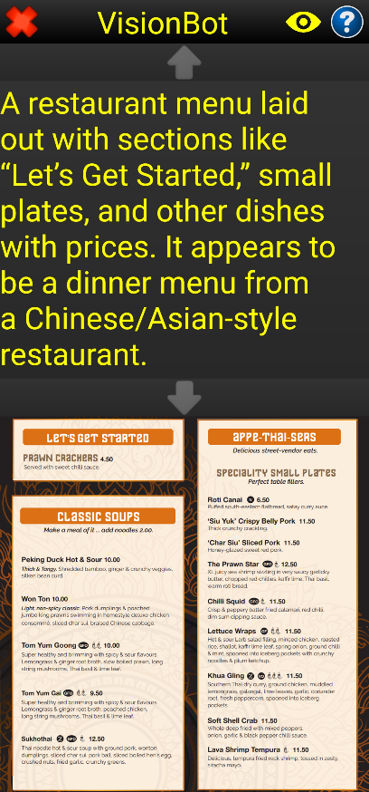

The ask button uses speech recognition. Tap it then speak after the beep. This lets you ask for more detailed information on the last photo, such as taking a photo of a menu then 'What options are vegetarian?'

Screen Mirroring

Screen Mirroring allows you to show what’s displayed on your phone or tablet screen on a Smart TV at the same time.

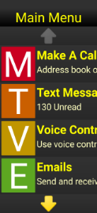 |  |  | 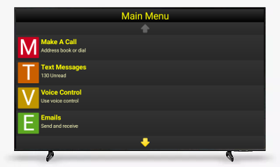
Synapptic Phone or tablet |  |  | Large screen TV

You still control everything through your Synapptic device but can use the large TV screen for the best magnification or to let friends and family see the screen as well.

When you select Screen Mirroring you will be shown a list of smart TVs that are connected to the same Wi-Fi network. The first time you select your TV you will likely need to use your TV remote to confirm and allow the connection. Subsequent attempts will connect without further prompting. | 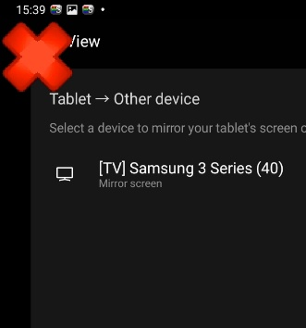

To stop Screen Mirroring, select your TV again from the list. This feature is only available on Samsung phones and tablets.

QR and Barcode Scanner

The screen will show a preview from the camera on the back of the device. Aim the camera in the direction of the code, anywhere from 6 inches to a few feet away.

When the code is scanned a bell sound will play and a list of results will be shown.

There are several types of result available when you scan a Barcode or QR code.

 | Calendar Event: The name and time of an event. You can view it or add it to your Calendar.
 | Contact: A person’s contact details, including name, address, phone number and email address. You will be able to view the details or add the contact to your Address Book.
 | Food: If you scan a food barcode, you can view Nutrition details such as Energy, Fats and Sugars per 100 grams. This information is taken from OpenFoodFacts.org, which collects international nutrition information from the general public.
 | Location: This will open in the Google Maps app if it is available. You will have options to View the closest street view or get either Walking or Driving directions.
 | Web Link: This will open the link in the Web Browser.
 | Wi-Fi: Smart devices that are already connected to a Wi-Fi network can share it as a QR Code, instead of needing to type the password. When scanned, you have options to View the Wi-Fi, or Connect to it.

Calculator

Type your calculation, then press the equals button in the bottom right of the screen. The result is both spoken out and displayed on screen in large print.  The top third of the screen displays the result. Under this are the number keys. On the far right of the screen running from top to bottom are buttons to clear the result, divide, multiply, minus and add.  The calculator can be used with the screen turned to either a portrait or landscape orientation. | 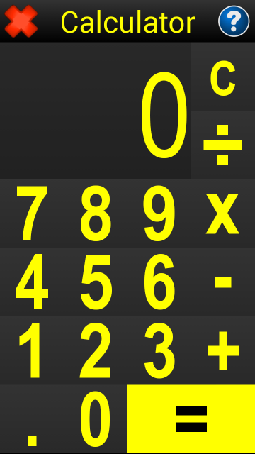

Clock

The clock shows the day, date, year and time in large print and also speaks out the details. The clock will show in a portrait or landscape orientation. | 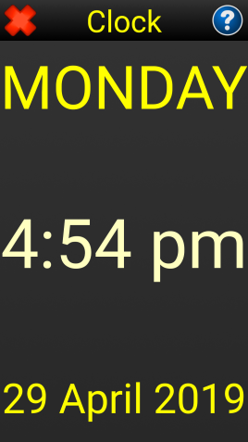

Timer

You set the time and the Timer counts down to zero. When the Timer hits zero, it will pop up an alarm screen letting you stop the alarm or snooze it for five minutes.

To start the Timer, press the Start button in the bottom left. While it is running, you can Pause or Resume by pressing the same button.  You can reset the Timer back to the starting time by pressing the Clear button in the bottom right. To reset it to zero, press the Clear button again.  The Timer will carry on counting and the alarm will wake the screen even if the screen has been turned off. | 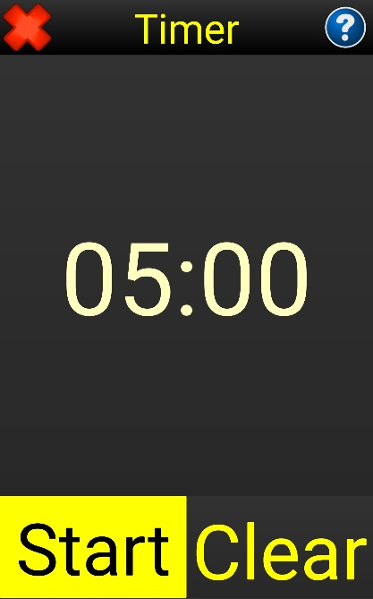

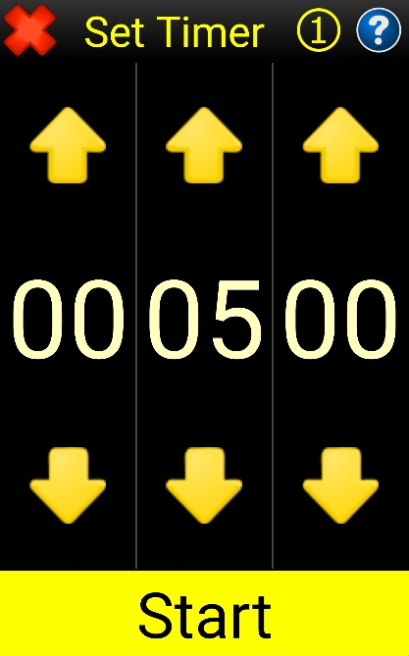 | When you first start the Timer, you’ll be taken to the Set Timer screen. This lets you set how long the Timer should run.  The top row of the screen lets you add hours, minutes and seconds. The middle row shows the current time and the bottom row lets you remove hours, minutes and seconds.  To switch between changing by 1 or changing by 5, you can press the Change By button in top right, next to help.
When you have the right time, press the Start button at the bottom of the screen.

Stopwatch

The Stopwatch starts at zero and counts up. It will carry on counting even if you close the Stopwatch.  To start the Stopwatch, press the Start button in the bottom left. Once it has started, you can Pause or Resume by pressing the same button.  You can reset the Stopwatch back to zero at any time by pressing the Clear button in the bottom right. | 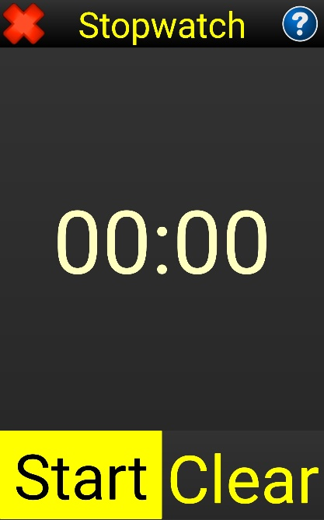

Torch

Touch the screen to turn the torch on or off. If the tablet or phone has a camera with a built-in flash, this flash light will be used as a torch. If no flash is available, the screen will be brightly illuminated instead. | 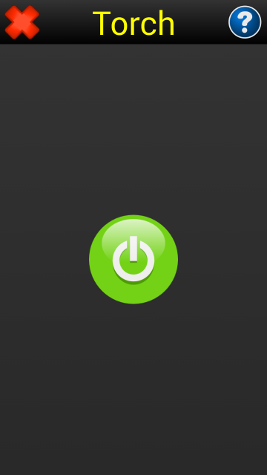

Compass

Place the tablet or phone on a flat surface, with the top of the screen pointing in the required direction. The compass will be spoken out every few seconds and also displayed on screen.  Please note, some devices may not have an electronic compass built-in. | 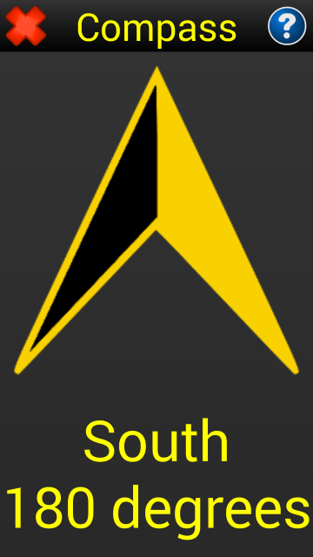

Spirit level

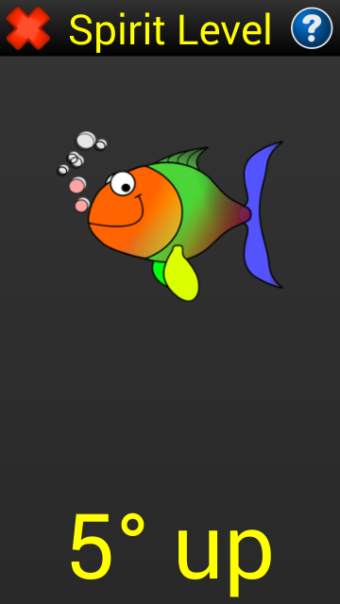 | Place the tablet or phone on a surface and the Spirit Level will both show and speak out the angle of the surface.  Our colourful, smiling, bubble-blowing fish shows the angle on screen. He can help you put up shelves, or just cheer up your day!

Meta AI

Meta Glasses are a smart device made by Meta that connect to your phone or tablet and give hands-free access to built-in AI. Ask what's in front of you, read text, make calls and find information on the go.

This menu allows easy access to the photos and videos taken by the Glasses. The following options are available:

View: This will show each photo or the thumbnail of each video in the middle of the screen. Buttons at the top and bottom allow you to navigate to the next and previous. There is also a Describe Photo button at the top right, next to Help.  Tapping on a photo will show it in full screen mode. While in full screen mode you can use two fingers and spread them apart to zoom in, or bring them together to zoom out. Tap on it again to exit full screen mode.  Tapping on a video will open the video player. It will start playing automatically. | 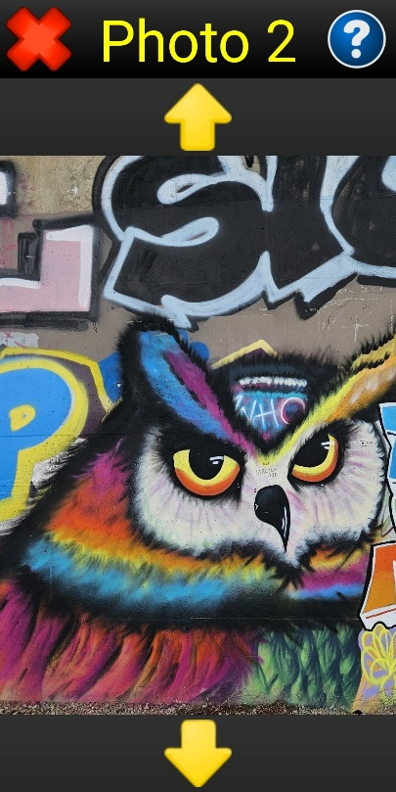

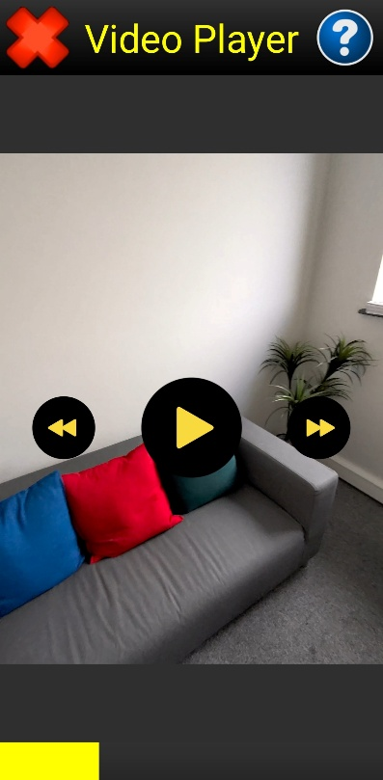 | Tap on the screen to pause the video and bring up the controls.  Tapping the left and right side of the screen let you skip forwards and back.  Tapping the middle will resume playing.  Touching the bottom of the screen will read out time remaining.  When you’re finished watching the video, tap on the Cancel button in the top left to return to viewing all Meta glasses photos and videos.
Delete: This will display all Meta photos and videos. Use the arrows to navigate, tap on the middle of the screen to select or unselect that file. A green tick will appear and the voice will indicate when a file is selected.

Once you have selected all the photos and videos you want to delete, select the OK button in the bottom left corner of the screen. Those will be permanently deleted.

Email: Use the arrows to navigate, tap on the middle of the screen to select. Press the OK button in the bottom left corner to attach those photos to an email.

You will then be guided through the normal email steps to select who to send them to, along with any message. Note you cannot send a video or too many photos at once.

Print: This will show you the list of photos and videos. Selecting a video will show a warning about being unable to print videos. Selecting a photo will take you to the print menu.

For further details about the standard Synapptic Print Menu, please see Appendix G.

Copy: From here, you can select photos or videos taken by Meta glasses and make a copy of them in the Synapptic Gallery.

The original will stay available here and must be deleted if you want it removed.

Meta AI: This will launch the Meta AI app, if it is installed. If not installed, you can go into our Settings Menu, down to Updates, then find it in the Recommend Apps section.

The app is not part of Synapptic and will use Synapptic Reader to provide a voice. The app is also where you can connect your glasses to your device, which needs to be done after purchase.

See Appendix E for further details about navigating Android screens with Synapptic Reader.

Entertainment menu

The Entertainment Menu consists of the following menu options:

(Note: Some options may not be available if you are running Synapptic on a Value product that uses the Synapptic-Lite software or if a feature is not supported in your country).

Music player

The music player can be used to play MP3 and other similar music or audio files. These could include music, talking books or talking magazines.  The top half of the music player screen details the name and duration of the current track. Place your finger on the top half of the screen to hear the track details spoken out. | 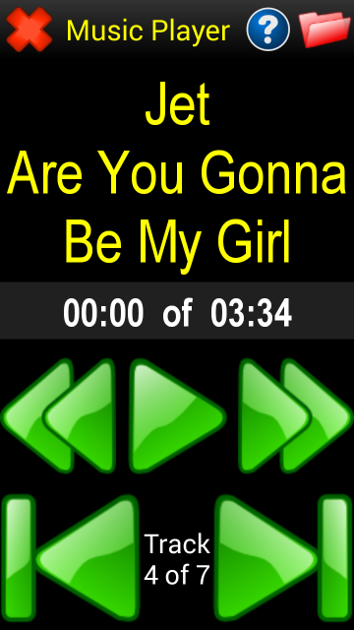

The bottom half of the screen contains the following buttons:

- Skip Back: Skip back by ten seconds.
- Skip Forward: Skip forward by ten seconds.
- Play / Pause: Play or pause the track.
- Previous Track: Selects the previous track and starts playing it.
- Next Track: Selects the next track and starts playing it.
- Between the Next Track and Previous Track buttons is a label detailing the total number of tracks along with the number of the current one.

Use your finger to explore the buttons in the bottom half of the screen. Release your finger on the button you wish to activate.

Use the red folder button in the top right of the Music Player screen to select a location to play from. This could be a folder on the tablet/phone or an external memory stick or SD card.  Folders are a good way of organizing your music, talking books and talking newspapers. When copying audio files to the device or memory stick/SD card, place related files in the same folder. This could be all files from an Elvis album placed in an Elvis folder. | 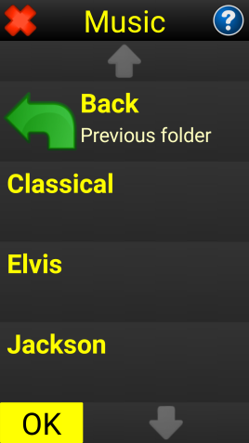

After pressing the red folders button a list of folders will display. Select the desired folder in the list. If you need to go back to the previous parent folder, press the Back button at the top of the screen. Press the OK button in the bottom left corner of the screen to continue. | 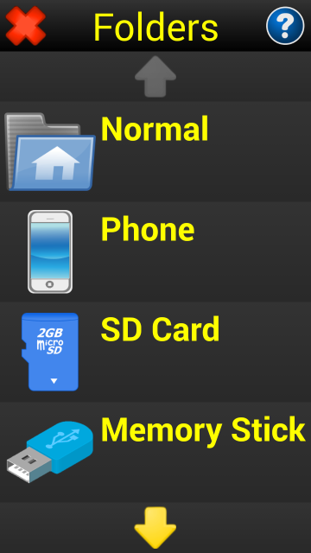

Please note: The Music Player screen is also used from other parts of Synapptic. For example, when playing a voice memo.

See Appendix A, at the end of this document, for details of how to copy audio files from a computer to the tablet or phone.

Top Tip: If you wish to select music from a memory stick, SD card or somewhere other than the normal Music folder, press the Back/Previous folder option until the Folders list displays. From the Folders list select the Normal music folder, Phone, SD Card or Memory Stick option.

Internet radio

When initially selected, the Internet Radio option downloads the latest list of radio stations from our website. Thousands of stations are provided, but further specific stations can be added upon request. Please contact us at help@synapptic.com with details of any new stations required.  The available menu options are: | 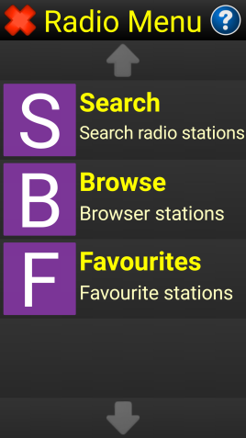

Searching for a station
Use the Search menu option to search for a particular station. Select the Search option at the top of the screen and a keyboard will display. Type in the word or words to search for, then press the Search button in the bottom left of the keyboard screen. All matching stations will then display.  Selecting a station on the search screen will start that station playing. | 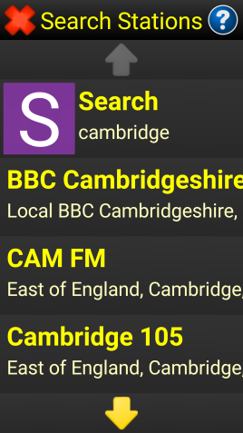

Playing a station
Selecting a station from the Search screen, Browse screen or Favourites screen will show the Radio Player screen. The station will start playing automatically.  When playing, the details of the station will be displayed on the top half of the screen. The bottom half of the screen contains a play / pause button. This button toggles between pausing and playing the station. | 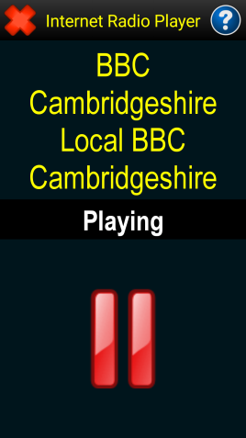

To adjust the volume of the radio use the volume keys, normally located on the left hand edge of the device.

If a particular station will not play, it may be that it is currently not transmitting. Try the station again later. If the problem persists, please report it to us as they may have changed the channel they are transmitting on.

Note: The screen will dim when playing a radio station, to save power when listening for long periods of time. Just slide your finger around the screen for it to display at full brightness again.

Browsing for stations
Browse radio stations in a list organised by country and region.

First select a country, and then select a region within that country. A list of radio stations for that region will display. For the UK some special regions are provided such as BBC Local, BBC National and National. These provide quicker access to BBC and other UK national stations.

→ | → | →

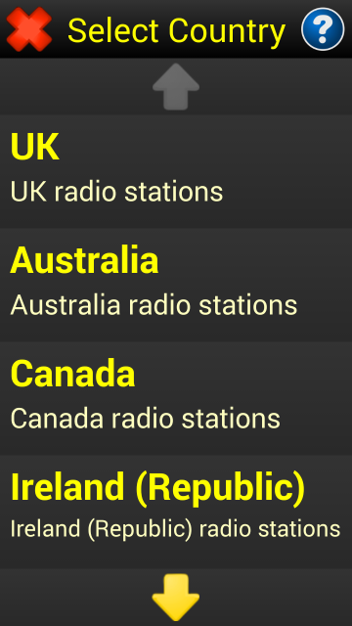 | 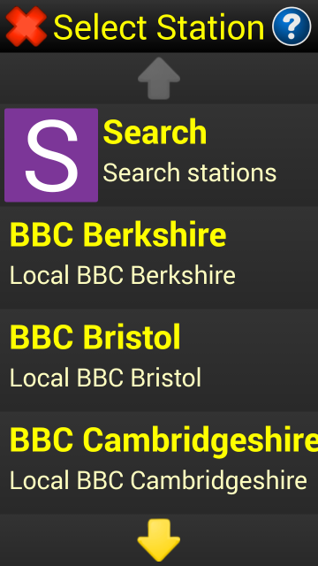 | 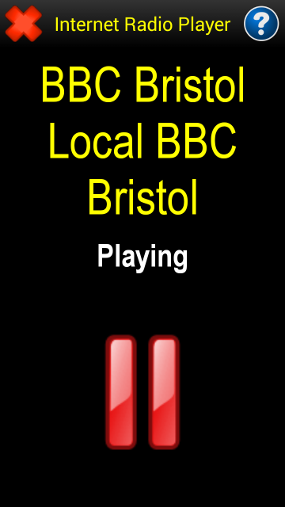

The radio will begin to play shortly after selecting a particular station. See the Playing section above for details about controlling the radio during playback.

Favourite stations
Use this screen to play or add a favourite radio station.  At the top of the screen is an option to add the last played station to the favourites list. You must have just played the radio station for this to work.  After selecting the Add option, the last played station will be added to the list.  The rest of this screen is taken up with the list of favourite stations. Slide your finger up and down the list to hear details of the favourite stations. Selecting a station from the list will start it to play. | 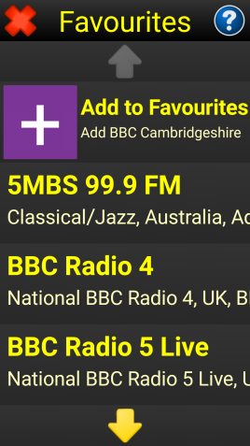

See the Playing section above for details about controlling the radio during playback.

Audio Books
The Entertainment Menu has two options for listening to audio books - RNIB Reading Services and Calibre Audio Library. They each have their own catalogue of books, which they make available for free to blind or partially sighted users.

To access them, you will need to create an account with them and enter your username and password into the Entertainment Settings option. For further information on how to create an account see Appendix H and I.

Playing a Book
Both Calibre and RNIB Reading Services use the same menu when playing an audio book. The top half of the screen will show the book and chapter, along with the current position and total length of the chapter.  The bottom half of the screen has two rows of options. The first has options to skip forwards or backwards by a minute, with the play or pause button in the middle.  The second has options to skip to the next or previous track and a button to read out current and total chapters in the middle. | 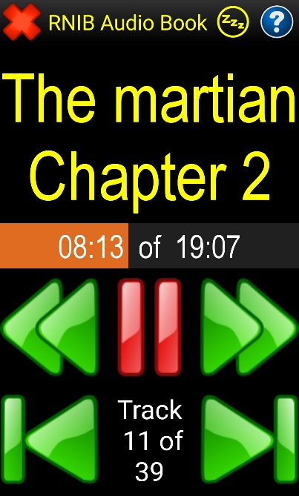

You can automatically pause the book after a set length of time by enabling the Sleep Timer. Press the button at the top right of the screen, just next to Help.

You can customize the Sleep Timer length and the Audio Playback Speed in the Entertainment Settings menu.

RNIB Reading Services
The RNIB offer a wide range of audio books for free to people in the UK who are blind or partially sighted. They can be downloaded directly to your device, over an internet connection.  To use RNIB Audio Books you will need to enter your username and password into the Entertainment Settings. If you do not already have an account with RNIB Reading Services, see Appendix H for further information on how to create one.  The RNIB Audio Books menu has the following menu options: | 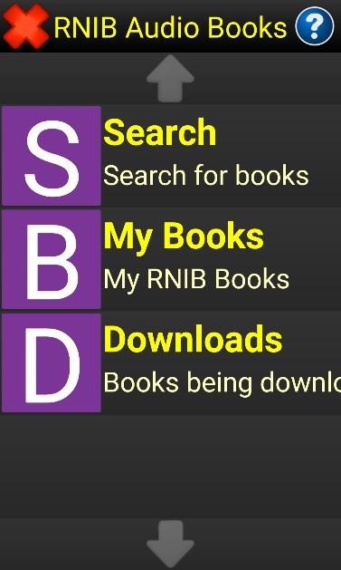

Search
The Search option will display a keyboard to let you type or dictate what to search for. You can search for part or all of the author, title, narrator or a keyword that might appear in the book description.

A list of books matching the search terms will then display. Selecting a book will open the Book Menu.

My Books
This screen lists the books that you have already downloaded onto your device. Selecting a book will open the Book Menu.

Downloads
This screen lists the books that you are currently downloading onto your device. If you lose access to the internet while downloading a book it will automatically try again when you are connected again.

Downloading can take a few minutes and you can use your device to do other things while you wait.

Book Menu
→ | → | →

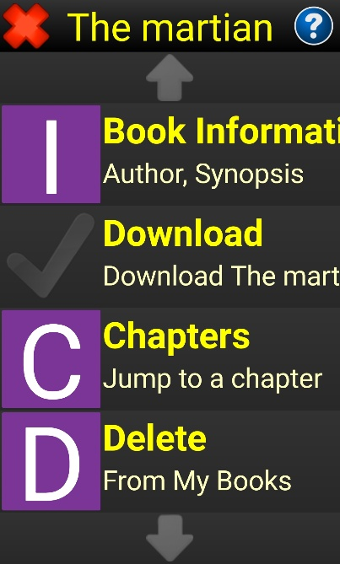 | 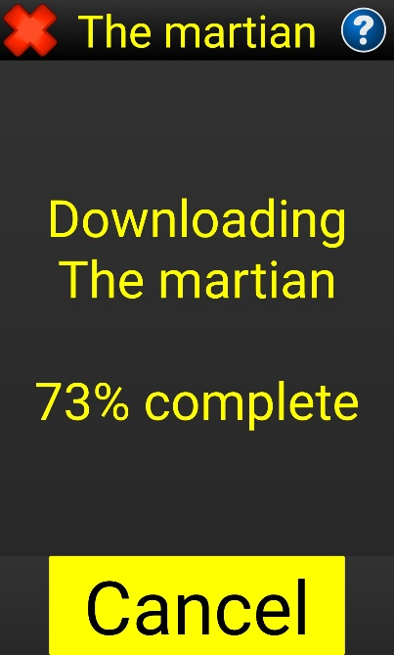 | 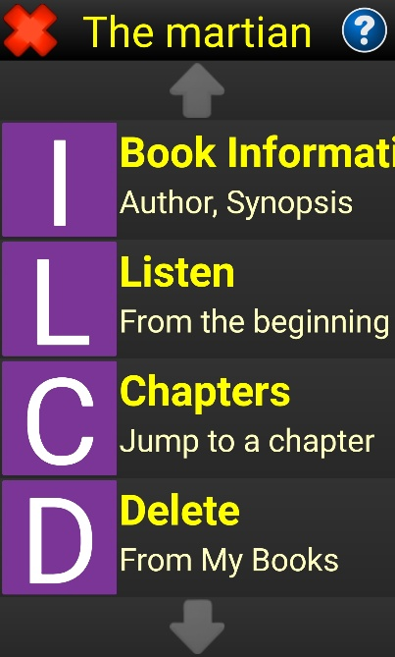

The Book Menu is opened when you select a book. To listen to a book, you will need to download it. Downloading can take a few minutes and you can use your device to do other things while you wait.

The number of books you can download is only limited by how many can fit in your device’s storage and there is no limit on how long you can keep them.

The following options are available:

Book Information. See information including the author, narrator, book length and a summary.

Download / Listen. When you first open the Book Menu, this option will let you download the book onto your device. If the book is already on your device this option will start playing the book. If you are already part way through it will resume listening from where you left off.

Chapters. View the list of chapters in the book or select one to start listening from that point.

Delete. Remove the book from your device.

Calibre
Calibre is a charity offering over 14 thousand audio books for a small subscription fee. Calibre lets you borrow up to 4 books at a time, for 28 days each.

To use Calibre, you will need to enter your username and password into the Entertainment Settings. If you do not already have an account with Calibre, see Appendix I for further information on how to create one.

When you open Calibre, it will take a moment to login and fetch the latest list of books available.

Calibre Menu
The Calibre menu has the following options:

My Books. See the list of books you have currently signed out or have downloaded onto your device.

Search. Type part or all of the title or author name to find matching books.

New Books. Browse through the books that have been added recently.

Categories. Browse the books by selecting a category or genre.
Authors. Browse the books by selecting an author.
Narrators. Browse the books by selecting a narrator.
Series. Browse the books by selecting a series.

Authors and narrators are listed alphabetically by surname. They also have a filter option to let you pick a letter and only show authors or narrators whose surnames begin with that initial, or show only authors and narrators with a book that is new to Calibre.

Search Results
After searching, picking a category, author or narrator you are shown the list of books matching your search criteria.

Selecting a book opens the Book Menu.

Book Menu
→ | → | →

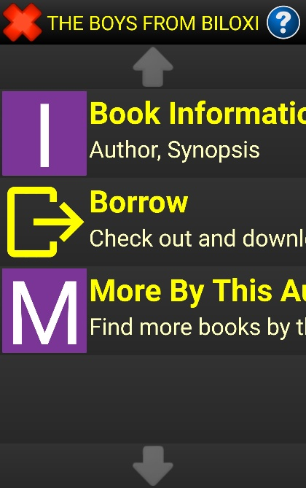 | 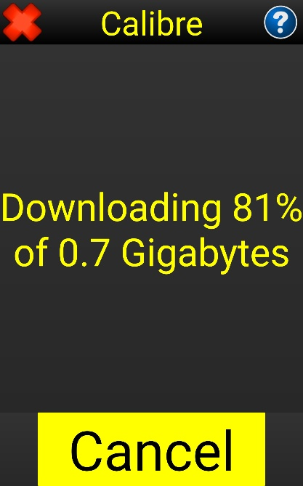 | 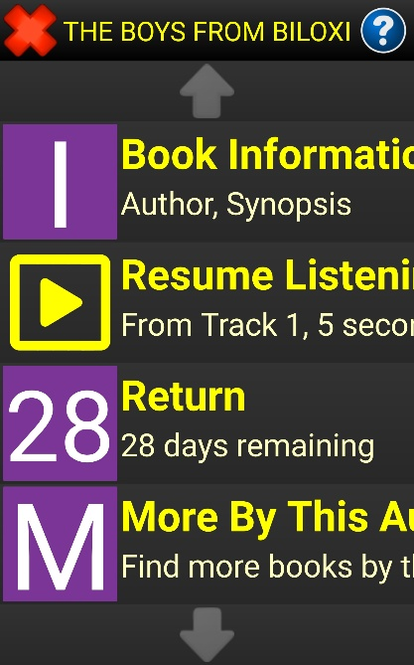

From here you can manage an individual audio book.

You can borrow up to 4 books at a time, after which you can listen to that book for 28 days. When the time runs out, they are automatically returned for you. You can borrow it again afterwards or return it early to free up a spot to borrow a different book.

When you borrow a book, a copy will be downloaded onto your device. Downloading will take a few minutes. You do not need to wait for it to finish downloading and can use your device to do other things while you wait.

There are 4 options available:

Book Information: Includes the author, narrator, book length and summary.

Listen: Start or resume listening from where you left off. If needed, this option will borrow the book and download it onto your device

Delete: Remove the book from your device.

More By: See any other books by the same author in the Calibre library.

USB Audio Player
Both Calibre and the RNIB supply audio books on a memory stick sent through the post. As well as almost all talking newspapers.

Use this menu to import and listen to books or talking newspapers that have been stored on a memory stick.
The first option is Import, which lets you copy books and newspapers from the memory stick onto your device.  It is followed by the list of saved books and newspapers.  When you select a saved book, you can play it, rename it or delete it. | 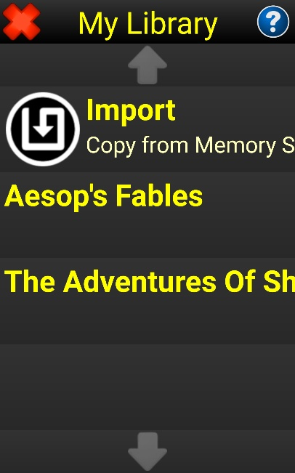

Import

To Import a talking book or newspaper, plug the memory stick into the adapter, then the other end of the adapter into the charging socket of the tablet or phone. Wait a few seconds for it to be recognised, then select the Import option.

Synapptic will ask for permission to access the memory stick. Press the Continue button at the bottom of the screen, then the OK button on the smaller pop up.

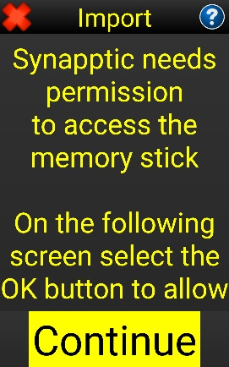 | 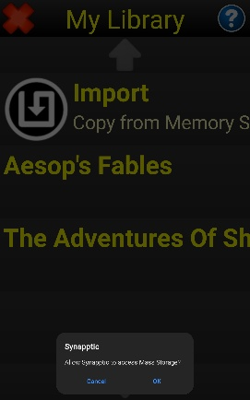 | 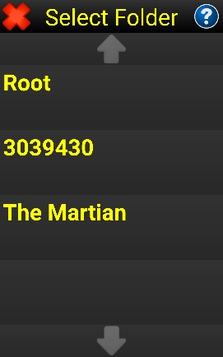 | 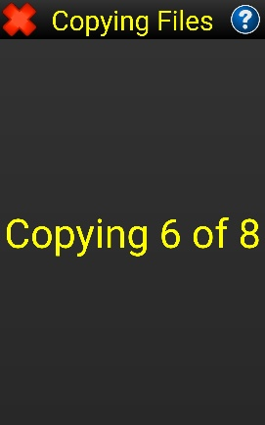

You will be shown a list of folders on the memory stick. The folders may be named after the book name, the date it was recorded or an ID number.
Select which folder you would like to import and each audio file will be copied onto your device. If you select a folder with a name that already exists in your library, Synapptic will warn you to rename it.

Top Tip: The Talking Book Player automatically bookmarks and will continue playback from the position you were last up to.

UK TV

Use this option to watch UK Freeview TV. From the Entertainment Menu select the UK TV option.

A list of available channels is displayed.  Use the Next and Previous arrows to scroll through the pages of channels if there are more channels than can fit on a single page.  Select a particular channel to start it playing. | 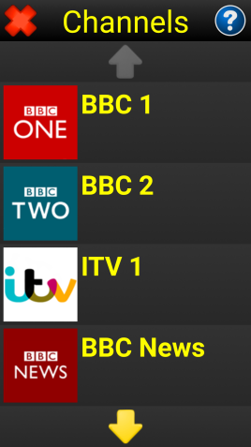
Playback is always in wide-screen landscape mode, so you may need to turn the tablet or phone by 90 degrees.



Use the volume keys on the edge of the tablet to change the volume.

To stop playback, press the red cross in the top left of the screen, you will be returned to the list of channels.

BBC iPlayer

BBC iPlayer provides the ability to watch or listen to just about any BBC TV or radio programme that has been broadcast over the last 7 days.

From the Entertainment Menu select the BBC iPlayer option.

After selecting the BBC iPlayer menu option, further options allow the choice of TV or Radio programmes. Playing TV and Radio is exactly the same process, so only playing TV is detailed below.

After selecting the TV or Radio option, a list of channels is displayed. Select the channel, then pick a day in the past 7 days.

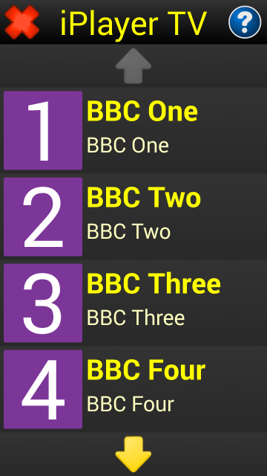 | → | 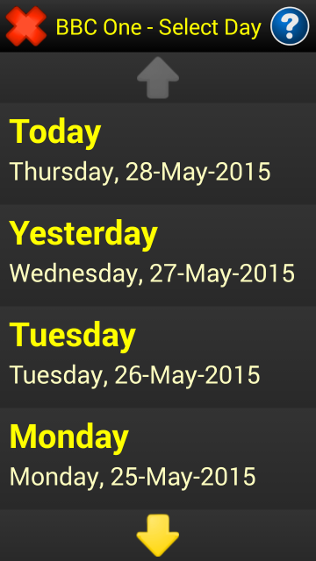

After selecting the channel and day, a list of available programmes will display.  By default, all programmes will play with audio description – if audio description is available for it.  Use the Audio Description setting on the iPlayer menu to change if programmes are to be audio described or not. | 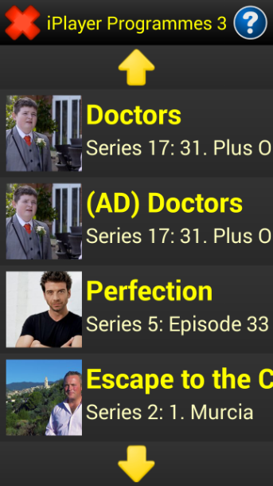

Select a program, then touch the middle of the screen to start it playing. The program will play in wide-screen landscape mode, so the tablet or phone will need to be rotated by 90 degrees.

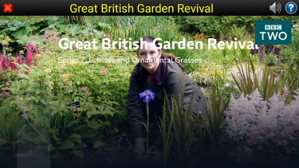

After selecting a particular programme, it may prompt you to confirm your age or warn you about the content. If you require speech feedback on this screen press the Speaker button in the top right to turn on Synapptic Reader.

When the programme is playing, touch the screen to reveal play and pause buttons, along with a time-bar that can be used to skip through a programme. If speech is needed on this screen use the Speaker button in the top right to turn on Synapptic Reader.

To exit the playback screen, press the red cross in the top left hand corner.

YouTube

YouTube is an amazing resource for watching films and video clips, listening to music, discovering and learning new skills or just watching the latest funny animal videos!  Search  From the YouTube menu select the Search option and then type in some search words. In this example we'll type in Lake District, to find some more information about the area. | 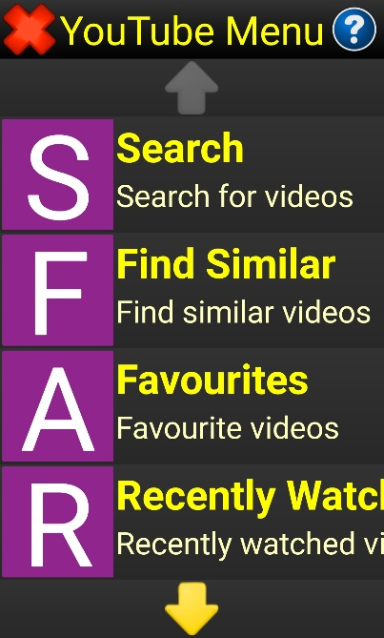

After typing in the search words a list of results will display. Use your finger to explore the items in the list. The details of each video will be spoken out as your finger passes over it. Lift your finger off the screen when you find the video you wish to play. | 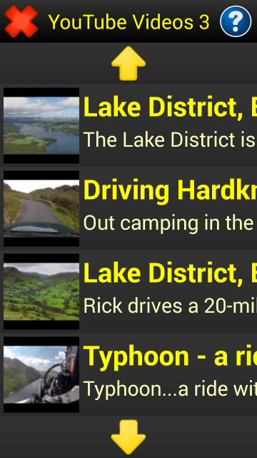

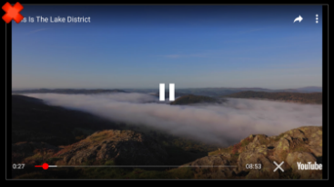  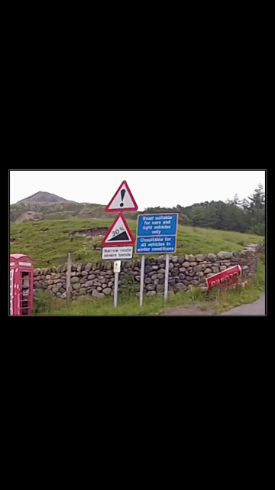 | 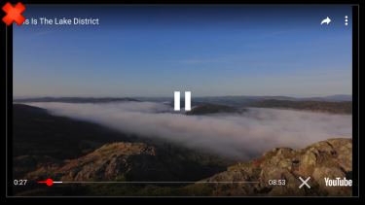  YouTube videos will play in portrait or landscape orientations. Turn your tablet or phone accordingly.

Synapptic Reader will automatically start and read out any buttons and text on screen. To hide any controls on screen, so you can see the full video, press the white cross towards the bottom right corner. When using Synapptic Reader the white cross will be labelled as ‘Hide Controls’.

When finished watching, press the red cross in the top left hand corner. The video will close and return to the list of videos.

Select another video, or press the red cross in the top left to go back to the YouTube menu. From there you can Search again or use the Find Similar option.

Find Similar
The Find Similar option will find videos similar to the last one watched. After selecting this option a list of similar videos to the last one watched will display.

Favourites
Use this option to add the last video watched to your list of favourite videos, or select a favourite video to play again.  When a video is selected in this list you are asked if you wish to play, share or delete it. | 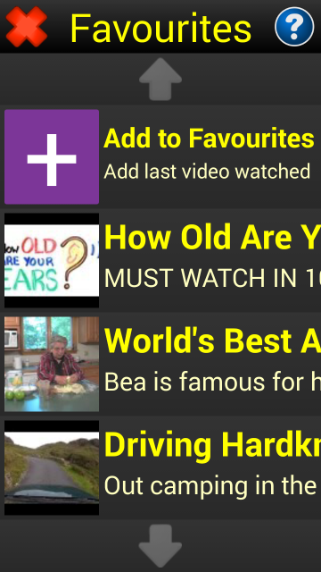
Recently Watched
You can revisit the last 50 videos you have watched here, organized by the most recent at the top.

YouTube Settings
The YouTube Settings options allows Safe Search to be turned on and off. With Safe Search turned on, videos only suitable for adults will be omitted from the list.

RSS news

The RSS News Reader makes it easy to catchup on the latest news from a variety of sources on the Internet. RSS feeds bring the news directly to you, avoiding the need to search the web or search around an individual web page. News articles are displayed in plain text, but images and links can be viewed as well if required.  There are thousands of RSS feeds available. Only the ones added to the My Feeds list are kept up to date on your tablet or phone. | 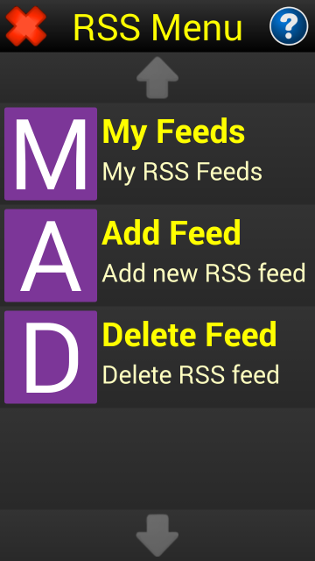

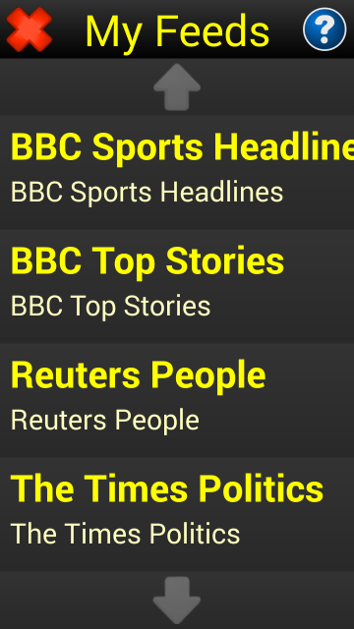 | → |  | → | 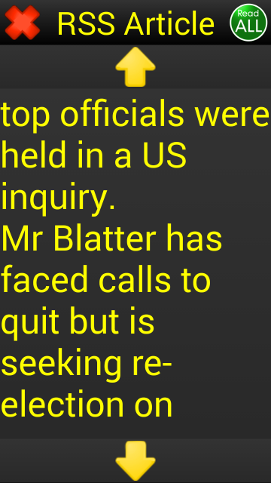

To read an article, first select the appropriate feed from the My Feeds option. Then select an article from the list of articles for this feed. Once an article is selected, a menu shows where you can read the full story, show any web links in the story or show the webpage version of the story along with any pictures.

Use the Add Feed option on the RSS Menu to add a new feed to the My Feeds list.  To type in a particular feed address, select the Type Address option. An RSS address is very much like a website address.  To keep things simple, we have put together a list of recommended feeds. Select the Recommended menu option, then pick from one of the 100 popular feeds we have included. | 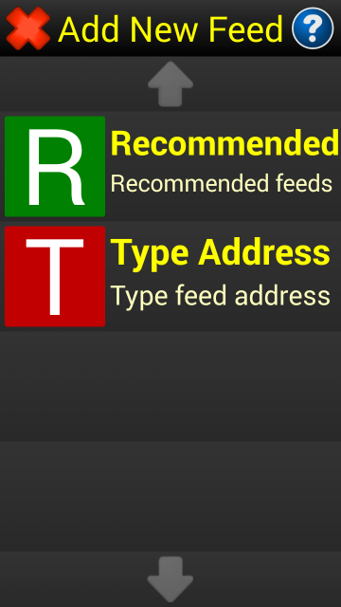

Use the Delete option on the RSS Menu to delete a feed from the My Feeds list.

Entertainment Settings

This menu allows you to enter account details if needed.

It also includes options for Playback Speed and Sleep Timer Length, which are used when listening to Audio Books through the USB Audio Player or RNIB Audio Books.

Social media

This menu option brings together shortcuts to certain social media features, from other parts of Synapptic, into one place.

- YouTube. View and share videos.

- Facebook. Catchup with friends and family.

- X (formerly known as Twitter). Read and comment on tweets from around the world.

Web browser

Surf the web easily with the Synapptic Web Browser. Navigate about the page using gestures or physical buttons, or magnify and touch items on screen.

The Web Browser Menu has options for searching the web, typing a web address, going to the home page, keeping a list of favourite web sites and allowing easy navigation back to recently visited sites.

From the Main Menu select the Web Browser option. The Web Browser Menu has the following options:-

Search: The search option shows the keyboard, where you can type in search words. Press the Search button in the lower left hand corner after you have typed in the search words. The results will then display. Select a search result to display its full web page.

Type Address: The Type Address option shows the keyboard, allowing a website address to be typed in. Press the Go button in the lower left hand corner after the address has been typed. The web page will then display.

Home Page: The factory setting for this is www.google.com but can be changed in the Web Settings screen - see below.

Favourites: After browsing a website, exit the browser and come to this menu option, where you can add the last visited page to the list of favourite web pages. Select any of the favourite web pages in the favourites list to open it, share it or delete it from the list.

Recently visited: Displays a list of the last 30 pages visited. Select any item in the list to browse that page. The list can be deleted by using the Delete History option in the Web Browser Settings Menu.

Web Browser Settings: The Web Browser Settings menu has the following options:

Volume Keys: The volume keys can act as physical buttons, that when pressed will read out and highlight the next or previous part of the current web page. Enable or disable the volume keys as navigation keys here.

Set Home Page: Sets the home page to the last visited web page.

Background Theme: Use the default black text on a light background or a dark background with white text.

Delete History: Deletes browsing history from the list of recently visited web pages.

Delete Cookies: Deletes cookies from the web browser. Cookies store small amounts of data specific to a particular user and website and allow websites to provide a more personalised experience.

Using the Web Browser

General
The Web Browser consists of a title bar at the top of the screen and the main web page area underneath. The title bar contains a number of buttons as described below:

On the left hand side of the title bar is the red cross to close the web browser and return to the previous menu.

There are three buttons on the far right of the title bar. From right to left these are:

The Back Button: Use this button to go back to the previously viewed page.

The Web Browser Mode button: Use this button to switch between Advanced and Basic Mode.

The Help button: Use this button to show a list of help topics for the Web Browser.

Web Browser Modes
The Synapptic Web Browser has two modes – Advanced and Basic. The layout of the screen and method of navigating differ between the modes.

 | Switch between the two by using the Web Browser Mode button towards the top right of the screen.

Basic mode offers magnification and basic speech feedback when navigating around a web page.

Advanced mode builds on Basic mode by giving you more control and information when relying on speech feedback, but is slightly more complicated to use than Basic mode.

We recommend starting with Basic mode, then use Advanced mode if needed for a more demanding page. You can freely switch between Basic and Advanced modes at any time and your selection is remembered.

Both Basic and Advanced modes are described below.

Basic mode

In Basic mode an extra button bar at the bottom of the screen displays with a Previous button on the left, a Next button on the right and an OK button in the middle. These ‘explore buttons’ highlight and speak out the next or previous items on the web page.

Using magnification and touch

To magnify a page, use the pinch and zoom technique. Place two fingers, close together, on the middle of the screen. Keeping both fingers on the screen, separate your fingers to magnify the page. To reduce magnification, do the reverse - place two fingers on the screen separated by a small distance. Keeping both fingers on the screen, move your fingers closer together.

When magnified, the page will be bigger than the screen size. To pan around and move parts of the page into view, place a single finger on the screen and immediately move it up, down, left or right. Then release your finger. Whilst your finger is on the screen and moving, the page will move with your finger.

When you touch an item on the page it is highlighted, then a description for it is read out, so you know if you have touched a link, button or just a paragraph of text.

For links and buttons, touching them once causes the system to read out a description. When touched a second time, the link is followed or the button pressed.

If a text box is touched, the keyboard is shown and text can be typed into the text box in the normal way.

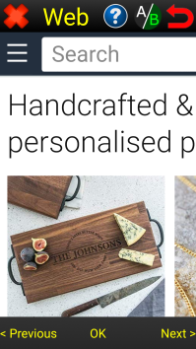 | 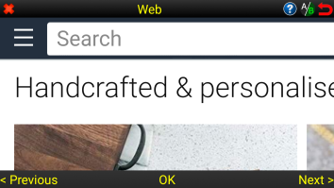

Rotate the phone or tablet from a portrait orientation to landscape to help fit more of the magnified page on the screen.

Using the Explore buttons

The web browser allows a page to be explored without using magnification and touch.

By using either the volume buttons (if configured) or the button bar at the bottom of the screen, the page can be explored item by item. The Next button on the button bar, or the volume down button, take you down the page to the next item. The Previous button on the button bar, or the volume up button, take you to the previous item on the page.

As you move to each item on the page, it is highlighted and a description for it spoken out.

If you move onto a link and wish to follow the link, press the OK button on the button bar at the bottom of the screen, or hold the Volume Down button for a second.

If you move onto a text box and wish to type some text, press the OK button or hold the Volume Down button for a second and the keyboard will display.

Advanced mode

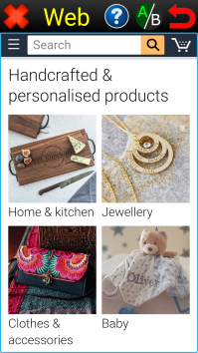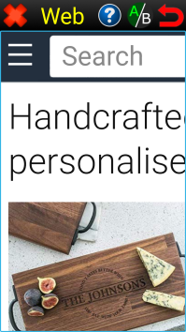

There are three methods for reading and navigating a web page in Advanced mode:

Web pages generally consist of a number of headings, paragraphs or text, links, images and buttons. Use one or all of the three methods described below to move about these various items.

- Using the physical volume keys as navigation buttons - this is the recommended method.
- Using explore-by-touch, sliding your finger about the screen to hear a description of the text or item under your finger.

- Using swipe gestures across the screen to move to the previous or next item on page.

These three options are detailed below. In addition to these three options, magnification can be used to zoom in or out of any page.

To magnify a page place two fingers about an inch (3cm) apart on the screen. Keep your fingers on the screen and move them closer together to zoom out or move them further apart to zoom in.

Use the physical volume keys as navigation buttons.

This is the recommended option and makes reading and operating a page simple, with no need to locate individual items on the page or use taps and gestures.

Press the Volume Down button to move to the next item on the page. It will be both highlighted and a description for it spoken out.

Press the Volume Up button to move to the previous item on the page. It will be both highlighted and a description for it spoken out.

Long press the Volume Down button to follow a link, press a button or show the keyboard when a text box is currently highlighted. (To long press the Volume Down button just keep it pressed for just over a second).

Typing into Text Boxes.

To show the Android keyboard when a text box (edit box) is highlighted, long press the volume down key. Run your finger over the lower half of the screen to find the first character you wish to type. Release your finger to type that character. Repeat this process to type the word or sentence required. Use the button in the bottom right of the Android keyboard to save, search or proceed to the next item. | 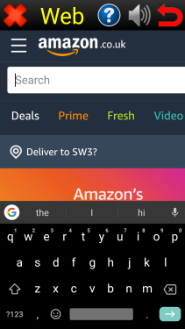

When typing with the Android keyboard, pressing the volume keys will move the cursor back and forward through the characters that have been typed. To jump out of the text box to the next item, long-press the volume down key. To jump to the previous item, long-press the Volume Up key.

Top tip! If you navigate to a page and the volume keys appear to not work, the most likely explanation is that the page has shown the keyboard straight away and wants you to type something into a text box. Pressing the volume keys at this point will move the cursor back and forward through the characters that have been typed - but because nothing has been typed yet, nothing will be spoken out.
To solve this problem, long press either the Volume Up or Volume Down keys to jump to the previous or next item on the page. Then use the volume keys to explore the items on the page normally.

Note: In the unlikely event that a link, button or text box won't activate by long pressing the Volume Down key, tap the screen twice quickly instead.

Use explore-by-touch

To explore by touch simply run your finger over the screen and it will read out whatever text or item is under your finger. It is important to note that items on the page won't take up the full width of the screen. There can be an item on the left and a different item on the right.

The item currently under your finger will be both spoken out and highlighted. Tap this same item again to select it. Alternatively, tap anywhere on the screen twice quite quickly to select it. Selecting an item will show the keyboard if the item is a text box, follow a link, tick or untick a tick box, or press a button.

- Use gestures

To explore the page using gestures, use one finger and swipe across the screen, starting from the left and going to the right. This will read out the next item on the screen. Swipe from right to left to read out the previous item on the screen. Swiping up or down the screen will achieve a similar result.

When you find an item you want to select, tap the screen once in exactly the same place. Alternatively, if tapping once in the same place it difficult, tap twice anywhere on the screen, quite quickly.

Advanced gestures.

Certain gesture settings can be changed by using the Synapptic Reader option in Synapptic Settings menu.

The following can be changed:

Tap Mode: Switch Synapptic reader between using Single/Double Taps on Double Taps only.

Advanced gestures. This changes the up / down gesture to cycle through different reading modes, that will make Synapptic Reader read out just headings or just links. Advanced gestures is turned off by default.

Text only view

A text-only view of any web page is available by pressing the help button in the top right, then selecting the Text-only option from the list of help topics. This option works in both Advanced and Basic modes. | 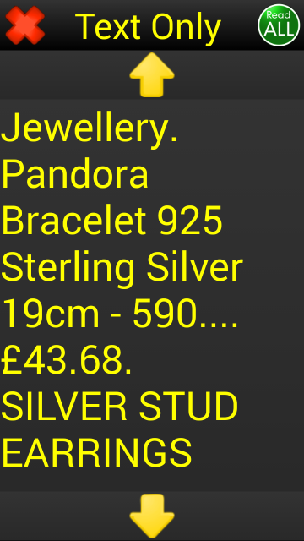

News from Synapptic

Never miss important news, competitions and information from Synapptic with the new Synapptic News menu option!  Select an article to read the full details. Each article includes text and images and everything is shown in large print and spoken aloud. | 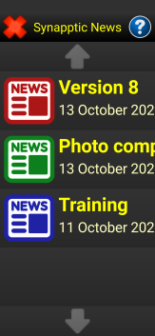

Tablet / Phone information

The Tablet/Phone Information screen gives details of Wifi signal, battery level, date and time and software version number.  When the screen first displays, it gives a quick spoken summary.  Move your finger about the screen to explore all options in full.  Note: Certain options below will only display on devices that accept a SIM card. | 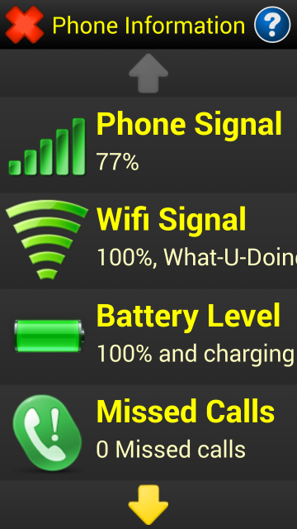

Phone Signal: The strength of the mobile phone signal as a percentage.

Wifi Signal: The strength of the Wifi signal as a percentage. (To connect to Wifi and type in any passwords, select the Tablet / Phone Settings option from the Main Menu, then select the Wifi option).

Battery level: The battery level as a percentage. Details about the battery charging are also given.

Notifications: Access to the notification from Android or other apps. These are how apps alert you to updates, changes or new messages. Opening a notification will take you out of Synapptic and open the relevant app with Synapptic Reader to help navigate.

Missed calls: Details of any missed calls are given here. They are also available in the Recently Called section of the Make a Call menu.

Ringer Modes: Allows the ringer to be turned on, off or set to vibrate, and the ringer volume and tone changed.

My Number: If your device accepts a SIM card it will be capable of making and receiving normal telephone calls. This option conveniently displays your telephone number.
Internet: An indication if there is currently a good connection to the Internet. This option takes a few seconds to update.

Date and Time: Reads out the current date and time.

Storage: Details how much storage is available on your device for downloads, music or audio books.

About Phone: Displays details about the version of software running on the Tablet or Phone.

Tablet / Phone settings

A number of settings are provided to allow the operation and look of the tablet to be customised. These settings are organized into a few categories.

From the Main Menu select the Tablet Settings or Phone Settings option. The Settings Menu will display, which contains the following options.

Wifi: Use this option to connect the tablet or phone to a Wifi connection. See the Connecting to Wifi section at the start of this User Manual for further details.

Sounds: The options for adjusting sound related settings.

- Voice On/Off: Use this option to turn the voice on or completely off.

- Voice Picker: Choose which voice Synapptic should use when speaking.

- Voice Volume: As well as being able to use the volume buttons on the edge of the tablet or phone, the voice volume can also be adjusted here.

- Voice Speed: The voice speed can be changed from slow level 7 through to fast level 7. The factory setting is Normal Voice Speed.
- Call Volume: This lets you choose the volume for phone calls.

- Verbosity: Verbosity can be set to normal or low. With a low verbosity setting the voice will speak fewer details for menu options and certain other screens.

- Ringer Volume: Ringer volume can be change both here and in the Phone Information option of the Main Menu. Ten levels of ringer volume are available.

- Ringtone / Notification Tone: Use these options to change the ringer sound or general notification sound.

- Beeps: When touching different items on the screen, different sounding beeps are made. Use this option to turn these sounds on or off.

- Key Vibration: Certain devices can be set to vibrate slightly when different options on the screen are touched. Use this option to turn vibration on or off.

Display: The options for adjusting the visual size and appearance.

- Colour Scheme: Change the text colour and background colour. Select a colour scheme from the list.

- Icon Colour: On menus, the icon is the big square with a single large letter in the middle, to the left of each menu item. Choose between having high contrast icons, that match the selected colour scheme, normal coloured icons or colourful icons that contrast each other.

- Zoom Level: Make text on the screen bigger or smaller.

Note: as zoom level increases, the number of menu items on any one page decreases - and vice versa.
It's worth experimenting with a range of different zoom levels, both higher and lower, to find the best settings. The system makes changes to the menu layout at different magnifications, that maximise visibility.

Also, see the Text Size option below, which allows the size of text when reading and writing to be independently changed to that set by the zoom level.

- Text Size: This option allows the size of text, when reading and writing, to be independently changed to that set from the Zoom Level. This setting changes the text size shown in the top half of the on-screen keyboard and when reading a note, message or email, etc.

- Font: Use this setting to change the font used within Synapptic. A selection of fonts is supplied with different shaped characters and different character spaces. Try out the various fonts and find one that makes the text on screen easiest to read.

- Brightness: The screen's brightness can be changed to one of ten levels, level ten being the brightest. Use a low value to conserve battery power.

- Keep Screen On: If the phone or tablet detects no activity for 60 seconds, the screen turns off to save the battery. Use this setting to keep the screen permanently on. This can be useful when first learning how to use Synapptic. Warning: Having the screen always on may cause the battery to drain quite quickly.

- Auto Rotate: By design, most screens will not change orientation as the phone or tablet is rotated. This option will allow all screens, including menus, to change orientation as the tablet or phone is rotated.

- Text Highlight: When the voice reads out notes, text messages or emails this option shows a coloured highlight around the words being spoken.
Customise: The options for the feel and layout of the menu.

- Menu Layout: Add or remove menu items. See Appendix C for further details.

- Menu Style: Switch the Main Menu between a multi-page list and a single page grid.

- Menu Operation: There are three ways to operate the touch screen.

1) Normal Single Tap mode - This is the recommended mode. In this mode an option on the screen can be tapped once to select it. Alternatively, place one finger on the screen and slide it around the screen to explore the various menu options. As your finger moves over each option it is both highlighted and a description for it spoken out. Lift your finger off the screen, to select the current option.

2) Double Tap mode. In this mode, tap an option on the screen once to hear a description for that option. Alternatively, explore the screen by sliding your finger around the screen to discover the various menu options. To select an option, just double tap the screen. (In summary, explore the menu options by sliding your finger around the screen or by single-tapping a given option, wait a moment, then double-tap the screen to select that option). The speed of the double-tap can be adjusted - see below.

3) Long Press mode. In this mode, tap an option on the screen once to hear a description for that option. Alternatively, explore the screen by keeping your finger on the screen and sliding it about to hear details of the various menu options. To select an option, hold your finger on a menu option for a few seconds. The length of time you have to hold your finger down can be adjusted - see below. A count-down timer/beeper will start counting from 3 to 1, then activate the chosen option.

Note: The operation of the Keyboard can be independently configured to the menu operation selected here. For example, the keyboard can be configured to operate with a single-tap even though the menu operation is configured as double-tap.

- Double Tap Speed: If using Double Tap as the menu operation mode, this setting changes how fast the double tap must be made in order to be recognised.

- Long-Press Speed: If using Long Press as the menu operation mode, this setting changes how long your finger must be held on an option for it to be selected.

- Reset: This lets you reset a customized Main Menu back to normal.

Updates: Use this option to check for the latest version of the Synapptic software. See Appendix C below for details.

Keyboard: The options for typing on the keyboard.

- Layout: Select between a QWERTY or ABC keyboard layout.

- Operation: Select whether the keyboard should remain in Single Tap mode when the menus are set to double tap or long press mode.

- Key Sounds: Each time a letter is typed using the on-screen keyboard, a keypress sound is made. Use this option to turn the keypress sounds on or off.

- Keyboard Speech: Configures the keyboard to speak either each letter, each completed word or both each letter and each completed word. The normal setting is each letter.

- Full Screen: When typing text into Android screens, the keyboard shows half height by default. This can force it to always display full screen.

See Appendix F for further details on using the Synapptic Keyboard on Android.

Reader: The options for customizing Synapptic Reader.

- Enabled: This enables or disables Synapptic Reader.

- Tap Mode: Here you can choose how to interact with a selected item when using Synapptic Reader. Select either Double Tap Only or Single/Double Tap. The default option is Single/Double Tap, which will enable Single Tap for the vast majority of situations, only falling back to double tap where Single Tap will not work.

- Volume Keys: Allows you to enable or disable the option to control Synapptic Reader using the physical volume buttons.

- Advanced Gestures: This determines whether Advanced Gestures are available when using Synapptic Reader. Advanced gestures changes how the Swipe up/down gestures is used. When on, swiping up or down the screen will change Synapptic Reader to read out just headings, links, words or characters. This setting is off by default.

- Show Back Button In Android: Allows you to enable or disable the Cancel and Go Back button in the top left when you go to an Android screen.

- App Call Overlay: Select when the Synapptic call screen should show for Android Apps like WhatsApp, Telegram or Messenger. Has options to show while calls are ringing and ongoing, just while ringing or not at all.

- Volume Adjustment: Synapptic Reader uses Accessibility Volume, which can be louder than your normal volume. This setting lets you control how loud it is compared to your regular sounds.

Advanced: The options for less commonly used or Android settings.

- Lock Screen: Choose a lock screen for Synapptic. Select from Swipe, PIN, PIN Silent or None.

- Auto Start: Synapptic will automatically start when the phone or tablet is powered on. Use this setting to turn Auto Start on or off. With Auto Start turned off, use the Synapptic icon in the list of Android Apps to start Synapptic when required.

- Connections: Quick shortcuts to access the Android Bluetooth and Flight Mode settings.

- Android Settings: This option offers a shortcut to show the Android Settings screen.

- Reset Settings: This option resets all colour settings, emails settings, etc., but does not delete any text messages, email messages or contacts. Use the de-activate menu option to deactivate Synapptic in preparation for moving it to another device.

- Remote Control: Use the Remote Control option to allow someone to operate your tablet or phone remotely over the Internet. A special security number displayed on-screen has to be told to the remote operator before they can take control of the device. Remote control is useful for training or technical support.

- My Number: If the phone or tablet accepts a SIM card, the mobile phone number is shown in the Tablet Information or Phone Information screen. Some older SIM cards do not expose their number, so this option can be used to manually type in the mobile number instead.

- Device Type: With the line between Tablets and Smartphones becoming ever more blurred, this setting allows you to pick which device Synapptic is running on. Synapptic automatically detects the device, so this setting does not normally need to be set.

- Language: Use this screen to select the language that menus and other text should use in Synapptic. Your selection here may also affect location-based searches and the availability of certain options on the Main menu, if they are not available in the selected location.

Help

The help option towards the end of the Main Menu contains help documents relating to the general use of the tablet or phone.  A search option can be used to search the hundreds of help documents contained within Synapptic, that are normally accessed via the help icon in the top right of a screen.  Help videos for certain topics are also available. (They can also be watched directly on YouTube). | 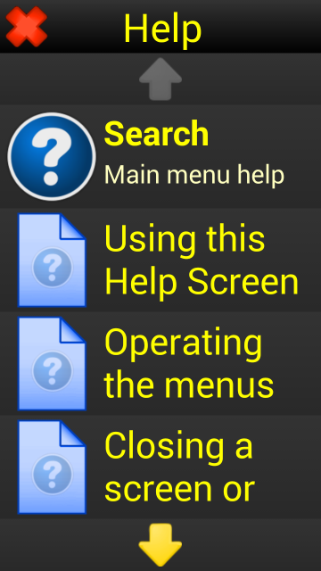

Android screens

Towards the end of the Main Menu is an option called Android Screens. This option hides Synapptic and shows the Android screens instead.

A prompt will ask if you wish to have speech feedback on the Android screens. If you select yes, Synapptic Reader will start.

See Appendix E for further details about navigating Android screens with Synapptic Reader.

Turn off

If your device has a Turn Off menu option at the end of the Main Menu, select this to fully switch off the device. The Android Power Off menu will display and Synapptic Reader will speak out the various menu options.

See Appendix E for details on how to use Synapptic Reader.

Appendix A - Connecting to a computer

Pictures, voice memos, music, talking books and other files can easily be transferred between your phone or tablet and a computer.

If you're using a Windows computer, connect your phone or tablet using the supplied USB cable. Open File Explorer and select This PC. Your phone or tablet should appear as a connected device.
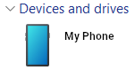

Double-click the device, then double-click Internal Storage. You will then see a number of folders containing the files stored on your phone or tablet.

Folder | Description
Memos | Voice memos recorded using the Voice Memo recorder are stored in here.
Music | MP3 audio files (of talking books, music and talking newspapers) and folders of MP3 audio files are stored here.  (As well as MP3, other file formats such as WAV, OGG, 3GP and MID files are supported).  MP3 tracks placed directly in the Music folder will appear under the Normal folder in the music player. Folders of MP3 files can be selected by their folder name within the music player.
DCIM/Camera | Pictures taken with the Camera are stored here. The View Photos menu option shows pictures from this folder.

When transferring files from your computer to your phone or tablet, you can usually ignore any messages about incompatible file formats.

When transferring files from your phone or tablet to your computer, we recommend copying the files to the computer first, then opening them from there.

Appendix B - Customising the Main Menu

Items on the Main Menu can be added, deleted or re-ordered. In addition, the Style of the Main Menu can be changed from a multi-page list to a single page grid.

From the Main Menu select the Settings option, then the Customise option.  Use the Customise option to re-order, add or delete items from the Main Menu. Use the Menu Style option to change the Main Menu to a grid or list. Reset a customised Main Menu back to normal using the Reset option. | 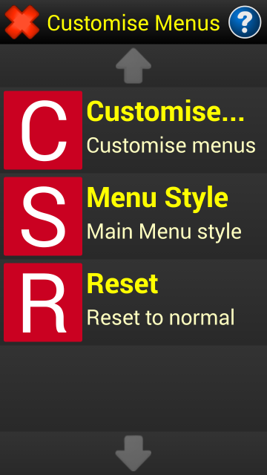

Adding, deleting and moving menu items

From the Customise Menu select the Customise… option.

A copy of the Main Menu will display, with a red border around it. The red border indicates that this is just a copy of the Main Menu and not the Main Menu itself.  Select a menu item to move or delete, or select the position for a new menu item to be inserted.  In this example we will move the Voice Control menu option to the top of the Main Menu. | 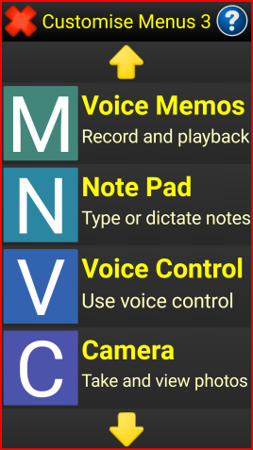

After selecting the Voice Control menu item we're asked which action we wish to perform on this item. The options are Move, Delete, Insert above or Insert below.  We'll select the Move option, as we want to move this item to the start of the Main Menu. | 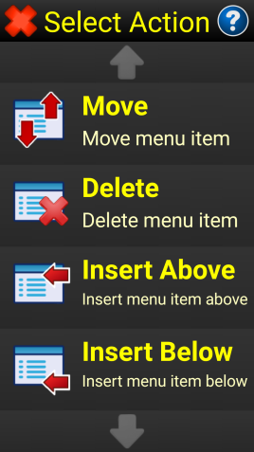

Type the new menu position number. In this case we type number 1. Press the OK button in the bottom left of the keyboard to continue. | 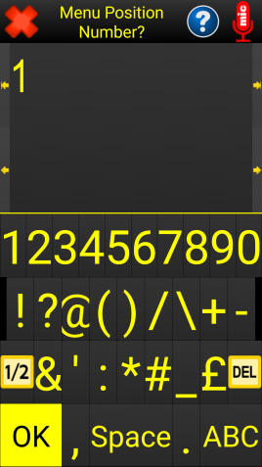

Now press the red cross several times until back at the start of the Main Menu. The Voice Control option will now be displayed at the top. | 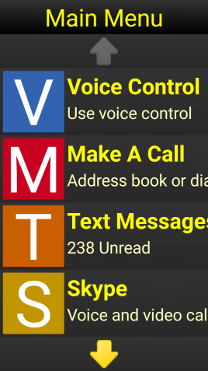

Top Tip: Use the Insert Above or Insert Below menu options to insert a new menu item into the Main Menu.

Certain menu items from the Entertainment menu, App Launcher menu and Tools menu can be added directly to the Main Menu for quick access.

These include: Electronic Magnifier, Reading Machine, Weather, Apps, Be My Eyes, Voice Control, Music Player, Where Am I, Internet Radio, Talking Books, TV, BBC iPlayer, YouTube, RSS News, Facebook and Recently Called.

Menu style

Use the Menu Style option to change the Main Menu between a multi-page list and a single-page grid.  The grid can allow much quicker access to certain menu options as no scrolling through pages is required. | 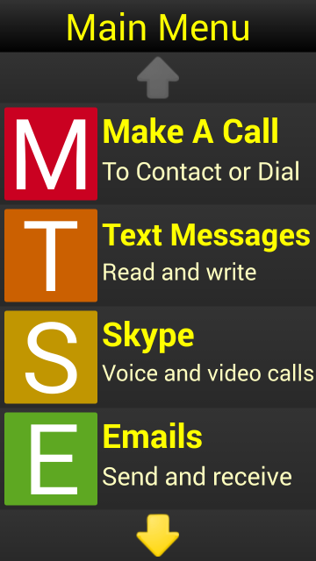 | 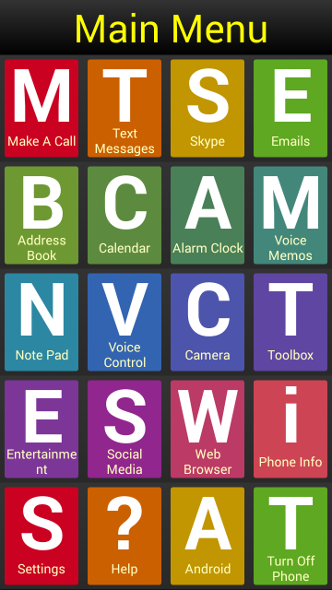

Reset menu

The Reset Menu option keeps the selected menu style, but changes the Main Menu items back to normal and removes any customisation.

Appendix C - Updating Synapptic software

Synapptic software comes with a free 12-month Basic Support Plan, which includes regular software updates.

When your free plan expires, we'll contact you about renewal options. (Please note: one plan covers all the Synapptic devices you own).

For details on our range of support plans, please visit our website at www.synapptic.com/updates.

We recommend using the Updates option in the Settings Menu to check for a new version of Synapptic every few months. This ensures you are using the latest version, and can benefit from any new features. See the News section of our website for details about major releases.

From the Phone Settings or Tablet Settings Menu select the Updates option, this will start the Update Helper.

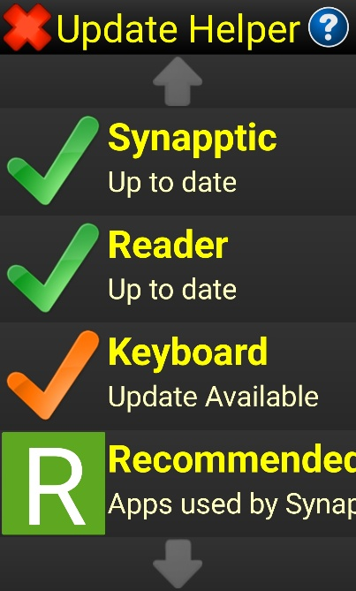

The Update Helper screen shows the essential parts of Synapptic with a green tick next to each when they are installed and set up correctly. An orange tick indicates another stage of setup is required, or a new update is available for that component.

If any option isn't complete you can tap on it to receive clear instructions and be taken to the screen needed for that option. Some setup tasks show Android screens. These will be automatically spoken out with Synapptic Reader, provided Synapptic Reader is installed.

If you update Synapptic, when you next power on the phone or tablet or start the Synapptic software again, a message will display indicating if the update was successful. In addition to this you may be asked to allow Synapptic certain permissions on your Android device (such as permission to be the default call screen and permission to send text messages). To work correctly, Synapptic will need to be allowed all the permissions it requests.

The last option on the Update Helper menu is Recommended Apps, which will show a list of applications that work well with Synapptic, or offer additional features. Apps with a green tick are installed correctly. Apps with no tick need to be installed. Select an app with no tick from the list and Synapptic will show an installation screen for it.

Please contact us if you require help updating Synapptic on your device. Our technical support engineers will be happy to remote control your device and update it for you.

Appendix D – Eccentric reading and line view mode

Eccentric reading is a method of reading whereby your gaze is fixed straight ahead, and instead of moving your eyes about the text, you move the text through an area of useable vision.

To help with eccentric reading of text messages, notes and emails, etc. Synapptic now includes a special Line View Mode.

When reading a note, email, text message, etc. Synapptic displays the note using the standard Synapptic reader screen.  This reader screen now has a new Line View option at the top, just to the left of the Read All button.    The new Line View button turns Line View on and off. | 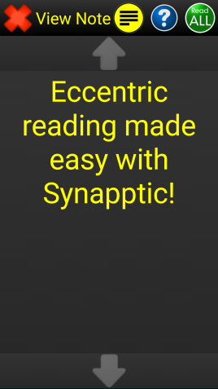

With Line View on, all text is converted to a single line of text. Hold the phone or tablet in an area of useable vision, then place a finger on the screen. Your finger can be used to scroll the text.  Keep your finger on the screen and slide it slightly to the left. The text will begin to scroll to the left. Slide your finger further left to increase the speed. Slide it back a little to the right to decrease the speed. When the speed slows to a stop the phone or tablet will vibrate slightly. | 

The phone or tablet will also vibrate when scrolling reaches either the start or end of the text.

By sliding your finger to the right, instead of the left, the text will scroll to the right. Again, the further you slide your finger the faster the scrolling will be.

If you release your finger when the text is scrolling, it will just continue scrolling at that speed. Tap the screen once to pause scrolling and tap again to continue at the previous speed.

To change the size of text, use a pinch and zoom technique. Place two fingers on the screen and separate them to increase the size of text. Bring them closer together to decrease the size of text.

If Line View mode is switched on, it will stay on until turned off again. Line View will also stay on between different screens. So, if you turn it on when reading a Note in Notepad, it will still be on when you read an email.

Appendix E – Using Synapptic Reader

Synapptic Reader is a simple but powerful screen reader for Android phones and tablets. It is used to read out Android apps or messages that aren't part of Synapptic. It goes step by step through each block of text or button on the screen and reads them out, one by one.

Synapptic Reader also places the familiar red Cancel and Go Back button in the top left of each App or Android message. This makes using Apps and Android features seamless and easy from Synapptic.

It can be used in three different ways:

- Using the volume keys

Each time you press the Volume Down button, Synapptic Reader will move to the next item on the screen and read it out. Pressing the Volume Up button will read out the previous item. When you get to the end of the items, it will make a dull thudding noise to let you know there aren't any more. Pressing Volume Down again will jump back to the start.

If it reads out something on the screen you can interact with - such as a video you can play or a box where you can type text in, it will audibly inform you. To activate it, press and hold the volume down button. After one to two seconds you will feel a buzz as the device vibrates to let you know it has been activated.

If you activate an item that lets you type in text then a keyboard will be shown on the bottom half of your screen. Run your finger over the keyboard to have the letters read out. Lift up your finger when you find the right one – that character will then be typed.

When typing in text, pressing the volume down key will move forward and the volume up key will move back through what you have typed. To stop typing and go back to having the screen read out, press and hold the volume down button to continue further down the screen, or press and hold the volume up button to go back up the screen.

Alternate control methods

There are two other ways of controlling Synapptic Reader. These are exploring by touch and exploring by gestures. All three control methods are available at the same time, you can use whichever you find most comfortable or swap between them without needing to change any settings.

- Explore by touch

To explore by touch simply run your finger over the screen and it will read out whatever you touch. You don't need to keep your finger on the screen and can just tap on what you want to have read out. Synapptic Reader will highlight what you have selected and read it out. If that is a link, a video or anything else that can be activated, then tap on it again to activate it.

If the screen you are reading is too long to be shown all at once, use two fingers and stroke upwards from the bottom of the screen to move further down, or stroke down from the top of the screen to move back towards the top.

It is important to note when using explore by touch that Android and Apps items don't always take up the full width of the screen. There can be an item on the left and a different item on the right.

- Explore by gestures

To explore by gestures, use one finger and swipe across the screen, starting from the left and going to the right. This will read out the next item on the screen. You can do the same thing by swiping down from top towards the bottom. To read out the previous item swipe upwards or towards the left.

When you find an item you want to activate, tap anywhere on the screen twice, quite quickly.

Finally, there is an option in the Synapptic Reader settings called Advanced Gestures. It is disabled by default but enabling it will change the swipe up and swipe down gesture. Instead of moving onto the next or previous item, this will let you choose what type of item to go to next. For example, Synapptic Reader will normally look for the next paragraph to read out. You could instead look for the next word or just the next letter. Going the other way, if you are reading a large amount of text you could look for the next heading, like a chapter title.

Appendix F – Synapptic Keyboard in Android

To make typing text outside of Synapptic easier, we have a keyboard for Android. It is installed and updated through the regular Updates menu – see Appendix C for more details.

This keyboard will inherit settings from Synapptic, including: Voice, Voice Speed, Beeps, Colour Scheme, Text Size, Font and all Keyboard settings.

By default, the Android keyboard will only cover half the screen.  In this mode, the text you are typing is shown within the Android screen. The bottom half of the screen is the regular keyboard layout, for both typing and speech recognition.  The middle of the screen has a row of buttons. From left to right, they are: | 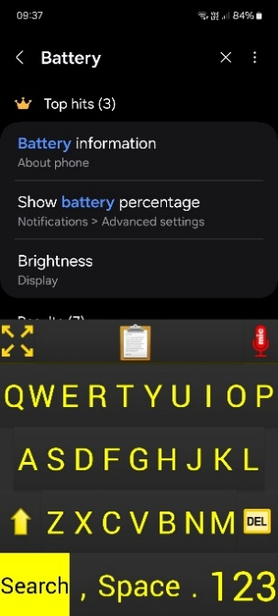 | 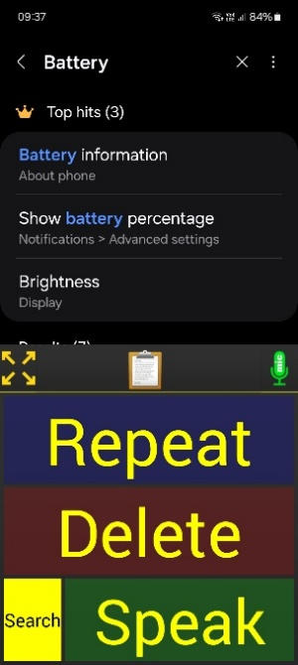

Full screen: Switch to the full screen view.

Paste: Any text that has been copied will be reproduced.

Speech Recognition: Toggle between speech recognition and typing. The first time you enable speech recognition it will ask permission to use the microphone.

While in half screen, Synapptic Reader will be active. This means running your finger over the screen will read out but to select a key will require a double tap or long press on the physical volume down button.

At any time, the keyboard can be switched into full screen mode by pressing the full screen button or by rotating the device into landscape orientation.
While in full screen mode, Synapptic Reader will deactivate and typing will work exactly the same as within Synapptic.

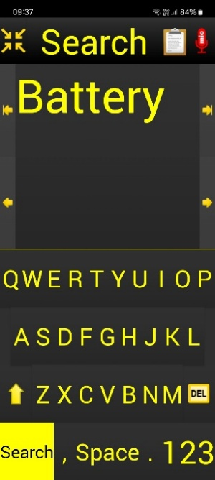 | 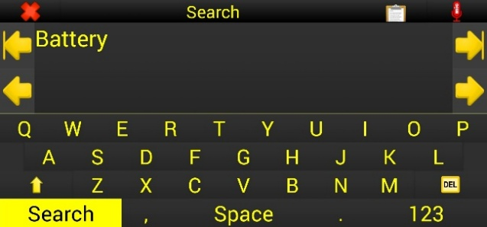 | 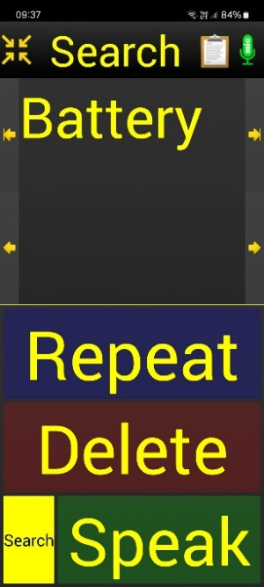
Portrait | Landscape | Dictate

Full screen mode entirely hides the Android screen and typed text is show in the top half, with the regular text size set in Synapptic.

To always show the keyboard in full screen mode, enable the Full Screen setting option within the Keyboard Settings in Synapptic.

Appendix G – The Synapptic printing menu

When printing a photo, note, email or letter the standard printing menu allows you to set the print size, preview the document and send the document to the printer.  There are four options available on the printing menu:  Text Size: Use the Text Size option to set the size of any text that will be printed.  Preview: Shows a preview of the document, | 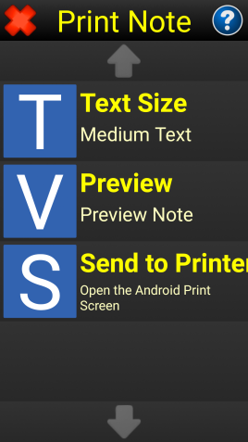
where you can use a pinch and zoom technique to magnify and inspect the finished document.

Send to Printer: This option sends the document to the printer. Before it’s actually sent to the printer an Android screen will display and Synapptic Reader will start. Press the yellow print button towards the top right of the screen to start printing.  Envelope: This is only available when printing a letter. You select the size envelope you are printing on and just the name and address of the recipient will be printed. | 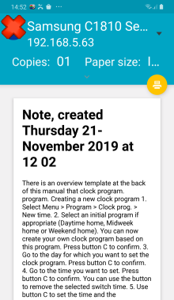

Appendix H – Register for RNIB Audio Books

To start using RNIB Audio Books you will need to create and validate an account through the RNIB Reading Services website. If you have trouble with this, call our helpline on 0191 909 7 909.

Use a web browser to navigate to the following site:

https://readingservices.rnib.org.uk/

Select the ‘Register’ link available near the top right of the screen.

You will need to provide your personal details including your full name, home address, telephone number and a working email address. You will also create a password for RNIB Reading Services.

When you’ve entered your details, the RNIB will process them and send you a confirmation email. It contains a link to confirm your account details. Select this link to validate your email address.

Finally, head to the Reading Services website once more and select the ‘Log In’ link near the top right of the screen. Use your email address and newly created password to log in.

Select the banner across the top of the screen with the option to complete your setup. This will ask you to confirm a few preferences and needs to be done before you can use the account in Synapptic.

To enter your Reading Services account details in Synapptic, go into the Entertainment menu, then into the Entertainment Settings option. There is an option to enter your email address and a second option for your Reading Services password.

Appendix I – Register for Calibre

To start using Calibre Audio Library you will need to create and validate an account through the Calibre Audio website. If you have trouble with this, call our helpline on 0191 909 7 909.

Use a web browser to navigate to the following site:

https://www.calibreaudio.org.uk/join

You will need to provide your personal details including your full name, home address, telephone number and a working email address.

When you’ve entered your details, Calibre will process them and send you a confirmation email with your membership number and password.

To enter your Calibre account details in Synapptic, go into the Entertainment menu, then into the Entertainment Settings option. There is an option to enter your membership number and a second option for your password.

Discover other Synapptic products

We make technology easy for everyone!

Our phones, tablets, smartwatches, smart glasses and accessories are all designed to make everyday technology easier and more accessible, helping you stay connected, entertained and informed. Across the range, you'll find features such as clear menus, high-contrast large text, voice output and voice control, depending on the product.
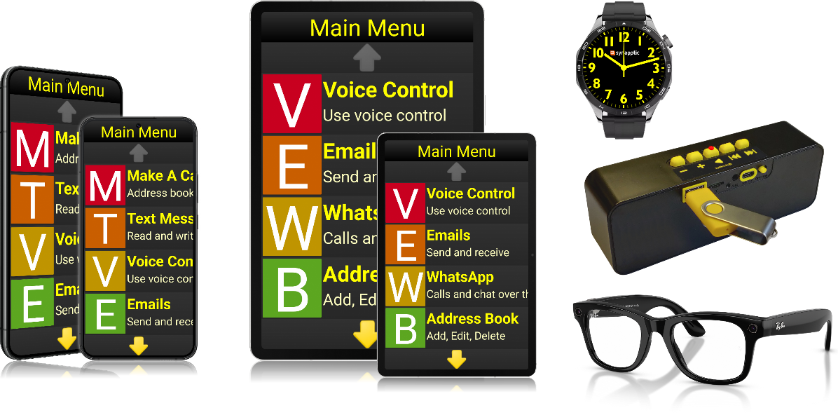

What our customers say

Real stories from people who use Synapptic every day

Featured testimonial: I have now had my new phone for a few weeks and want to say how tremendously impressed I have been by Synapptic. Everything has been excellent - brochure, website, video demonstrations, advice and help before and after purchase, prices, accessories and the user manual.

It has been so much easier dealing with a small, friendly British company like Synapptic than struggling with a faceless large corporation! A tremendous amount of thought and care has gone into the special features and how they’re presented in a clear and logical way.

Synapptic is providing a wonderful service for people with visual impairments, and I am recommending you enthusiastically to friends. Thank you for all you have done!

About Synapptic

Synapptic is dedicated to creating easy-to-use and innovative solutions that help anyone with sight loss use phones, tablets and other mobile technology.

We’re a family run business, formed in 2012 and based in
Durham, in the north east of England.

 | All our products are designed and developed in the UK.



We’re proud that Synapptic is award winning!






Tel  Web  Email | 0191 909 7 909  www.synapptic.com  sales@synapptic.com | Synapptic Ltd  Adelaide House,  Belmont Business Park,  Durham, DH1 1TW | 

